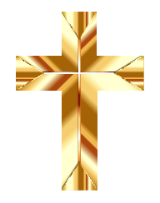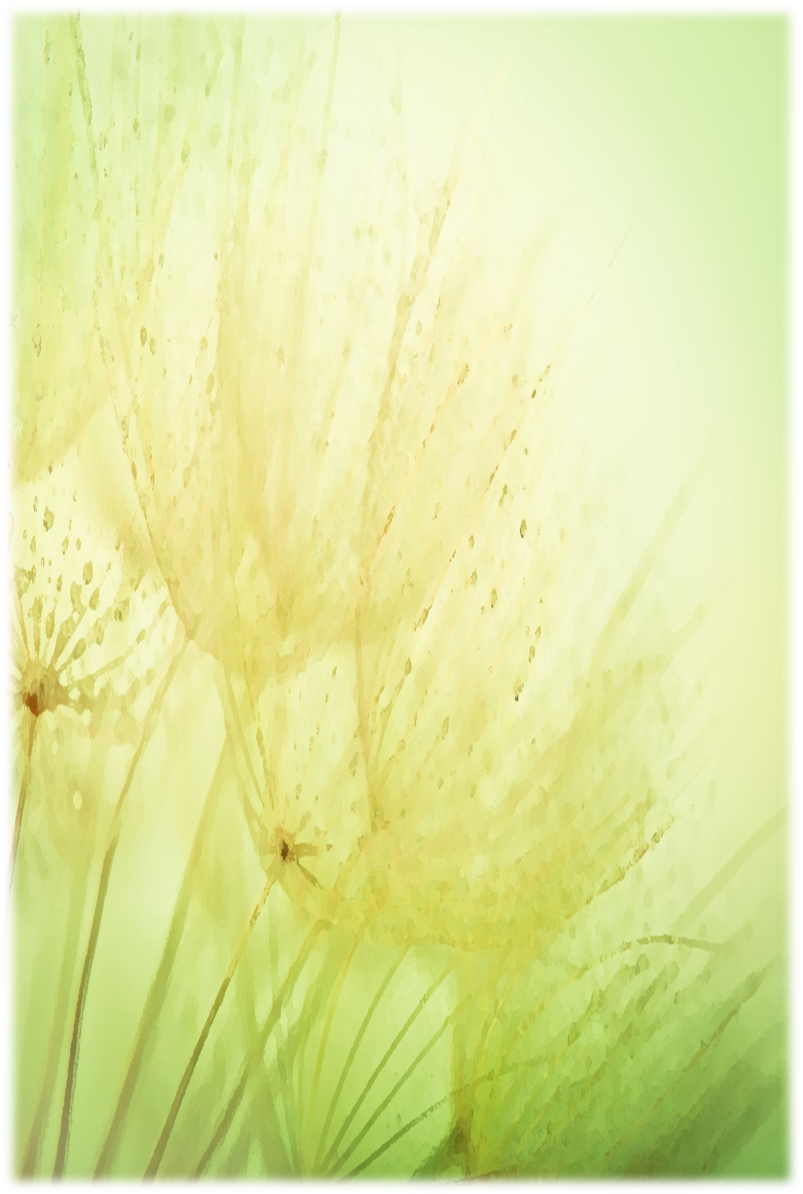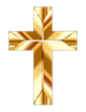

**You are invited to join us in celebrating**

**the 50th (+) Anniversary of the Ordination of**

**Fr Barry Hughes**

**The Mass of Celebration will be on**

**Sunday 9th October, 2022**

**at 10.30 am**

**at St Theresa’s Church, Albion**

**Refreshments will be served in the Multipurpose room.**

**Please advise if the plate to share is sweet or savoury.**

**RSVP name and number attending**

**to Ann Maree on 0401192079 or annmaree.sanford@stellamaris.org.au**

**By Monday 26th September**

[This Photo](https://freepngimg.com/png/29175-christian-cross) by Unknown Author is licensed under [CC BY-NC](https://creativecommons.org/licenses/by-nc/3.0/)

