St. Theresa’s Parish Community Newsletter

Parish Priest: Fr Barry Hughes
Presbytery: 17 Drummartin St., Albion 3020
Phone: 9311 3091
email: caalbion@netspace.net.au
Mobile: 0428 533 391
Polish Chaplain: Fr Marian Szeptak
Residence: 185 William St, St Albans 3021
Phone: 9310 9057

St. Theresa’s Primary School – 9311 9070
16 Drummartin St., Albion 3020
Principal: Rob Macklin

Mother of God Primary School – 9363 1734
Blanche St., Ardeer 3022
Principal: Assunta Iacovino

“Do Small Things Well”

PASSION (PALM) Sunday Year A 1 & 2 April 2023

WALK FOR JUSTICE FOR REFUGEES ON PALM SUNDAY, APRIL 2nd
Join CAPSA at 1:00pm for a group reflection and prayer led by Fr Andy Hamilton SJ, with official Walk for Justice music and speeches starting around 1:30pm. Where? We will be meeting at the far right side of the State Library of Victoria (near the Joan of Arc statue and next to Little Lonsdale St – you’ll see a large ‘CAPSA’, ‘Jesuit Social Services’ or ‘Xavier Social Justice Network’ banner).

MASSES THIS WEEK  ST THERESA’S  Drummartin St, Albion  10.30am Sunday  MOTHER OF GOD  Blanche St, Ardeer  10.00am Wednesday (Pol)  10.15am Sunday (Polish)  QUEEN OF HEAVEN  Holt St, Ardeer  8.00am Wednesday  9.00am Sunday  CHRIST’S CATHOLIC COMMUNITY  Prayer Group meets every Thursday, 7.00 - 8.30pm, at Queen of Heaven Church. All are welcome |  | CUPPA AFTER MASS  Join us today after each Mass for a cuppa and a chat  PARISH LEADERSHIP TEAM  Meeting on Wednesday 5th April, 7.00pm at St Theresa’s School  ROSTER  Latest Counters Roster has been emailed this week or a copy will be available at the back of the Church  COLLECTIONS RECEIVED  Thanksgiving $1360 Loose Money $350 Presbytery $601  ***REMINDER; Please return your Project Compassion Boxes and  envelopes next week***  COUNTERS 9th April Team 3: M Poulter, A Correya  READINGS Today Next Week  Isaiah 50.4-7 Acts 10.34a,36-43  Ps 22.7-8,16-17,18-19,22-23(R.1) Ps 118.1-2,16-17,22-23(R.24)  Philippians 2.6-11 Colossians 3.1-4  Matthew 26.14-27.66 John 20.1-18
EASTER CEREMONIES 2023
Holy Thursday, 06th April 7.00pm - Queen of Heaven, Mass of the Lord's Supper
Good Friday, 07th April 10.30am - Queen of Heaven to Mother of God, Stations of the Cross
3.00pm - Mother of God, Solemn Ceremonies
Easter Saturday, 08th April 7.00pm - St Theresa's, Easter Vigil Mass
Easter Sunday, 09th April 9.00am - Queen of Heaven, Mass
10.30am - St Theresa's, Mass
SUPPER INVITATION After Easter Vigil Mass in multi-purpose room at St Theresa’s School. Please bring a plate to share.

POLISH EASTER CEREMONIES at Mother of God
Holy Thursday 7.00pm Good Friday 5.00pm
Saturday Blessing of Food 11.00am Easter vigil 5:00pm
Easter Sunday 10.15am Easter Monday 9.00am

PARISH MOVIE MORNING…Change of Date…. Monday 3rd April 10am, Sunshine Village Cinema, Tickets $9. RSVP Ann-Maree Ph: 0401 192 079
REFLECTIONS – PALM SUNDAY
Written by Michael McGirr
It is only once in every three years that we publicly share together Matthew’s full account of the arrest, trial and death of Jesus. Today is that day. Matthew’s passion is rich in every sense of the word. It is the longest account of what Jesus endured and it also has the most diverse cast of characters. Only Matthew devotes time not only to the tragic fate of Judas, who was filled with remorse, but even to the thirty pieces of silver that were used to buy a cemetery for foreigners called the Field of Blood. Only Matthew tells us about the dream of Pilate’s wife which leads her to send a message to her husband that he should have nothing to do with Jesus. Matthew’s Gospel features a number of dreams. Joseph is told in a dream to take Mary as his wife, to flee with his family to Egypt and later to return from Egypt. Dreams are one of the many links between Matthew’s Gospel and the Hebrew scriptures.
This is by no means to say that Matthew’s Gospel is merely an interesting piece of literature. It is only to suggest that, in Holy Week, Matthew’s Passion is a wonderful encounter to enter slowly as we spend time with the Lord, allowing the mystery of the cross to deepen within us. One commitment we might make is to take a section each day this week and stay with it for ten minutes.
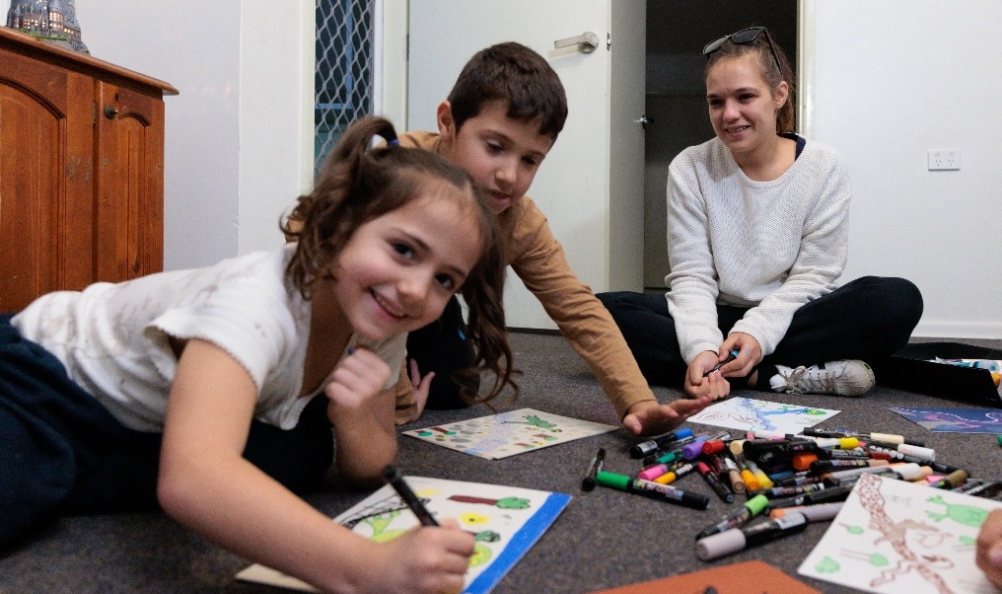
Monday Mt 26: 14-35, Tuesday Mt 26: 36-56, Wed Mt 26: 57-75, Thursday Mt 27: 1-26, Friday Mt 27: 27-56, Saturday: Mt 27: 57-66.
The trial and death of Jesus reminds us of the tragedy of injustice that continues to this day in so many places around the world. Throughout Lent, Caritas Australia, through Project Compassion, has attempted to draw our attention to many important issues in our world. We have been invited to take up the cross and follow Jesus in our own time. We can pray, with Jesus, ‘Let it be as you, not I, would have it.’

Sixth Sunday of Lent (Palm Sunday)
1 & 2 April
Every day, more than 200 million children miss out on school, around 690 million people go hungry and 2.2 billion people cannot access clean drinking water. In recent years, COVID-19 has also devastated vulnerable communities already living in poverty, with the health and economic impacts to reverberate for years to come.

It’s through the generous support of people like you that we are able to continue to help lift vulnerable communities out of poverty – support that is needed now more than ever.

Thank you for your continued support for Project Compassion – past, present and future. Together, we can help vulnerable communities face their challenges today and build a better tomorrow For All Future Generations.

St Theresa’s Parish is committed to the safety of children, young people and vulnerable adults

