St. Theresa’s Parish Community Newsletter

Administrator: Fr Dixon George IVDei
Presbytery: 17 Drummartin St., Albion 3020
Phone: 9311 3091
email: albion@cam.org.au
Website: https://pol.org.au/albion/Home.aspx
Polish Chaplain: Fr Marian Szeptak
Residence: 185 William St., St Albans 3021
Phone: 9310 9057

St. Theresa’s Primary School - 93119070
16 Drummartin St., Albion 3020
Principal: Rob Macklin

Mother of God Primary School - 93631734
Blanche St., Ardeer 3022
Principal: Assunta Iacovino

“Do Small Things Well”
___________________________________________

SECOND SUNDAY IN EASTER Year B 6 & 7 April 2024

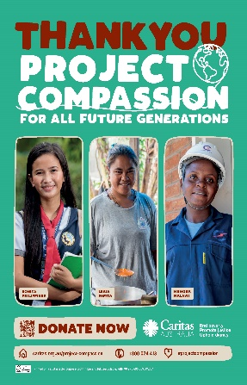
Caritas Australia would like to THANK YOU!

Caritas Australia would like to THANK YOU for supporting Project Compassion 2024. Your generosity will empower the world’s most vulnerable communities to grow stronger and lift themselves out of poverty. Together, we can help vulnerable communities face their challenges today and build a better tomorrow, for all future generations.
You can donate through Project Compassion donation boxes and envelopes available from your parish, by visiting caritas.org.au/project-compassion or by calling 1800 024 413

MASSES THIS WEEK  ST THERESA’S  Drummartin St, Albion  9.00am Friday  10.30am Sunday  MOTHER OF GOD  Blanche St, Ardeer  10.00am Wednesday (Pol)  9.00am Thursday  6.00pm Friday (Polish)  5.30pm Saturday  10.15am Sunday (Polish)  QUEEN OF HEAVEN  Holt St, Ardeer  8.00am Wednesday  9.00am Sunday  RECONCILIATION (Individual Confession)  Saturday 13th April, 10.00am at Queen of heaven or other times and places on request |  | CUPPA AFTER MASS  Join us today after each Mass for a cuppa and a chat.  APOLOGIES for mix up with time for Blessing of Food at Mother of God at Easter. We didn’t get the change in time for the previous week newsletter.  COLLECTIONS RECEIVED  Thanksgiving $727 Loose Money $272  Presbytery $918 Easter Offering $57  ANNUAL COLLECTION for Holy Places raised $1797.Thank you.  PROJECT COMPASSION THANK YOU  Our Parish has raised $2174 to support Caritas Australia. Thank you to all who have given so generously. Returning any Envelopes or Boxes as soon as you can would be appreciated.  COUNTERS 14th April Team 3: M Azzopardi, M Camenzuli  READINGS Today Next Week  Acts 4.32-35 Acts 3.13-15,17-19  Ps 118.2-4,16-18,22-24 (R1) Ps 4.1,3,6,8 (R.6b)  1 John 5.1-6 1 John 2.1-5  John 20.19-31 Luke 24.35-48

PARISH CARAVAN, Safety Beach / Dromana SCHOOL HOLIDAYS
If you would like to use our Caravan please call the Parish Office on 9311 3091 to book. It sleeps up to six (very cosy) and costs $60 per night

St Theresa’s Parish is committed to the safety of children, young people and vulnerable adults

REFLECTION ON THE GOSPEL by Fr Michael Tate

Thomas the Doubter seeing the wounds

The true believers in the Risen Christ kept Thomas the Doubter within their circle, rather than expelling him. This gave him a further opportunity to experience the very Real Presence of the Risen Lord and his gift of peace. Companionable patience is our best response to those struggling with belief in even fundamental tenets of the faith.

Thomas saw that the wounds of Christ were still present, not obliterated. Does this suggest that our redeemed bodies will bear the marks of the wounds unjustly inflicted on us? However, they will not be disabling to our personality because they will be incorporated into the resurrection life of Christ. Incredibly, our self-inflicted wounds, i.e. our sins, will be obliterated in the mercy of God.

Pope Francis emphasises that it was in responding to the invitation to touch the wounds of Christ that Thomas understood Christ’s true identity, exclaiming: ‘My Lord and my God’. It is only by touching the wounds of Christ in many different people in many different situations that we can authentically make the same act of faith.

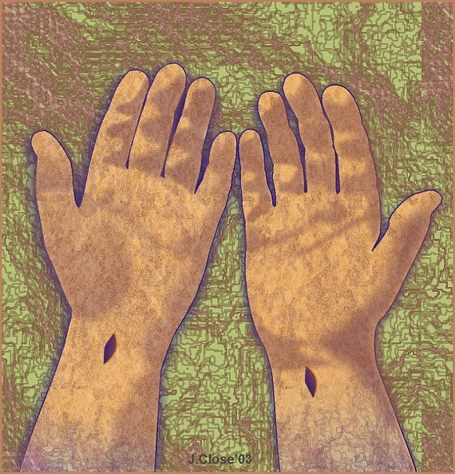
We could take a moment to pray for the strength to touch the wounds of Christ in others, ‘the least’. And we could pray that, wounded as we may be by the vagaries and injustices of life, we may be liberated from their evil effects as the Risen Lord adopts our wounds as his own.

© Fr Michael Tate; mtate@bigpond.com

