.fE
St. Theresa’s Parish Community Newsletter

Parish Priest: Fr Barry Hughes
Presbytery: 17 Drummartin St., Albion 3020
Phone: 9311 3091
email: caalbion@netspace.net.au
http://pol.org.au/albion/Home.aspx
Mobile: 0428 533 391
Polish Chaplain: Fr Marian Szeptak
Residence: 185 William St., St Albans 3021
Phosne: 9310 9057

P
9310 905
St. Theresa’s Primary School - 93119070
16 Drummartin St., Albion 3020
Principal: Rob Macklin

Mother of God Primary School - 93631734
Blanche St., Ardeer 3022
Principal: Assunta Iacovino

“Do Small Things Well”

FOURTH SUNDAY IN ADVENT Year A 17 & 18 December 2022

CHRISTMAS MASS TIMES
Christmas Eve Saturday 24th December Mother of God Church, Blanche St., Ardeer 6.00pm
Queen of Heaven Church, Holt St., Ardeer 8.00pm
St Theresa’s Church, Drummartin St., Albion 12.00 Midnight
Mother of God Church, Blanche St., Ardeer (Pol) 12.00 Midnight
Christmas Day Sunday 25th December Queen of Heaven Church, Holt St., Ardeer 9.00am
Mother of God Church, Blanche St., Ardeer (Polish) 10.15am
St Theresa’s Church, Drummartin St., Albion 10.30am
MASSES THIS WEEK  ST THERESA’S  Drummartin St, Albion  9.00am Friday  MOTHER OF GOD  Blanche St, Ardeer  10.00am Wednesday (Pol)  9.00am Thursday  6.00pm Friday (Polish)  QUEEN OF HEAVEN  Holt St, Ardeer  8.00am Wednesday  RECONCILIATION  Saturday 24th December 9.00 am Queen of Heaven  10.00am St Theresa’s  11.00am Mother of God |  | FUNERAL MASS For Bronislawa Lawicki on Thursday 22nd December at Mother of God. Rosary 10.30am, Mass 11am  2023 COLUMBAN CALENDAR  Available at each church. Cost $10. New design and free online art guide www.columban.org.au/artguide  MELBOURNE OVERSEAS MISSION  We raised $672 last week. Thank you.  COLLECTIONS RECEIVED  Thanksgiving $729 Loose Money $312 Presbytery $572  COUNTERS 25 December  Team 1: D Catania, E Catania, C Xuereb  READINGS Today Next Week  Isaiah 7.10-14 Isaiah 52.7-10  Ps 24.1-2,3-4ab,5-6 (R.7c+10b) Ps 98.1,2-3a,3b-4,5-6(R.3bc)  Romans 1.1-7 Hebrews 1.1-6  Matthew 1.18-24 John 1.1-18

COLLECTION TO SUPPORT THE PEOPLE OF UKRAINE
Given the continuing suffering being inflicted on people in Ukraine, in many ways it will not be a very happy Christmas there. Many Ukrainians have sought refuge in neighbouring countries. At all our Christmas Masses next weekend there will be a special collection to support those seeking to relieve some of the suffering there.

CARITAS AUSTRALIA Global Gift Christmas cards
A great way to share joy this Christmas is with a Gift Card to your loved ones that will truly make a life-changing impact. Here is the link for the Online order www.globalgifts.org.au or see Church noticeboard for details.

St Theresa’s Parish is committed to the safety of children, young people and vulnerable adults

What is the real 'reason' for the season: sin or love?
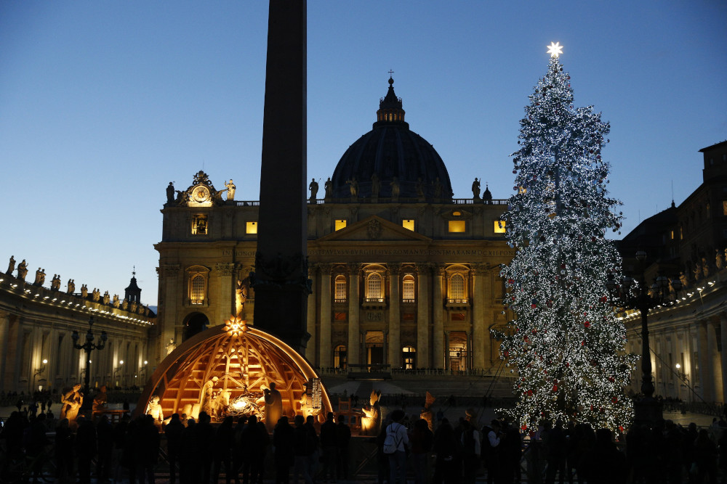
The Nativity scene and Christmas tree decorate St. Peter's Square at the Vatican Dec. 5. (CNS/Paul Haring)
BY DANIEL P. HORAN
Bumper stickers and internet memes tend to spring up this time of year, beckoning onlookers to "remember the reason for the season" or exhort readers to "keep Christ in Christmas." While undoubtedly well-meaning in their origin, these slogans have also been coopted by conservative commentators in recent years as a kind of political cri de coeur that signals a made-up "war on Christmas."
Even though there is no such thing as a "war on Christmas," at least not in the United States, I do find the rallying cry "remember the reason for the season" very interesting, especially because of its inadvertently theological invitation.
The question "Why did God become human?" has been the focus of theological reflection for as long as the earliest Christian community began proclaiming that the Word became flesh and made his dwelling among us (John 1:14). The most famous consideration of this question comes in the form of a treatise by St. Anselm of Canterbury, Cur Deus Homo? (literally: "Why the God-Man?").
The question is one of the divine ratio — that is "reason," "motivation" or "logic" — for the coming of Christ into the world. Anselm begins his exploration with the presumption that human sinfulness is the biggest issue at play. Subsequently, we need to be reconciled to God, something we cannot accomplish on our own. It can only, ultimately, be achieved by one who is both divine and human; hence the Incarnation.
For Anselm, sin is the reason for the season. He believes that if humanity had not sinned, if we had continued to enjoy the rectitude and right relationship Adam and Eve are said to have enjoyed with God before the Fall, the eternal Logos would never have needed to become human. The Incarnation is, for Anselm, a sign of God's benevolence, but it is also entirely predicated on our disobedience, pride, sin and need for reconciliation.
This has come to be known in theological circles as the "majority opinion" about the divine reason for the Incarnation. Indeed, if you were to poll a selection of average Christians leaving church this Sunday and ask them: "Why did God become human?" the most common answer is likely to be "to save us from our sins."
Yet even as most Christians believe that the reason God became human is sin, this is hardly a theme in Christmas cards. And most secular and religious Christmas songs tend to be lovely, cheerful, and often upbeat. With a few exceptions, like the classic "God Rest Ye Merry Gentlemen," there is hardly acknowledgement that the popular understanding of the "reason for the season" is human sinfulness.
I'm not suggesting we need more Lenten or Good Friday-themed Christmas songs. Rather, I think we have the whole focus on sin wrong in the first place. And I'm far from alone in that view.
The "majority opinion" about the divine ratio for the Incarnation is not the only view. There is a longstanding theological and spiritual tradition dating back to the New Testament itself that holds that even if we had not sinned, God would still have become human!
The technical language for this admittedly "minority opinion" (minority only because it is lesser known, not at all less true) is known as supralapsarianism. That's just a fancy word for "not occasioned by or dependent on 'the Fall' " (from supra meaning "above" or "apart from" and lapsus meaning "the Fall"). The "majority opinion" is known as infralapsarian (from infra meaning "dependent on").
This longstanding, perfectly orthodox, entirely sound theological view argues that the Incarnation was always part of God's plan for creation and that the Word becoming flesh was never primarily motivated by human sin or anything else outside of God's absolute freedom.
The issue here is the unfortunate conflation that many people have made over the centuries between the need for reconciliation and the need for salvation. As the second century theologian St. Irenaeus of Lyons explained in his classic treatise Adversus Haereses, God's plan for creation always included God's plan for salvation, which he understood (following St. Paul) as the recapitulation of the whole of creation back to God's self.
When God created, God also willed to bring all of creation to glory through a finite share in the divine life, which is accomplished by the Incarnate Word and Holy Spirit.

Decorations illuminate the entrance to the Viennese Christmas Market at City Hall at Square in Vienna Dec. 6. (CNS/Reuter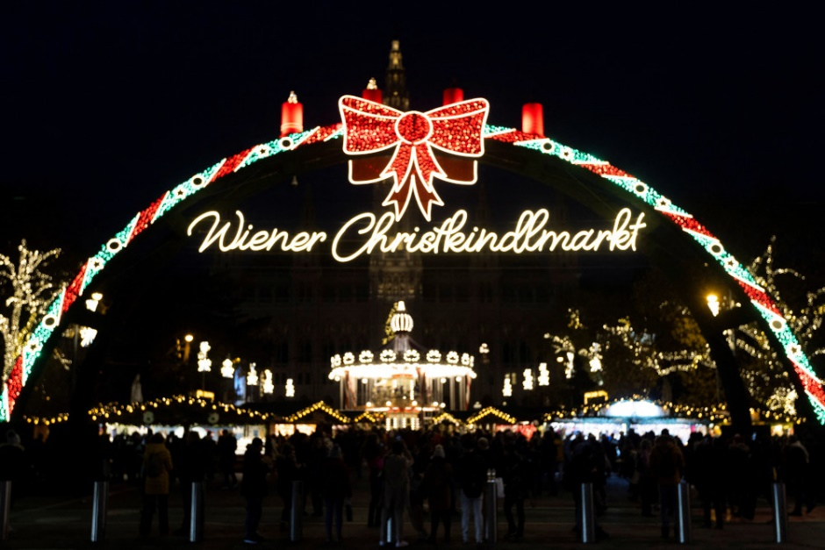

Our Eastern Christian siblings have maintained this tradition much better than most of us Western Christians have. But many Western Christian theologians and saints have advanced the sound doctrine that the divine reason for the Incarnation is primarily about God's love, freedom and plan for creation and salvation long ahead of any chance humanity had to sin or exercise disobedience.
Take, for example, the contemporary of Anselm, a fellow Benedictine monk named Rupert of Deutz, who wrote several treatises in which he presented a supralapsarian argument for the Incarnation in response to the classic counterfactual question: "What if humanity had not sinned?" His answer is that there is plenty of reason to believe with confidence that God would still have become human, a position he defends with scripture and the theological tradition.
Or consider some of the greatest theologians at the nascent universities of Paris and Oxford in the early 13th century, such as the Franciscan Alexander of Hales, Dominican St. Albert the Great or the secular master Robert Grosseteste, who served as the chancellor of Oxford before becoming Bishop of Lincoln. Like Rupert before them, they each offered their own contributions to the supralapsarian position on the Incarnation.
Perhaps the most famous medieval contributor to this theological tradition is the Franciscan Blessed John Duns Scotus, the scholar who also developed the philosophical argument that would eventually become the Catholic framework for the dogma of the Immaculate Conception of Mary.
Many modern theologians and spiritual writers, both Catholic and Protestant, have also contributed to this tradition, including Jesuit Fr. Karl Rahner, Karl Barth, Wolfhart Pannenberg, Trappist Fr. Thomas Merton, St. Joseph Sr. Elizabeth Johnson, among others.
None of these historical or contemporary figures deny the reality of sin or the need we have to be reconciled to God, which is indeed accomplished by Jesus Christ through his life, death and resurrection. The issue centers on not putting the proverbial cart before the horse, confusing one of the effects of the Incarnation for the primary or exclusive reason for it.
Just because Christ accomplishes our reconciliation with God, a need originating from our sinfulness, does not mean that is the only reason or even the primary reason God became human.
Love. Love is the reason God wanted to enter the world as one of us, to draw near to us in the most intimate way possible: taking on our very materiality (sarx), our very vulnerability (Philippians 2:6-11), our shared experience of human relationship in this world. If we humans had exercised our free will in obedience and never sinned, we wouldn't have needed redemption or reconciliation for sin, but God would still have entered the world as one of us out of love and the desire to bring us and all of creation to share in God's life in salvation.
I think the way Merton summarizes this in his book New Seeds of Contemplation says it best:
The Lord would not only love His creation as Father, but He would enter into His creation, emptying Himself, hiding Himself, as if He were not God but a creature. Why should he do this? Because He loved His creatures, and because He could not bear that His creatures should merely adore him as distant, remote, transcendent, and all powerful.
Again, it is divine love that is the primary motive. Not only can we give thanks that Christ has reconciled us to God because of our sin, but also and more fundamentally we can praise God at Christmas for the divine love and absolute freedom reflected in God's desire to draw close to us as one of us from all eternity.
Now that is a reason for the season worthy of Handel's "Hallelujah" chorus or "O Holy Night" or even a bumper sticker.

