.fE
St. Theresa’s Parish Community Newsletter

Parish Priest: Fr Barry Hughes
Presbytery: 17 Drummartin St., Albion 3020
Phone: 9311 3091
email: caalbion@netspace.net.au
http://pol.org.au/albion/Home.aspx
Mobile: 0428 533 391
Polish Chaplain: Fr Marian Szeptak
Residence: 185 William St., St Albans 3021
Phone: 9310 9057

P
9310 905
St. Theresa’s Primary School - 93119070
16 Drummartin St., Albion 3020
Principal: Rob Macklin

Mother of God Primary School - 93631734
Blanche St., Ardeer 3022
Principal: Assunta Iacovino

“Do Small Things Well”

SECOND SUNDAY IN ADVENT Year A 3 & 4 December 2022

MASSES THIS WEEK  ST THERESA’S  Drummartin St, Albion  8.00am Friday  10.30am Sunday  MOTHER OF GOD  Blanche St, Ardeer  10.00am Wednesday (Pol)  9.00am Thursday  6.00pm Friday (Polish)  5.30pm Saturday  10.15am Sunday (Polish)  QUEEN OF HEAVEN  Holt St, Ardeer  8.00am Wednesday  9.00am Sunday |  | CUPPA AFTER MASS 3 & 4 December  Join us today after each Mass for a cuppa and a chat.  2023 COLUMBAN CALENDAR  Available at each church. Cost $10. New design and free online art guide www.columban.org.au/artguide  COLLECTIONS RECEIVED  Thanksgiving $902 Loose Money $214 Presbytery $495  COUNTERS 11 December  Team 2: M Azzopardi, M Camenzuli  FEAST DAYS THIS WEEK  Wednesday 7th December St Ambrose  Thursday 8th December Immaculate Conception  READINGS Today Next Week  Isaiah 11.1-10 Isaiah 35:1-6, 10  Ps 72.1-2, 7-8, 12-13, 17 (R.7) Psalms 146:6-10  Romans 15.4-9 James 5:7-10  Matthew 3.1-12 Matthew11:2-11

CARITAS AUSTRALIA Global Gift Christmas cards
A great way to share joy this Christmas is with a Gift Card to your loved ones that will truly make a life-changing impact. Here is the link for the Online order www.globalgifts.org.au or see Church noticeboard for details.

DAILY PRAYER WITH THE ADVENT CALENDAR
Novena. We could all pray the prayer on the card of the day in the Advent Calendar (emailed last week, paper copies available in the churches) 10am each morning of Advent wherever we are at that time. On Fridays after 9am Mass (8am this week) at St Theresa's a 'cuppa' will be held at the home of one of the mass attendees & at 10am we say the Prayer 'together'. If anyone is 'housebound' & would like us to come & say the Prayer in your home with you, please advise Ann-Maree on 0401 192 079.

MELBOURNE OVERSEAS MISSION
A special collection will be taken up at all masses next weekend (Dec 10 and 11). MOM, an initiative of the Catholic Archdiocese of Melbourne is currently supporting people in need in Papua New Guinea, Peru, Pakistan and Israel. Please give generously.

ST JOHN OF GOD HEALTH PROJECT
Building of two three-bedroom homes for intellectually disabled adults has begun at 54-56 Blanche St, opposite Mother of God Church. Our Parish has leased the land which was formerly the convent site to St John of God Health. A blessing of the project will be held on Tuesday 13th December at 10.30am. A representative of St John of God will speak about the project at all Masses on a future weekend.

PARISH DINNER
After a slight gliche, a last minute change of venue, 28 of us enjoyed our last 'Parish Dinner' for 2022.
'Santa' even found us at the new venue.Thank-you to everyone who has come along & supported our 'Parish Dinners'. Best wishes for a Safe, Happy & Healthy 'Christmas & New Year' Season, see you in 2023.

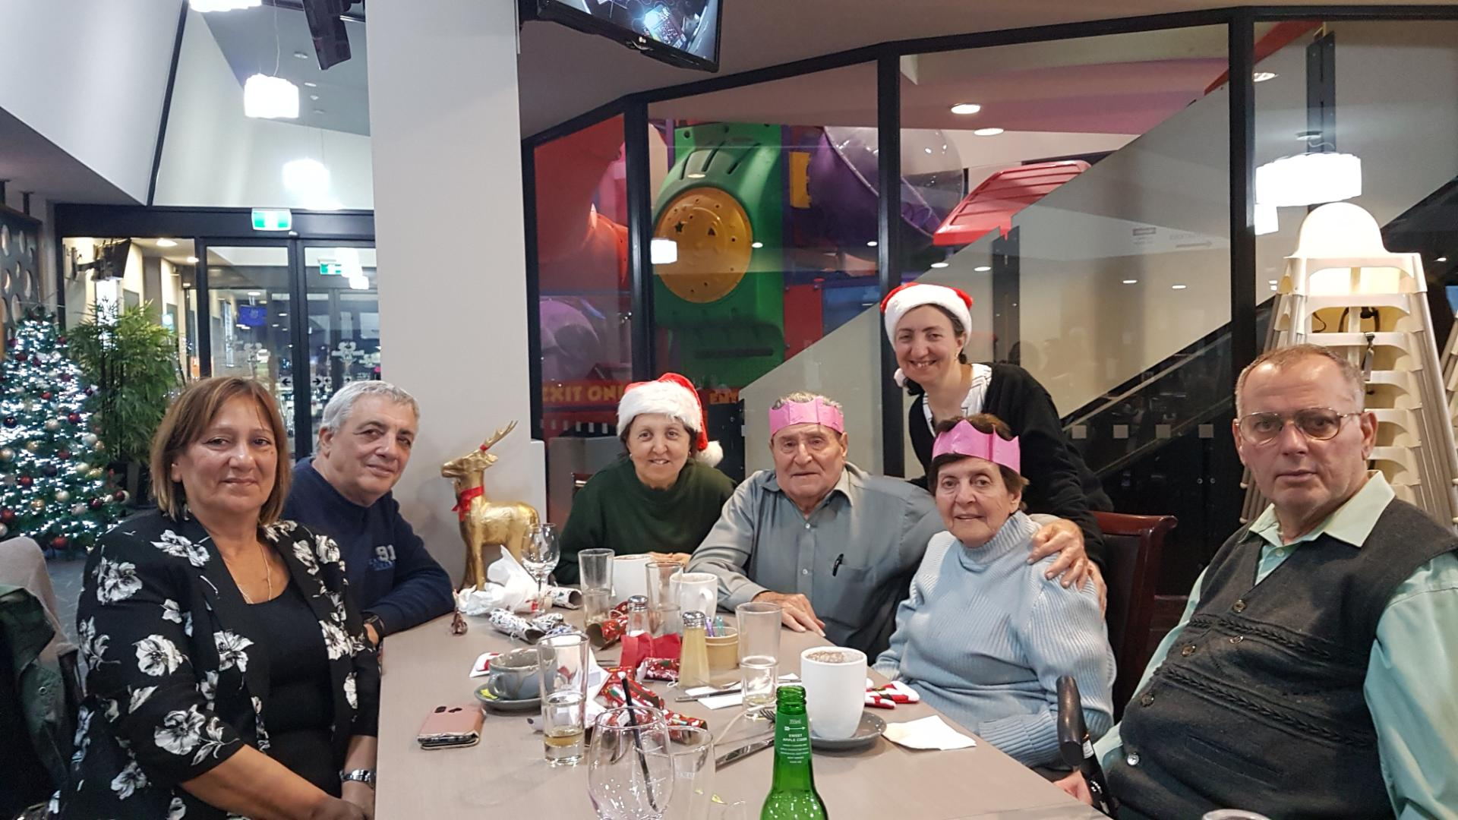

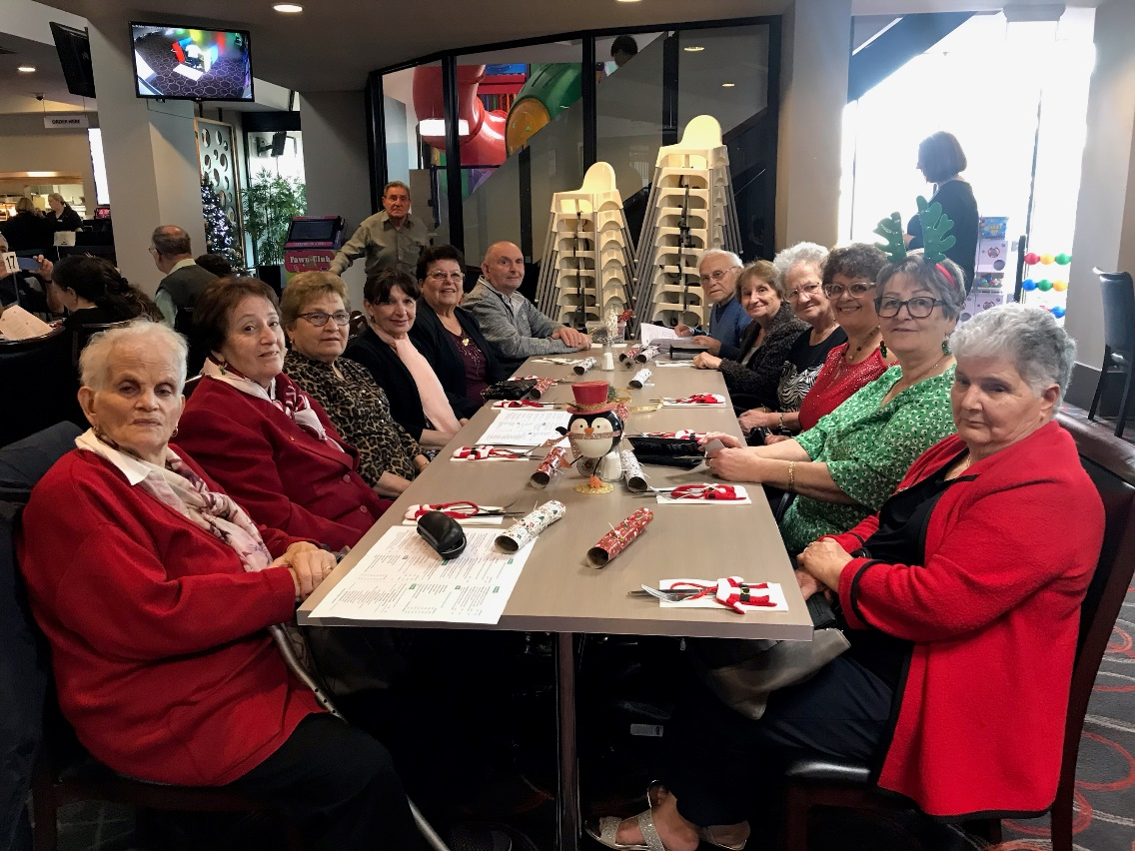

St Theresa’s Parish is committed to the safety of children, young people and vulnerable adults

SECOND SUNDAY OF ADVENT YR A

2nd Sunday of Advent Reflection
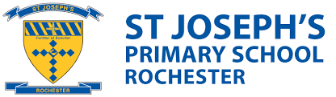
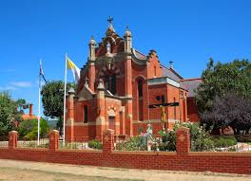
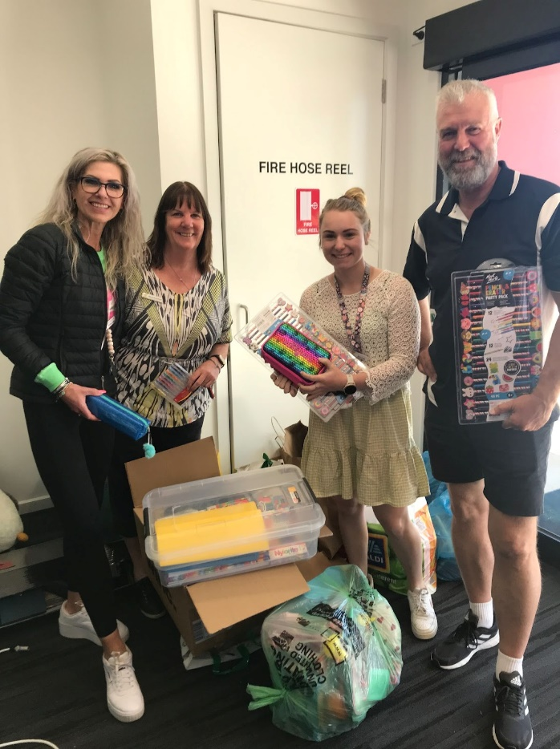
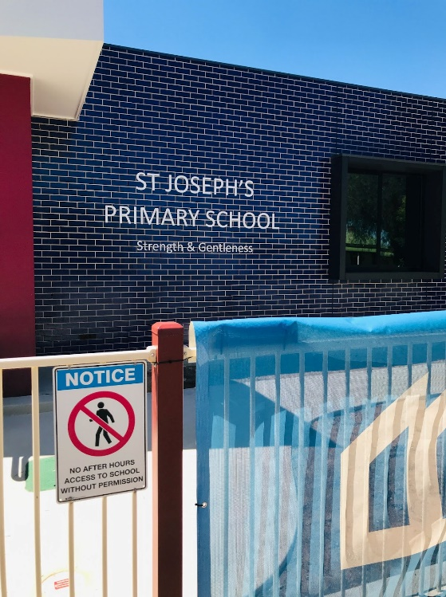
Last Friday I had the pleasure of traveling to the township of Rochester in Northern Victoria. I was there to visit Saint Joseph Catholic Primary School. Over the past few weeks the teachers and parish community had been gathering school materials, stationary, picture story books and small gifts. These were collected because the school had been majorly affected by the recent floods.

At present the repairs to the school have been given high priority and there was a lot of construction and cleaning up going on. Because of this fast-tracking, the Principal Elizabeth Trewick believes they will be able to resume normal teaching back in their school by February next 2023.
Each day the Preps to Grade 2s are bussed to Elmore, whilst the Grade 3-6s travel to Junortoun, just outside of Bendigo.
The school staff that were in attendance that day, Yvette, Maria, Amy and Peter were so astounded and appreciative of all the generous donations that were delivered and asked that I convey their gratitude to all involved.

This act of kindness is representative of everyone’s generosity and demonstrates an act of Social Justice towards the wider community. As we that have not been directly affected by the floods keep those that have been, in our thoughts and prayers over this Advent and Christmas season.

Since it is my final reflection for the year, I would like to take this opportunity to wish everybody a special, holy and safe Christmas and summer break.

Regards Doriana Cooper
REL St Theresa’s

