.fE
St. Theresa’s Parish Community Newsletter

Parish Priest: Fr Barry Hughes
Presbytery: 17 Drummartin St., Albion 3020
Phone: 9311 3091
email: caalbion@netspace.net.au
http://pol.org.au/albion/Home.aspx
Mobile: 0428 533 391
Polish Chaplain: Fr Marian Szeptak
Residence: 185 William St., St Albans 3021
Phosne: 9310 9057

P
9310 905
St. Theresa’s Primary School - 93119070
16 Drummartin St., Albion 3020
Principal: Rob Macklin

Mother of God Primary School - 93631734
Blanche St., Ardeer 3022
Principal: Assunta Iacovino

“Do Small Things Well”

FIRST Sunday of Lent Year A 25 & 26 February 2023
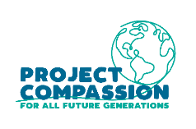
CARITAS AUSTRALIA PROJECT COMPASSION – LAXMI STORY
After losing her father when she was just 10-years-old, Laxmi was at risk of falling further into extreme poverty. But with the support of our partner Caritas Nepal, Laxmi joined a child's club, became a leader in her school and is now a mentor to other children in her village.
Please donate to Project Compassion 2023.

PROJECT COMPASSION BOXES AND ENVELOPES
Please take home a Project Compassion box or a set of donation envelopes to support Caritas Australia. With your help, we have been able to support vulnerable communities around the world to tackle poverty, food security, education, water and sanitation and disaster risk reduction to build a better future for all. By visiting caritas.org.au/project-compassion, or by calling 1800 024 413.

MASSES THIS WEEK  ST THERESA’S  Drummartin St, Albion  9.00am Friday  10.30am Sunday  MOTHER OF GOD  Blanche St, Ardeer  10.00am Wednesday (Pol)  9.00am Thursday  6.00pm Friday (Polish)  5.30pm Saturday  10.15am Sunday (Polish)  QUEEN OF HEAVEN  Holt St, Ardeer  9.15am Wednesday  9.00am Sunday  COMMUNITY LENTEN PRAYER  Each Friday after 9.00am Mass at St Theresa’s, then gather at the Presbytery |  | CUPPA AFTER MASS  Join us next weekend after each Mass for a cuppa and a chat.  Why not take this opportunity to enjoy the company of your fellow parishioners, and get to know one another better? Please bring a plate to share.  CHRIST’S CATHOLIC COMMUNITY  Prayer Group meets every Thursday, 7pm - 8.30pm at Queen of Heaven Church. All are welcome  COLLECTIONS RECEIVED  Thanksgiving $578 Loose Money $300 Presbytery $595  THANK YOU  We raised $620 for Caritas Australia special collection for Turkey and Syria you’re generosity is so appreciative for all the people affected.  COUNTERS 19th March  Team 2: M Azzopardi, M Camenzuli  READINGS Today Next Week  Genesis2.7-9,16-18,25;3.1-7++ Genesis 12.1-4  Ps 51.1-2,3-4a,10-11,12+15 (R1) Ps 33.4-5, 18-19, 20+22, (R.22)  Romans 5.12-19 2 Timothy 1.8b-10  Matthew 4.1-11 Matthew 17.1-9

PARISH MOVIE MORNING …..Monday 27th Feb at 9.45am, meet Sunshine Village Cinema, tickets $9. No RSVP

St Theresa’s Parish is committed to the safety of children, young people and vulnerable adults

REFLECTION ON THE READINGS
Written by Michael McGirr
Nelson Mandela said that education was the most powerful weapon we can use to change the world. There are plenty of people who would agree with him. One of them is Oprah Winfrey who said that education was the way to move mountains, build bridges and to change the world. Today’s readings certainly suggest the value of reading.

The story from the Book of Genesis comes from pre-history. It has often been misunderstood to suggest that sin entered the world through one woman. This is not true. On the contrary, the readings tell us that the world is good. When humans try to overstretch their boundaries, trouble follows and the experience of beauty and harmony is threatened. We need to choose our teachers. Are we going to listen to God or the serpent?

In our modern world, the serpent takes many forms. There are many threats to the harmony of the human race and the beauty of our natural environment. Likewise, today’s story of the temptations in the wilderness from Matthew’s Gospel shows us that some lessons are difficult. Jesus actually teaches the devil. He tells the evil one that God is in charge. Jesus has to decide which voices he will follow. He has to learn that some ideas may not be as good as they sound. All the kingdoms of the world, Jesus learns, are no substitute for an honest and life-giving relationship with God.

Each week during Lent, Caritas Australia asks us to think about a special story. The story focuses on someone who has benefitted from your generosity through Project Compassion. This week, we hear about 16-year-old Laxmi who lives in a remote part of Nepal. Your help has enabled her to overcome family hardship to pursue her education. She was tempted to give up on school. But Project Compassion enabled her to follow a more positive direction and to realise what she could achieve for her community by becoming an engineer. The evil spirit will always get us to focus on what we don’t have. The spirit of light will show us what is truly possible.

LAXMI’S STORY – NEPAL

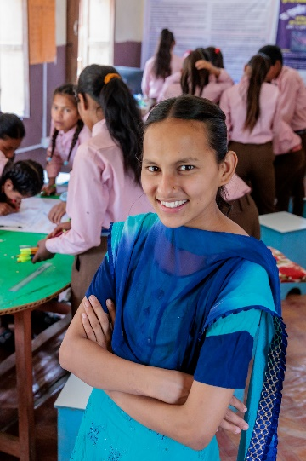
16-year-old Laxmi lives in one of the most remote communities in Nepal which experiences high levels of poverty.

Laxmi’s chance at a better life was through education, supported by her parents. Sadly, when she was 10 years old, her father passed away and Laxmi stopped going to school.

Before her father’s passing, Laxmi joined a child's club at her school that was run with the support of Caritas Nepal, through the Nepal Livelihoods and Resilience Program. Child's clubs support students to develop their speaking, writing and leadership skills through extracurricular activities.

Thanks to the support of her child's club, Laxmi was encouraged to resume her education. She became an active member of her child's club, where she developed the skills and confidence to become a leader, advocating for clean water taps at her school. “If I don't get to study, then I'll experience hardship. I'll have to struggle like mother. If I don't get to study, then I'll have no knowledge,” Laxmi said.

Laxmi is now excelling in her studies and working towards her dream of becoming a civil engineer. She has become a mentor to other girls in her village, encouraging them to stand up for their rights and creating lasting change For All Future Generations.

