St. Theresa’s Parish Community Newsletter

Parish Priest: Fr Barry Hughes
Presbytery: 17 Drummartin St., Albion 3020
Phone: 9311 3091
email: caalbion@netspace.net.au
Mobile: 0428 533 391
Polish Chaplain: Fr Marian Szeptak
Residence: 185 William St., St Albans 3021
Phone: 9310 9057

St. Theresa’s Primary School - 93119070
16 Drummartin St., Albion 3020
Principal: Rob Macklin

Mother of God Primary School - 93631734
Blanche St., Ardeer 3022
Principal: Assunta Iacovino

“Do Small Things Well”
___________________________________________

THE FEAST OF THE EPIPHANY 6 & 7 January 2024

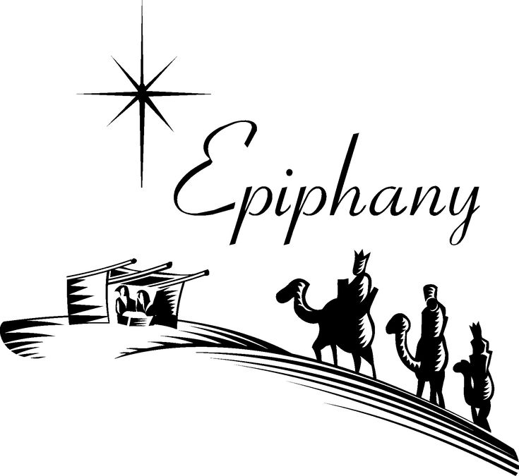

MASSES THIS WEEK  ST THERESA’S  Drummartin St, Albion  9.00am Friday  10.30am Sunday  MOTHER OF GOD  Blanche St, Ardeer  10.00am Wednesday(Pol)  9.00am Thursday  6.00pm Friday (Polish)  5.30pm Saturday  10.15am Sunday (Polish)  QUEEN OF HEAVEN  Holt St, Ardeer  8.00am Wednesday  9.00am Sunday  RECONCILIATION (Individual Confession)  Saturday 13th January, 10.00am at Queen of Heaven or other times and places on request |  | CUPPA AFTER MASS  Join us today after each Mass for a cuppa and a chat.  CHRIST’S CATHOLIC COMMUNITY  Prayer Group meets every Thursday, 7.00 - 8.30pm, at Queen of Heaven Church. All are welcome.  COLLECTIONS RECEIVED  Thanksgiving $727 Loose Money $376  Presbytery $542 Christmas Offering and collection $775  COUNTERS 14th January  Team 5: J Camilleri, M Buhagiar, J Zammit  FEAST DAYS  Baptism of the Lord, 08 January  READINGS Today Next Week  Isaiah 60.1-6 1 Samuel 3.3b-10,19  Ps 72.1-2,7-8,10-11,12-13 Ps 40.1+3a,6,7-8,9(R.7-8)  Ephesians 3.2-3a,5-6 1 Corinthians 6.13c-15a.17-20  Matthew 2.1-12 John 1.35-42

ESTIA HEALTH Do you need some respite Aged Care?
Estia Health Ardeer has an option for respite, please call Gabrielle to set up a time to have a look at our lovely home, Ph: 0419 336 841. 30 North St, Ardeer 9360 4552.

St Theresa’s Parish is committed to the safety of children, young people and vulnerable adults

REFLECTION ON TODAY’S READINGS

SCRIPTURE COMMENTARY by Brendan Byrne SJ

The very ancient Feast of the Epiphany celebrates the fact that Israel’s Messiah is also the Saviour of the entire world. We believers of later generations take this more or less for granted. But it is clear that for the earliest Christians of non-Jewish (‘Gentile’) origin it was a source of immense wonder and gratitude. The passage from the Letter to the Ephesians read as today’s Second Reading (Eph 3:2-3, 5-6) speaks of it as a great ‘mystery’, one which Paul himself came to know by revelation (his experience on the Damascus Road; cf. Gal 1:16), before becoming, as Apostle to the Gentiles, the principal instrument of its realisation.

Faced with this ‘mystery’ of the extraordinary richness and scope of God’s salvation, the early Christians went back to the Scriptures of Israel to find traces of its foretelling. The Book of Isaiah, more especially the oracles of the post-exilic prophet(s) we hear in chapters 40-66, proved a rich mine for this purpose. They feature the kind of inclusive vision that emerges so magnificently from the text set for today’s First Reading (Isa 60:1-6). It has clearly influenced Matthew’s account of the coming of the Wise Men, which forms the Gospel.

The reading from Isaiah addresses the holy city, Jerusalem. The image seems to be that of the break of dawn. All around, in the valleys, is darkness (‘night still covers the earth and darkness the peoples’). But the highly elevated city of Jerusalem is beginning to catch the rays of the rising sun, a magnificent light identified with the ‘glory of the Lord’. At this, the nations begin streaming to Jerusalem, bringing their riches to place before the God of Israel.

The wonderful Gospel story of the coming of the Wise Men from the East (Matt 2:1-12) catches up and expands upon this vision. It is interesting that Matthew’s gospel, which of the four gospels is most at pains to portray Jesus in Jewish light, lets this episode where Gentiles bring gifts dominate its story of Jesus’ childhood. The Gospel will conclude on the same note with the great Commission, ‘Go,
therefore, and make disciples of all nations, ...’ (28:16-20).

There are so many ways to draw rich reflections from this episode. I think it is important to bring out the blend between pagan wisdom and (Jewish) scribal information that leads the wise men to the Saviour. Their own natural gifts, the wisdom of their people and their scientific investigations (astronomy), have impelled their quest. They have seen the ‘Star’ that the biblical prophecy in Numbers 24:17 indicated would be a sign of a King of the Jews who would have universal significance. They have followed this star, but they need the scribal wisdom of Israel to locate the One whose birth it announces (in Bethlehem). Revelation comes, then, from a combination of natural wisdom and biblical prophecy.

Not only do they pay homage to the infant Jesus as their ruler: they place before him the rich gifts of their culture and these are graciously received. Joseph has faded from view; it is Mary, the mother of Jesus, who receives their gifts on his behalf.

Their journey has been one of faith and risk. The treacherous and murderous figure of Herod looms over all, presaging the Passion that is to come. But the riches of God’s salvation will go to the Gentiles.
In the beautiful words to the Wise Men that the English novelist Evelyn Waugh puts on the lips of the Empress Helena:
‘... you came and were not turned away. You too found room before the manger. Your gifts were not needed, but they were accepted and put carefully by, for they were brought with love. In that new order of charity that had just come to life, there was room for you, too.’ (Helena [Penguin, 1963] 145.)

We too walk in the footsteps of the wise men, sharing their longing, their faith, and the joy of their discovery, and bringing our own gifts to the Lord.

