.fE
St. Theresa’s Parish Community Newsletter

Parish Priest: Fr Barry Hughes
Presbytery: 17 Drummartin St., Albion 3020
Phone: 9311 3091
email: caalbion@netspace.net.au
http://pol.org.au/albion/Home.aspx
Mobile: 0428 533 391
Polish Chaplain: Fr Marian Szeptak
Residence: 185 William St., St Albans 3021
Phosne: 9310 9057

P
9310 905
St. Theresa’s Primary School - 93119070
16 Drummartin St., Albion 3020
Principal: Rob Macklin

Mother of God Primary School - 93631734
Blanche St., Ardeer 3022
Principal: Assunta Iacovino

“Do Small Things Well”

THIRD Sunday of Lent Year A 11 & 12 March 2023

CARITAS AUSTRALIA PROJECT COMPASSION
Zimbabwe is experiencing an intense drought, exacerbated by climate change. With the support of Caritas Hwange, Priscilla learnt conservation farming skills to grow drought-resistant crops and started poultry farming to support her family during the current food crisis. Please donate to Project Compassion 2023

MASSES THIS WEEK  ST THERESA’S  Drummartin St, Albion  9.00am Friday  10.30am Sunday  MOTHER OF GOD  Blanche St, Ardeer  10.00am Wednesday (Pol)  9.00am Thursday  6.00pm Friday (Polish)  5.30pm Saturday  10.15am Sunday (Polish)  QUEEN OF HEAVEN  Holt St, Ardeer  8.00am Wednesday  9.00am Sunday  RECONCILIATION (Individual Confession)  Saturday 18th March, 10.00am at St Theresa’s |  | FUNERAL MASS for John Azzopardi at St Theresa’s, Tuesday 1.00pm  COMMUNITY LENTEN PRAYER  Each Friday after 9.00am Mass at St Theresa’s, we will gather at the Presbytery  ROSTER  The new Reader/Commentator Roster is out now, you should receive a copy by email or a copy will be at the back of the church for you to collect.  COLLECTIONS RECEIVED  Thanksgiving $681 Loose Money $255 Presbytery $673  COUNTERS 19th March  Team 4: J Camilleri, M Buhagiar, J Zammit  FEAST DAYS  St Patrick,17 March  READINGS Today Next Week  Exodus 17.3-7 1 Samuel 16.1b,6-7,10-13  Ps 95.1-2,6-7ab,7c-9 (R.7c+8a) Ps 23.1-3a,3b-4,5,6 (R.1)  Romans 5.1-2,5-8 Ephesians 5.8-14  John 4.5-42 John 9.1-41

PARISH FINANCE COMMITTEE
Volunteers required joining our Finance Committee expression of interest please speak to Fr Barry or contact Parish office on 9311 3091

THANKSGIVING ENVELOPES New Envelopes out now please pick up your set at the back of the church

FIRST PARISH SOCIAL DINNER FOR 2023 Tuesday 14th March Time: 6.00pm at Deer Park Club 780 Ballarat Rd, Deer Park…RSVP Ann-Maree by Monday 13th March on 0401 192079

MOTHER OF GOD SCHOOL - KABOOM KIDS SPORTS 4.00pm to 6.00pm, Wednesday 15th March
Please join us for our first community event this year. Kaboom sports for children 4.00 – 5.15pm, followed by staff/parent races and Sausage Sizzle 5.15 – 6.00pm
REFLECTIONS – THIRD SUNDAY OF LENT
Written by Michael McGirr

Every summer seems to get a little longer and a little hotter. We have all become conscious of issues surrounding water. Either there seems to be too much, as during last year’s summer floods or when the sea levels rise in the Pacific. Other times, there seems to be too little water as when the rivers in our country run low or members of God’s family around the world experience drought.

Caritas Australia, through Project Compassion, has been responding to the dire needs of places such as Ethiopia and Somalia where a cruel drought, compounded by a shortage of grain from Ukraine, has led to dire consequences. Today’s readings may well cause us to reflect on the current state of God’s creation.

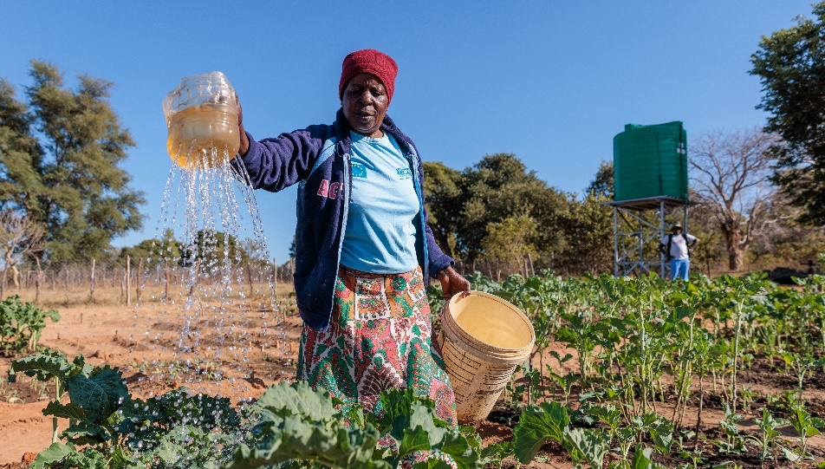
In the book of Exodus, we hear that people are complaining to Moses because they are dying of thirst. In the Gospel, Jesus meets a woman in a Samaritan town. She has come to draw water from the well in the hottest part of the day. In both cases, access to water is precarious. Yet God responds not only to a thirst for water but to a deeper thirst as well. Moses’ people are thirsty for direction, leadership and hope. The woman in John’s Gospel has a thirst for love and acceptance which, Jesus tells her, will come from within if she is able to accept him and his message of life. As the story unfolds, we learn of her loneliness and see her reconnecting with her community.

This week, Caritas Australia shares with us an account of its response to a water shortage in Zimbabwe. Thanks to our support for Project Compassion, Caritas is involved in providing access to water in many places. It seems such a basic thing. One we mostly take for granted. But once a community has access to water, it grows in every possible way. People have more time for healthcare and education. People find energy to build their future. This week’s scripture readings have a strong sense of a hope-filled future. May we too, in our time, be sources of hope for all future generations.

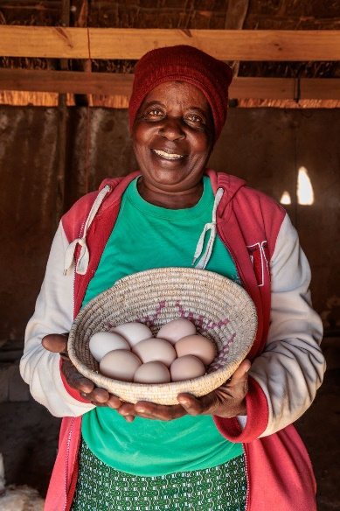
PRISCILLA’S STORY – ZIMBABWE

Priscilla lives in the Hwange district in Zimbabwe with her husband, Charles, and their two grandsons. Climate change continues to bring unprecedented challenges for people living in the most vulnerable and remote communities in Zimbabwe.
With the support of Caritas Hwange, Priscilla learnt conservation farming skills to grow drought-resistant crops to support her family during the current food crisis. Priscilla was able to produce a bumper harvest in her first year of practising conservation farming. Priscilla used the funds from her harvest to start poultry farming, which enabled her to sell eggs to pay for her grandchildren’s school fees, books and stationery. The poultry farming provides a safety net for Priscilla and her family during times of hardship, like the current drought.

While the situation in Zimbabwe and across eastern Africa remains dire, the work of Caritas Hwange means that Priscilla can learn the skills she needs to build resilience and support her family during this current food crisis.

St Theresa’s Parish is committed to the safety of children, young people and vulnerable adults

