.fE
St. Theresa’s Parish Community Newsletter

Parish Priest: Fr Barry Hughes
Presbytery: 17 Drummartin St., Albion 3020
Phone: 9311 3091
email: caalbion@netspace.net.au
http://pol.org.au/albion/Home.aspx
Mobile: 0428 533 391
Polish Chaplain: Fr Marian Szeptak
Residence: 185 William St., St Albans 3021
Phosne: 9310 9057

P
9310 905
St. Theresa’s Primary School - 93119070
16 Drummartin St., Albion 3020
Principal: Rob Macklin

Mother of God Primary School - 93631734
Blanche St., Ardeer 3022
Principal: Assunta Iacovino

“Do Small Things Well”

FOURTH Sunday of Lent Year A 18 & 19 March 2023

CARITAS AUSTRALIA PROJECT COMPASSION
Thu lost his leg after stepping on a land mine in Vietnam. With the support of the Centre for Sustainable Rural Development, Thu can now earn extra income and care for his wife as she recovers from a stroke. Please donate to Project Compassion 2023

MASSES THIS WEEK  ST THERESA’S  Drummartin St, Albion  9.00am Friday  10.30am Sunday  MOTHER OF GOD  Blanche St, Ardeer  10.00am Wednesday (Pol)  9.00am Thursday  6.00pm Friday (Polish)  5.30pm Saturday  10.15am Sunday (Polish)  QUEEN OF HEAVEN  Holt St, Ardeer  8.00am Wednesday  9.00am Sunday  RECONCILIATION (Individual Confession)  Saturday 25th March, 10.00am at Mother of God |  | PARISH FINANCE COMMITTEE  Volunteers required joining our Finance Committee expression of interest please speak to Fr Barry or contact Parish office on 9311 3091  COMMUNITY LENTEN PRAYER  This Friday after 9.00am Mass at St Theresa’s, we will gather at the Presbytery  COLLECTIONS RECEIVED  Thanksgiving $723 Loose Money $259 Presbytery $598  COUNTERS 26th March  Team 1: D Catania, E Catania, C Xuereb  FEAST DAYS  St Joseph, spouse of the Blessed Virgin Mary, 20 March  The Annunciation of the Lord, 25 March  READINGS Today Next Week  1 Samuel 16.1b,6-7,10-13 Ezekiel 37.12-14  Ps 23.1-3a,3b-4,5,6 (R.1) Ps 130.1-2,3-4,5-6,7b-8 (R.7b)  Ephesians 5.8-14 Romans 8.8-11  John 9.1-41 John11.1-45

PARISH MOVIE MORNING Mon 27th March 10am, Sunshine Village Cinema, Tickets $9. No RSVP

MARRIAGE ENCOUNTER Weekend 28 – 30 April 2023 in Melbourne
“Live Your Best Life in Love”
Every relationship is a journey and the grind of everyday life can cause you to lose touch with your spouse. This weekend gives married couples the tools to keep passion alive in a gentle, nurturing environment, away from pressures and distractions of daily living .The weekend is based around Catholic values and couples of all faiths are welcome .Please check our website for more details.
Information/Bookings: Phone Mercy & James 0409 183 676

St Theresa’s Parish is committed to the safety of children, young people and vulnerable adults

REFLECTIONS –FOURTH SUNDAY OF LENT
Written by Michael McGirr

There are many occasions when we ask the question why and can’t find the answer for which we are looking. Why did we miss out on a job? Why did someone we love get cancer? Why can’t we find a place to live that we can afford? Why do some days seem so difficult?

It is good to sit with our confusion and even grief. It is good to share it with the Lord who loves us so tenderly. But sometimes we have to step aside from the question why did this happen? It may be better to start with where can I go from here? What small steps will enable me to face the future in a positive spirit?

Today’s readings touch upon these issues. In the Gospel, Jesus encounters a person who was born blind. The bystanders want to know why this happened. They think it must be because either he or his parents did something wrong. They are looking backwards. Jesus prefers to look forward. He says "he was born blind so that the works of God may be displayed in him." In other words, his blindness presents opportunities for growth, not a pretext for blame. The letter to the Ephesians similarly reminds us that we are on a journey from darkness to light. The whole of Lent could be described in those words. The letter says ‘try to discover what the Lord wants of you.’ It asks us in terms of possibilities! The same thing happens when Samuel anoints David. It doesn’t matter that David is a young shepherd. He has a big future, as anyone familiar with the Bible well knows.

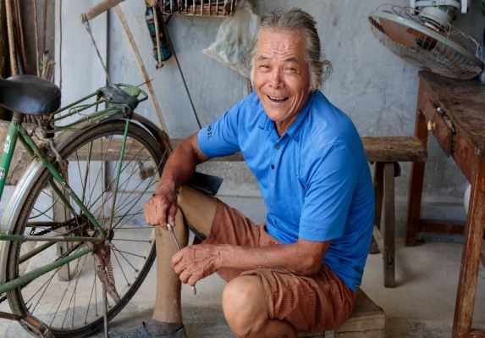
This week Project Compassion shares with us the story of Thu, who lives in Vietnam. At the age of 12, Thu’s life was thrown into chaos when he trod on a land mine that had been left behind after the Vietnam War. Surely, he must have asked why he was among the unlucky ones. He might have asked the same thing again when his wife suffered a stroke. But Thu joined the Empowerment of People with Disabilities program, supported by Caritas Australia through our local partners, the Centre for Sustainable Rural Development. As with so many others, your generosity enabled Thu and his family to build a brighter future. Thank you for helping in this wonderful work of transformation.

THU’S STORY – VIETNAM
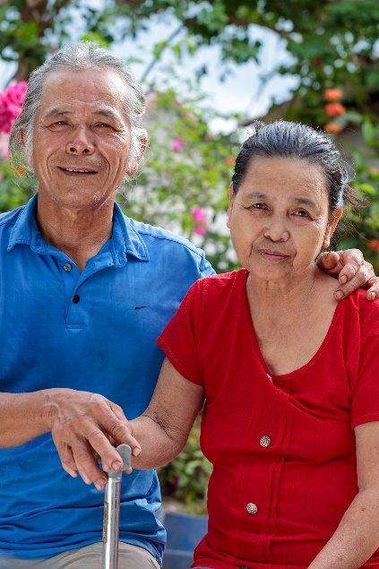
When Thu was 12 years old, he lost his leg after stepping on an unexploded land mine – from the Vietnam War. Living with a disability in rural Vietnam presented many challenges for Thu, who worked mainly as a rice farmer. After his wife, Linh, suffered a stroke, he had to take on the additional role of carer for his wife.
“She is my wife and we have been living together and depending on each other, I am the one to be there with her and for her,” Thu said.
Thu joined the Empowerment of People with Disabilities program, supported by Caritas Australia through our local partners, the Centre for Sustainable Rural Development (SRD).
Through the program, Thu learnt livelihood, financial and independent living skills and joined a Village Savings and Loans Association (VSLA) where he could interact with other people with disabilities and earn income through making incense sticks.
The VSLA helped Thu to obtain a loan so that he could set up a barber shop and earn extra income to support his family. The project also helped Thu to build an accessible toilet for Linh, who has become more independent thanks to the support of a physiotherapist.

