St. Theresa’s Parish Community Newsletter

Parish Priest: Fr Barry Hughes
Presbytery: 17 Drummartin St., Albion 3020
Phone: 9311 3091
email: caalbion@netspace.net.au
Mobile: 0428 533 391
Polish Chaplain: Fr Marian Szeptak
Residence: 185 William St, St Albans 3021
Phone: 9310 9057

St. Theresa’s Primary School – 9311 9070
16 Drummartin St., Albion 3020
Principal: Rob Macklin

Mother of God Primary School – 9363 1734
Blanche St., Ardeer 3022
Principal: Assunta Iacovino

“Do Small Things Well”

Fifth Sunday of Lent Year A 25 & 26 March 2023

Walk for Justice for Refugees on Palm Sunday, April 2nd. Join CAPSA at 1:00pm for a group reflection and prayer led by Fr Andy Hamilton SJ, with official Walk for Justice music and speeches starting around 1:30pm. Where? We will be meeting at the far right side of the State Library of Victoria (near the Joan of Arc statue and next to Little Lonsdale St – you’ll see a large ‘CAPSA’, ‘Jesuit Social Services’ or ‘Xavier Social Justice Network’ banner).
PROJECT COMPASSION Project Compassion brings together Australian schools, parishes and supporters to raise funds for people in vulnerable communities across the world. This year, we introduced you to the story of four inspiring people whose lives have been transformed with your generous support: Laxmi, Tereesa, Priscilla and Thu. Today, they are creating a better world for their families, their communities and for all future generations.

MASSES THIS WEEK  ST THERESA’S  Drummartin St, Albion  9.00am Friday  10.30am Sunday  MOTHER OF GOD  Blanche St, Ardeer  10.00am Wednesday (Pol)  NO 9.00am Thursday  6.00pm Friday (Polish)  5.30pm Saturday  10.15am Sunday (Polish)  QUEEN OF HEAVEN  Holt St, Ardeer  8.00am Wednesday  9.00am Sunday  PALM SUNDAY  Blessing of Palms. Gather outside for blessing of Palms and Procession before each Mass next Weekend |  | CUPPA AFTER MASS  Join us next weekend after each Mass for a cuppa and a chat.  Why not take this opportunity to enjoy the company of your fellow parishioners, and get to know one another better? Please bring a plate to share.  PARISH FINANCE COMMITTEE  Volunteers required joining our Finance Committee expression of interest please speak to Fr Barry or contact Parish office on 9311 3091  COMMUNITY LENTEN PRAYER  This Friday after 9.00am Masst St Theresa’s, we will gather at the Presbytery  COLLECTIONS RECEIVED  Thanksgiving $864 Loose Money $329 Presbytery $592  COUNTERS 2nd April Team 2: M Azzopardi, M Camenzuli  READINGS Today Next Week  Ezekiel 37.12-14 Isaiah 50.4-7  Ps 130.1-2,3-4,5-6,7b-8 (R.7b) Ps 22.7-8,16-17,18-19,22-23(R.1)  Romans 8.8-11 Philippians 2.6-11  John11.1-45 Matthew 26.14-27.66

PARISH MOVIE MORNING…Change of Date…. Monday 3rd April 10am, Sunshine Village Cinema, Tickets $9. RSVP Ann-Maree Ph: 0401 192 079

St Theresa’s Parish is committed to the safety of children, young people and vulnerable adults

REFLECTIONS –FIFTH SUNDAY OF LENT
Written by Michael McGirr
It must be difficult for somebody who has never experienced love to understand the Gospels. They are so full of different emotions, many of them tender. Just think of the beautiful reconciliation between Jesus and Peter after the resurrection. Jesus allows Peter to say that he loves him on no less than three occasions.
Thankfully, most of us can write down a long list of people we have loved and also of those who have loved us. Many names would appear on both lists! We keep a special place in our hearts and prayers for the people we know who have died. Even after a long time, their memory will still bring a tear to our eyes. That sorrow comes from a place of deep gratitude. God changes the world one heart at a time.
When we encounter today’s Gospel, the story of the raising of Lazarus, we are in a world of emotion. Martha and Mary are grieving for their brother. Jesus loves these two women. Thomas, the twin, is full of bravado and bluster, just as he was later when he wanted proof of the resurrection. Both Martha and Mary are disappointed, even angry, that Jesus has not come sooner. Jesus weeps at the grave of his friend. The mourners who have come to comfort the family must also have been sensitive to the situation. When Jesus says ‘I am the resurrection and the life’ he is not explaining an idea. He is responding to the deepest longings of our hearts, as he always does.
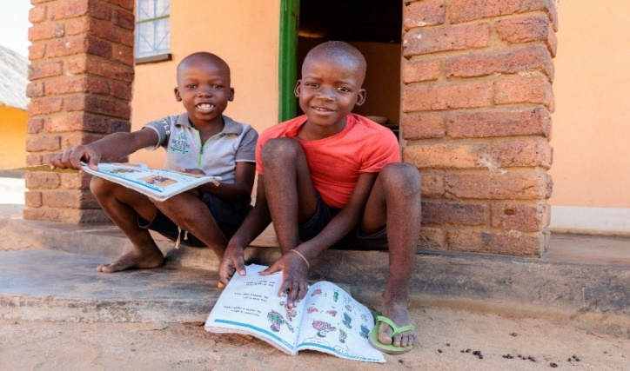
Today’s Psalm reminds us ‘My soul is longing for the Lord more than the watcher for daybreak.’ Over the last few weeks we have shared some of the stories presented to us by Caritas Australia to make us more aware of the inspirational work we can support through Project Compassion. There have been stories from Zimbabwe, Vietnam, Nepal and First Australians. Through your generosity, Caritas Australia is able to support partners in 18 different countries. These are all people who, not unlike Lazarus, are longing to be unbound and set free. The Gospel calls us to believe in the Life to which Jesus invites us; that Life is built on justice and compassion.

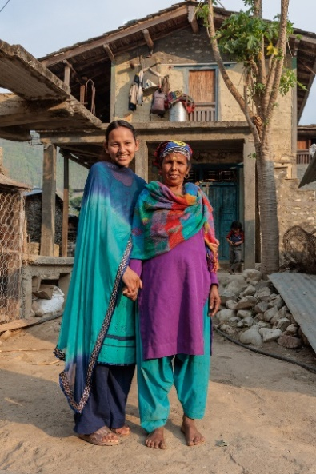
Project Compassion brings together Australian schools, parishes and supporters to raise funds for people in vulnerable communities across the world. This year, we introduced you to the story of four inspiring people whose lives have been transformed with your generous support: Laxmi, Tereesa, Priscilla and Thu.
Today, they are creating a better world for their families, their communities and for all future generations.
Project Compassion is a demonstration of the faith, empathy and generosity of our supporters. It is the lifeblood of Caritas Australia – without it, we could not do the vital work we do. Thank you for helping transform lives today and for all future generations.

