*St. Theresa’s Parish Community Newsletter*



Administrator: Fr Dixon George IVDei

Presbytery: 17 Drummartin St., Albion 3020

Phone: 9311 3091

email: [albion@cam.org.au](mailto:albion@cam.org.au)

Website: https://pol.org.au/albion/Home.aspx

Polish Chaplain: Fr Marian Szeptak

Residence: 185 William St., St Albans 3021

Phone: 9310 9057

St. Theresa’s Primary School - 93119070

16 Drummartin St., Albion 3020

Principal: Rob Macklin

Mother of God Primary School - 93631734

Blanche St., Ardeer 3022

Principal: Assunta Iacovino

*“Do Small Things Well”*

_________________________________________

FEAST OF THE ASCENSION OF THE LORD Year B 11 & 12 May 2024

CARITAS AUSTRALIA’S 60TH ANNIVERSARY ONLINE PHOTO EXHIBITION!

To mark the 60th anniversary of Caritas Australia, we have compiled a selection of our favourite 60 photos. Vote for your favourite photo to go into the draw to win a beautiful Indigenous Australian artwork from Djilpin Arts.. The artwork is a painting by Harry Malibirr which depicts five dreaming stories. Visit our website [caritas.org.au/faces-of-caritas-australia-60th-anniversary](https://www.caritas.org.au/faces-of-caritas-australia-60th-anniversary/?utm_source=ParishBulletin&utm_medium=Referral&utm_term=&utm_content=60ANNIV&utm_campaign=RET_2024_60ANNIV_DIGI_LEADS), choose a photo from the gallery and vote via the online form. Entries close 30 June 2024

|  |  |  |
| --- | --- | --- |
| MASSES THIS WEEK  ST THERESA’S  Drummartin St, Albion  *8.30am Friday Reconciliation*  9am Friday  10.30am Sunday  MOTHER OF GOD  Blanche St, Ardeer  10am Wednesday (Pol)  9am Thursday  6pm Friday (Polish)  *5pm Saturday Reconciliation*  5.30pm Saturday  10.15am Sunday (Polish)  QUEEN OF HEAVEN  Holt St, Ardeer  8am Wednesday  *8.30am Sunday Reconciliation*  9.00am Sunday  RECONCILIATION  *(Individual Confession) other times by Appointment*  HOLY ROSARY  Before Wednesday & Friday Masses |  | COMMUNION FOR THE SICK Will be offered Wednesday at QOH area, Thursday at MOG area, Friday at ST T area during the last week of each month. Please call the Parish Office to book an appointment.  BAPTISM DURING MASS At Queen of Heaven next Sunday for Matilda Lambert  ROSTER  A monthly roster for Mother of God Church cleaning will be out this week  COLLECTIONS RECEIVED  Thanksgiving $683 Loose Money $292 Presbytery $558  COUNTERS 19th May  Team 3: M Azzopardi, M Camenzuli  FEAST DAYS  St Matthew, Apostle, 14 May  READINGS Today Next Week  Acts 1.1-11 Acts 2.1-11  Ps 47.1-2,5-6,7-8(R.5a) Ps 104.1ab+24ac,29b-30,31+34 (R30)  Ephesians 4.1-13 Galatians 5.16-25  Mark 16.15-20 John 15.26-27; 16.12-15 |

THANK YOU FROM CATHOLICCARE VICTORIA

Because of the generosity of our parish community ($654), the mission can continue; to create transformational personal impact, and empower every individual to live life to the full. Thank you for helping those in need!

AUSTRALIAN CATHOLIC MAGAZINE The winter addition is out now FREE and has many articles on Science and Faith.

*St Theresa’s Parish is committed to the safety of children, young people and vulnerable adults*

REFLECTION On the Gospel by Nick Brodie

Pope Francis encourages us to contemplate two aspects of the Ascension. ‘On the one hand it directs our gaze towards heaven,’ he says. ‘On the other, it reminds us of the mission of the Church.’

The Pope points out that these two aspects are interconnected. In this feast we do not remember Jesus’ bodily departure so much as celebrate his continuing presence in the world through the Christian community.

The Pope suggests that ‘the Ascension exhorts us to lift our gaze toward heaven, in order to return it immediately to the earth, to implement the tasks that the Risen Lord entrusts to us.’ As today’s Gospel declares, Jesus is in heaven. Yet, by ‘working with’ his disciples, he is also still present in the world.

In a particular way in his encyclical *Laudato Si’* Pope Francis draws out the importance for Christians of proclaiming ‘the Good News to all creation’. Picking up scriptural teaching, he highlights how ‘all creation is bound up with the mystery of Christ’ and reminds us that the Eucharist should motivate us ‘to be stewards of all creation.’

People of the Ascension, therefore, do not just tell other people about Jesus. Rather, People of the Ascension, as the Pope puts it, ‘seek Christ along the paths of our time’. We are called to serve the poor and the needy and the world in which they live. We are called to become ‘visible signs of hope’ for the whole of creation.

THANK YOU MUM:

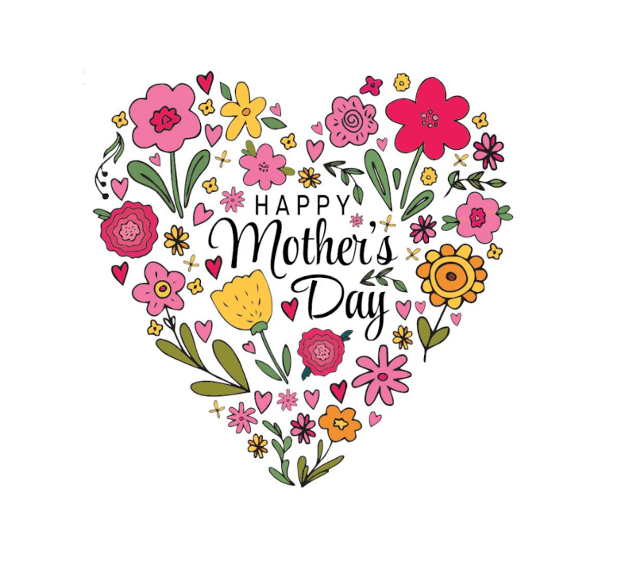Thank you, dear Lord, for our mothers: who were brave enough to give us birth, who loved us through many growing-up years, who taught us about God and love and being good, who often got no thanks, whose ears could hear the slightest cry, whose eyes didn’t miss much either, whose hands held and bathed and picked us up, whose hearts were often broken, who always forgave and forgot, who encouraged us when things went badly, who always had time to listen to us, who worked so hard to make things go well, who made the world so much better — who deserve our love on Mother’s Day and every day even for eternity. Amen. Happy Mother’s Day!