.fE
St. Theresa’s Parish Community Newsletter

Parish Priest: Fr Barry Hughes
Presbytery: 17 Drummartin St., Albion 3020
Phone: 9311 3091
email: caalbion@netspace.net.au
Mobile: 0428 533 391
Polish Chaplain: Fr Marian Szeptak
Residence: 185 William St., St Albans 3021
Phone: 9310 9057

P
9310 905
St. Theresa’s Primary School - 93119070
16 Drummartin St., Albion 3020
Principal: Rob Macklin

Mother of God Primary School - 93631734
Blanche St., Ardeer 3022
Principal: Assunta Iacovino

“Do Small Things Well”

29th SUNDAY OF ORDINARY TIME YEAR C 15 & 16 October 2022

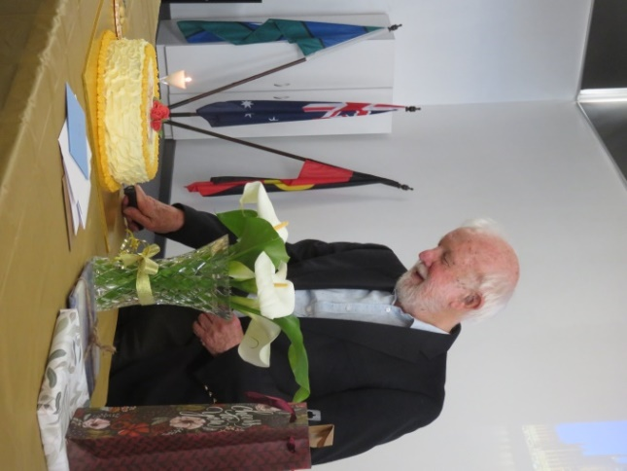
An ENORMOUS THANK-YOU on behalf of Fr Barry's Jubilee Event Committee to everyone throughout the Parish Community from Parishioners, Leadership Team & Schools. We all had a part to play which made it a memorable day especially for Fr. Barry and all.
And from me a big thank you to the Event Committee and all who helped them, and a big thank you to all for congratulatory greetings, generous gifts, and participation in the celebrations. Father Barry
We encourage everyone to view our website for more photos of the day.

MASSES THIS WEEK  ST THERESA’S  Drummartin St, Albion  9.00am Friday  10.30am Sunday  MOTHER OF GOD  Blanche St, Ardeer  10.00am Wednesday (Pol)  9.00am Thursday  6.00pm Friday (Polish)  5.30pm Saturday  10.15am Sunday (Polish)  QUEEN OF HEAVEN  Holt St, Ardeer  NO MASS Wednesday  9.00am Sunday |  | RECONCILIATION (Individual Confession)  Saturday 22nd October, 10.00am at Mother of God.  SPECIAL COLLECTION World Mission Sunday  Next week 23 October  COLLECTIONS RECEIVED  Thanksgiving $633 Presbytery $547  COUNTERS 23 October  Team 3: D Kabira  FEAST DAYS THIS WEEK  St Ignatius of Antioch, 17 October  St Luke, Evangelist, 18 October  READINGS  Today Next Week  Exodus 17.8-13 Sirach 35.15-17,20-22  Ps 121.1-2,3-4,5-6,7-8 (R2) Ps 34.1-2,16-17,18+22 (R.6)  2 Timothy 3.14 – 4.2 2 Timothy 4.6-8, 16-18  Luke 18.1-8 Luke 18.9-14

FINAL 'PARISH DINNER' FOR THE YEAR Christmas Theme
Thursday night 24th November, 6PM @ Westend Bistro, McIntyre Road.
3 Course Set Menu plus 1 drink $25 per person. RSVP & enquiries to Ann-Maree by 1st November
PH: 0401 192 079. (Flyer will be put up on each noticeboard this weekend).

29th Sunday in Ordinary Time 16th October 2022

Whilst wanting to consider this week’s reading, I could not do so without first acknowledging the wonderful celebration we had last weekend. It was to congratulate and give praise to our own Fr, Barry on achieving such an amazing milestone of 52 years of service as a diocesan priest.
There was a real sense of love and friendship permeated by all that were present. It was wonderful to see so many of Fr.Barry’s family and friends. Many were from years gone by and many from his present, but all had come with the one goal, and that was to celebrate with Fr. Barry.
To all the personnel involved behind the scenes, top job!!! You helped to make this day so very special for him.

The squeaky wheel gets the grease is an American proverb or metaphor used to convey the idea that the most noticeable (or loudest) problems are the ones that get attended to. (Just like the widow in the parable)

When we truly believe in something or want something so badly, we are willing to go outside of our comfort zone. The widow was painfully persistent, because she believed in her cause. God knows all our wants and needs and if we truly believe, we will turn to Our Father over and over in prayer.
Who knows when our prayers will be answered?
Who knows if it will be what we expected?
But we do know that we can hold steadfast.
That God is always there for us.
That God is always listening to our prayers.
That God will respond in his own time.

Never ever underestimate the power of prayer.
There will be times in your life when life deals you up challenges beyond your control. Then all you can do is pray, pray and pray some more, and then some more. Eventually you will come to realize that God has got this. It may not always be the outcome you were expecting, but other good things come out of challenging situations.

On a totally different note, don’t you just love the characters Jesus chose for his parables.
A lowly widow, who was far more persistent than the average person, and a judge, who doesn’t fear God or even respect people! What an interesting combination!

The above comments were from my personal perspective, so now let us read from two of my favourite scriptural analysers.

Dianne Bergant Commentary
… Jesus tells a parable about the need for persistence in prayer. The judge is unjust because he failed to ensure justice for all. The woman is a widow, a member of one of the most oppressed classes in Israelite society. Though vulnerable, she is bold. As indifferent as the judge seems to be toward her case, so is she persistent in her demands of him. He will not give in; she will not give up. The persistence of the woman becomes the model of resoluteness for God’s chosen ones. Like the woman in the parable, they cannot be certain regarding when God will respond, and so they must persist. The passage ends with Jesus posing a sobering question: ‘When the Son of Man comes, will he find faith on the earth?’…

Greg Sunter Reflection
… Does this teaching about the need for continual prayer mean that God needs to be convinced of our cause? Does a one-off prayer not get heard? Is God swayed by the force of numbers? Can the prayers of ten people carry more weight than the prayers of one? All these questions miss the point of the parable. It is not God who needs our prayers, but we who have to recognise, through prayer, our need for God’s mercy and gracious love. The constancy of prayer is not to convince God but to remind ourselves of our dependence upon God…

By Doriana Cooper - Religious Education Leader at St Theresa School

St Theresa’s Parish is committed to the safety of children, young people and vulnerable adults

