.fE
St. Theresa’s Parish Community Newsletter

Parish Priest: Fr Barry Hughes
Presbytery: 17 Drummartin St., Albion 3020
Phone: 9311 3091
email: caalbion@netspace.net.au
Mobile: 0428 533 391
Polish Chaplain: Fr Marian Szeptak
Residence: 185 William St., St Albans 3021
Phone: 9310 9057

P
9310 905
St. Theresa’s Primary School - 93119070
16 Drummartin St., Albion 3020
Principal: Rob Macklin

Mother of God Primary School - 93631734
Blanche St., Ardeer 3022
Principal: Assunta Iacovino

“Do Small Things Well”

30th SUNDAY OF ORDINARY TIME YEAR C 22 & 23 October 2022
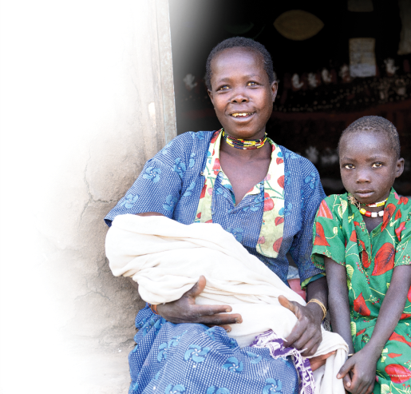
CATHOLIC MISSION SUNDAY APPEAL
This week Catholic Mission offers us the opportunity to be part of a life-changing program which aims to help prevent malnutrition, especially in babies and young children, and help disadvantaged families provide food for their loved ones. The Deberety Goat Rearing Centre is a dream of the local Church and community in Emdibir. When established, the Centre aims to provide nutritious goats milk for families in need, like Neela’s, so that babies like Ajani can be healthy and strong. Please give generously to help kickstart this life-giving program by using the appeal envelope, going online at catholicmission.org.au/ethiopia, or scanning the QR code, or by contributing to the special collection.

MASSES THIS WEEK  ST THERESA’S  Drummartin St, Albion  9.00am Friday  10.30am Sunday  MOTHER OF GOD  Blanche St, Ardeer  10.00am Wednesday (Pol)  9.00am Thursday  6.00pm Friday (Polish)  5.30pm Saturday  10.15am Sunday (Polish)  QUEEN OF HEAVEN  Holt St, Ardeer  8.00am Wednesday  9.00am Sunday |  | CHRIST’S CATHOLIC COMMUNITY  Prayer Group meets every Thursday, 7.00 - 8.30pm, at Queen of Heaven Church. All are welcome  COLLECTIONS RECEIVED  Thanksgiving $840 Loose Money $370 Presbytery $623  COUNTERS 30 October  Team 4: J Camilleri, M Buhagiar, J Zammit  FEAST DAYS THIS WEEK  Sts Simon & Jude, Apostles, 28 October  READINGS Today Next Week  Sirach 35.15-17,20-22 Wisdom 11.22 – 12.2  Ps 34.1-2,16-17,18+22 R.6 Ps 145.1-2,8-9,10-11,13cd-14 R.1b  2 Timothy 4.6-8, 16-18 2 Thessalonians 1.11 – 2.2  Luke 18.9-14 Luke 19.1-10

FINAL 'PARISH DINNER' FOR THE YEAR Christmas Theme
Thursday night 24th November, 6PM @ Westend Bistro, McIntyre Road.
3 Course Set Menu plus 1 drink $25 per person. RSVP & enquiries to Ann-Maree by 1st November
PH: 0401 192 079. (Flyer will be put up on each noticeboard this weekend).

NEW BUILDING
Building on the former convent site at 54-56 Blanche St., opposite Mother of God Church, is due to commence this week. The site has been leased by the Parish to St John of God Accord who will build two three bedroom homes for the care of adults with an intellectual disability.

Reflection on the Gospel
Parable of the Pharisee and the Tax Collector – Luke 18:9-14

This is a very famous parable. I think most people know this one off by heart, especially if you are a catholic school teacher. Jesus used parables as a way to teach and to help us reach a deep sense of the inner truth. They are open-ended stories that can be applied to our own lives. We have the opportunity to reflect, draw on how we feel and connect with the story to find its message. The message you find has the potential to make a difference in your life and the life of others.

So, what did I get from this parable?

At that time, the Pharisees were held in high esteem in the Jewish culture. Tax collectors, on the other hand, were collaborators with the Romans. They also cheated people to increase their earnings and were despised. In this story, Jesus makes out the Pharisee to be the “villain” and the tax collector to be the “hero”. This is a complete reversal of how these roles were perceived.

Why is this the case? Jesus is showing us that it is not social status which matters in the eyes of God but rather how our hearts are oriented.

Therefore, there are two things that stand out for me in this parable:

One is unconditional love and the other is not to judge other people. We are shown that comparing ourselves to others in a judgemental way is not favoured and we are trying to place ourselves on higher grounds – gaining superiority.

Unfortunately, I feel that this has been the case with religious groups in general from the beginning of time. We think by coming to worship God on a Sunday and being a good citizen is enough because we don’t commit crimes or break the law. It’s more than being seen at mass on a Sunday appearing to be reverent for the hour. It’s how you live your life in between going to worship God in your community. Every person born in this world is a child of God and has a place in heaven. Jesus didn’t come to save the Pharisees; he came to save all those who would reach out and be saved.

The focus in this parable is being selfless as well as being honest with wanting to redeem yourself when we know we have done wrong or hurt another in some way. Jesus is not holding the man up because he’s a tax collector. He’s holding him up because the man deeply and sincerely knows that he’s betrayed his people. He knows that what he’s doing is cheating. He’s not saying, “Well, everybody else is doing it.” He takes it so seriously that the only thing he can say is, “Have mercy on me. I’m a sinner.” The tax collector knows his need for forgiveness.

We are what God has made us; nothing more, nothing less. We are what God made us and he made us with great love and affection. Every human comes from God regardless of their talents or whether they are better off or worse off. God is on everybody’s side. This is a wonderful parable, it’s not what you do for a living, but how we do it … doing it with love.

Marie D’Orazio

Mother of God School

+
St Theresa’s Parish is committed to the safety of children, young people and vulnerable adults

