.fE
St. Theresa’s Parish Community Newsletter

Parish Priest: Fr Barry Hughes
Presbytery: 17 Drummartin St., Albion 3020
Phone: 9311 3091
email: caalbion@netspace.net.au
http://pol.org.au/albion/Home.aspx
Mobile: 0428 533 391
Polish Chaplain: Fr Marian Szeptak
Residence: 185 William St., St Albans 3021
Phone: 9310 9057

P
9310 905
St. Theresa’s Primary School - 93119070
16 Drummartin St., Albion 3020
Principal: Rob Macklin

Mother of God Primary School - 93631734
Blanche St., Ardeer 3022
Principal: Assunta Iacovino

“Do Small Things Well”

31st SUNDAY OF ORDINARY TIME YEAR C 29 & 30 October 2022

FINAL 'PARISH DINNER' FOR THE YEAR CHRISTMAS THEME
Thursday night 24th November, 6PM @ Westend Bistro, McIntyre Road.
3 Course Set Menu plus 1 drink $25 per person.
RSVP & enquiries to Ann-Maree by 1st November PH: 0401 192 079.

MASSES THIS WEEK  ST THERESA’S  Drummartin St, Albion  10.30am Tuesday All Saints Day  9.00am Friday  10.30am Sunday  MOTHER OF GOD  Blanche St, Ardeer  10.00am Tuesday (Polish)  All Saints Day  10.00am Wednesday (Pol)  9.00am Thursday  6.00pm Friday (Polish)  5.30pm Saturday  10.15am Sunday (Polish)  QUEEN OF HEAVEN  Holt St, Ardeer  9.00am Tuesday All Saints Day  9.00am Wednesday All Souls day  9.00am Sunday |  | CUPPA AFTER MASS 5 & 6 November  Join us next weekend after each Mass for a cuppa and a chat.  Why not take this opportunity to enjoy the company of your fellow parishioners, and get to know one another better? Please bring a plate to share.  COLLECTIONS RECEIVED  Thanksgiving $827 Loose Money $345.20 Presbytery $507  WORLD MISSION SUNDAY  We raised $435.30 last week. Thank you  COUNTERS 6 November  Team 1: D Catania, E Catania, C Xuereb  FEAST DAYS THIS WEEK  All Saints, 1 November  St Charles Borromeo, 4 November  READINGS Today Next Week  Wisdom 11.22 – 12.2 2 Maccabees 7.1-2,9-14++  Ps 145.1-2,8-9,10-11,13cd-14 R.1b Ps 17.1,5-6,8+15 (R.15b)  2 Thessalonians 1.11 – 2.2 2 Thessalonians 2.16-3.5  Luke 19.1-10 Luke 20.27-38

PARISH FOOD BANK
We are low in food at the moment. If you are able, any donations would be appreciated. Items to make a quick meal, such as crackers & soup, tinned vegetables, preserved fruits, long life milk & cereal, pasta and pasta sauces would be a great help. You can drop off at the office or at the Churches.

SEEKING LOCAL ACCOMADATION
A woman from our Parish is looking for a room/bungalow to rent, if you are able to help please contact the Parish Office on 9311 3091.

DONATIONS FOR BABY CLOTHES AND EQUIPMENT
If you have nursery equipment, clothes or toys that you no longer use, we can get it to someone who really needs it. Please donate to the Church or drop off at our Parish Office.

MASS ANOINTING OF THE SICK
A special mass will be held Thursday 17th November 12noon at Mother of God, followed by a lunch at Mother of God School all parishioners welcome.

INVITE VOLUNTEERS FOR COUNTING
Our parish is seeking volunteers to help counting the collections. Usually this happens after Sunday mass or Monday morning at the Presbytery Office if interested please contact Fr. Barry or our Parish Office on 9311 3091.

CELEBRATING FR. BARRY’S 50TH ANNIVERSARY

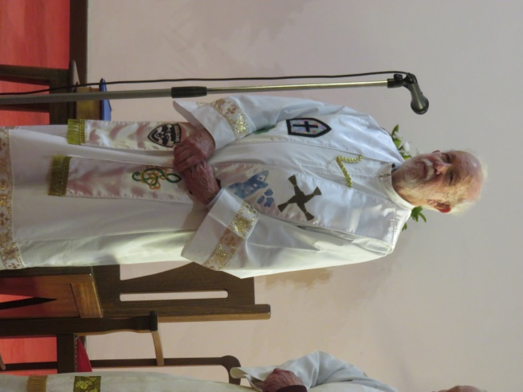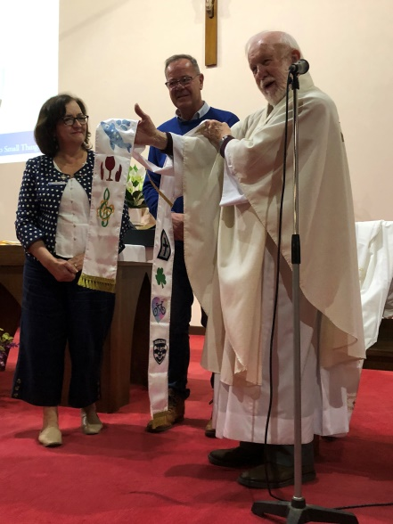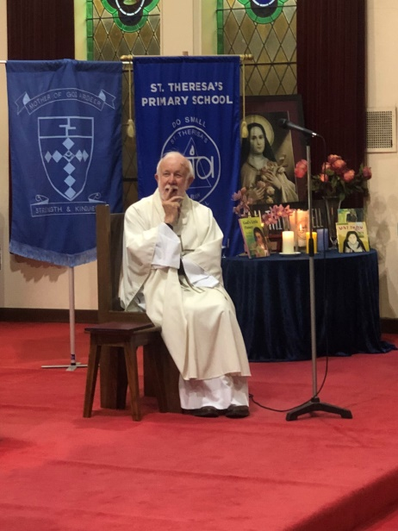

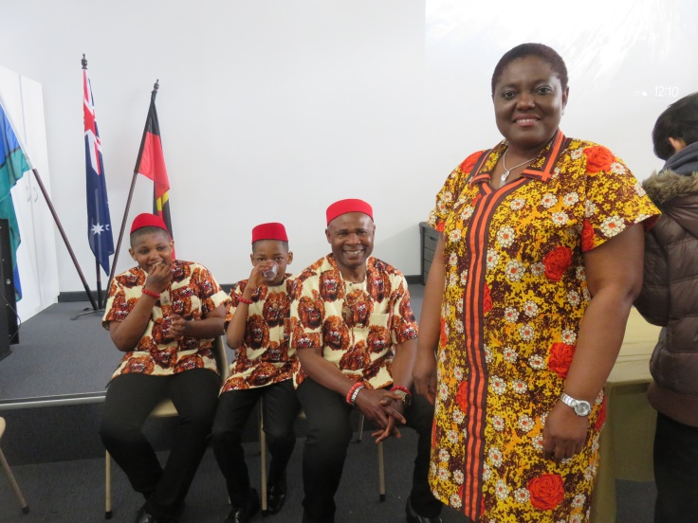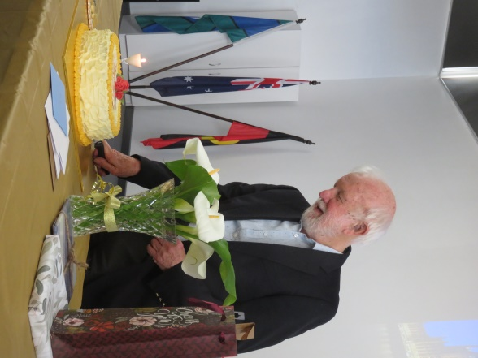

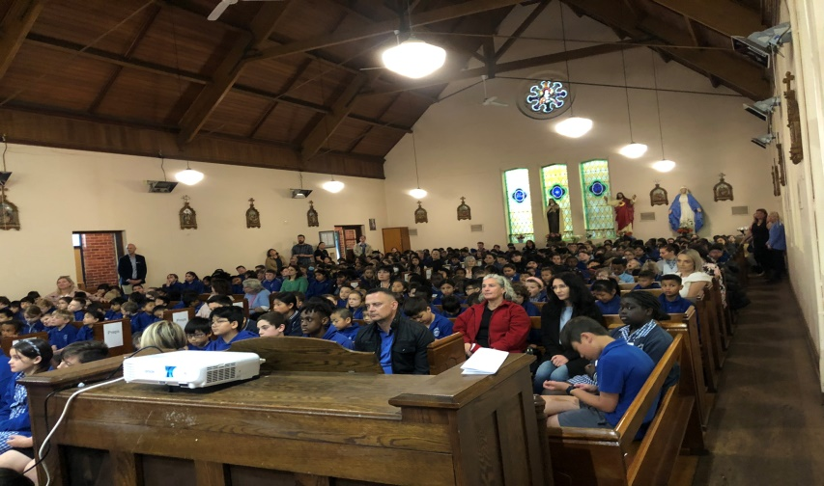

A REFELCTION ON THE GOSPEL

Saving the Lost: Zacchaeus (19:1-10)

This Sunday’s Gospel is the story of Zacchaeus the tax collector. This story is often used as an example of the phases of reconciliation.

Traditionally, the 4 phases of reconciliation have been:
- Confession of sin;
- Expression of contrition or sorrow for sin;
- Doing penance ("satisfaction"), which expresses a desire to avoid sin; and
- Absolution from sin.

Another way of looking at the phases of reconciliation is:
Realization - An awareness that there is a grievance. An acknowledgment that there is a problem.
Identification - Empathizing and understanding the aggrieved.
Preparation - What are you prepared to do to reconcile? Are you prepared to go the distance towards reconciliation?
Activation - The action(s) that are necessary for change. Putting in the effort and the work to make the change

How does Jesus help Zacchaeus move towards reconciliation with his community and with God? As with other stories in the Gospel of Luke, this one can also be understood as Jesus saving the lost.

Luke has consistently shown how Jesus cared for those in need and for those rejected by society. In the Zacchaeus account these themes are summed up in beautiful detail. The account is unique to Luke's Gospel, just as the parables of the lost sheep, the lost coin and the compassionate father are. In return to Jesus' openness to him, Zacchaeus makes the proper response. Having accepted Jesus' initiative, Zacchaeus becomes generous with his resources, even seeking to make restitution for past wrongs. He is a rich man who gets through the eye of the needle.

As Jesus proceeds into Jericho, his visit has attracted a large crowd. Zacchaeus, a rich chief tax collector, also is interested in Jesus. In his culture Zacchaeus would be regarded totally negatively by his community because his wealth was "extorted" from fellow Jews on behalf of occupying Rome. This explains the public reaction to Jesus' invitation later in the story. Luke will seek to reverse that perception.

The tax collector is too short to see over the crowd, but his desire is so great that he exercises creativity in attaining his goal. A sycamore-fig tree is like a short oak tree, with a squatty trunk and wide branches. So Zacchaeus has a high camera angle on the event.

Jesus takes the initiative, calling for Zacchaeus. Jesus announces that it "is necessary" (dei) for him to stay with this eager spectator. In the ancient culture, the request revealed Jesus' acceptance of Zacchaeus; therefore it stuns the crowd (v. 7). The request meets with public scepticism, which allows Jesus to make a point about the nature of his mission. Zacchaeus's attempt to glimpse Jesus has become much more.

Zacchaeus responds by coming down the tree and receiving Jesus with joy. Here joy is the response of a man who has fulfilled God's will despite the protests of many who surround him. The crowd's grumbling recalls earlier grumbling about Jesus' associations (5:30).

Zacchaeus responds: "Here and now I give half of my possessions to the poor, and if I have cheated anybody out of anything, I will pay back four times the amount." Two actions substantiate Zacchaeus's new approach. A new generosity means that half of his assets are going to those in need. In addition, anyone who was robbed will be paid back with the highest penalty the law allows, a fourfold restitution.

This rich man, touched by Jesus and responding with faith, exemplifies the restoration of a "lost one" and opens up his resources to be shared with others. He does not have to sell everything to receive Jesus' commendation. His heart is in the right place when it comes to possessions. So Zacchaeus becomes an exemplary rich disciple.

Jesus announces, "Today salvation has come to this house, because this man, too, is a son of Abraham." He speaks of the tax collector's spiritual heritage here. Now this one has been joined to the great patriarch of faith. Zacchaeus's access to God's blessing has been gained through faith. Not only that, but Jesus' mission has been fulfilled "The Son of Man came to seek and to save what was lost." Jesus does what the nation had failed to do in the past, become a shepherd to lost sheep. Jesus' initiative is a requirement of his mission. In order to find the lost, he must seek the lost. In such cases even the rich and rejected can be a part of the flock. Faith brings Jesus home to stay in Zacchaeus's heart and the lost sheep back to the Shepherd.

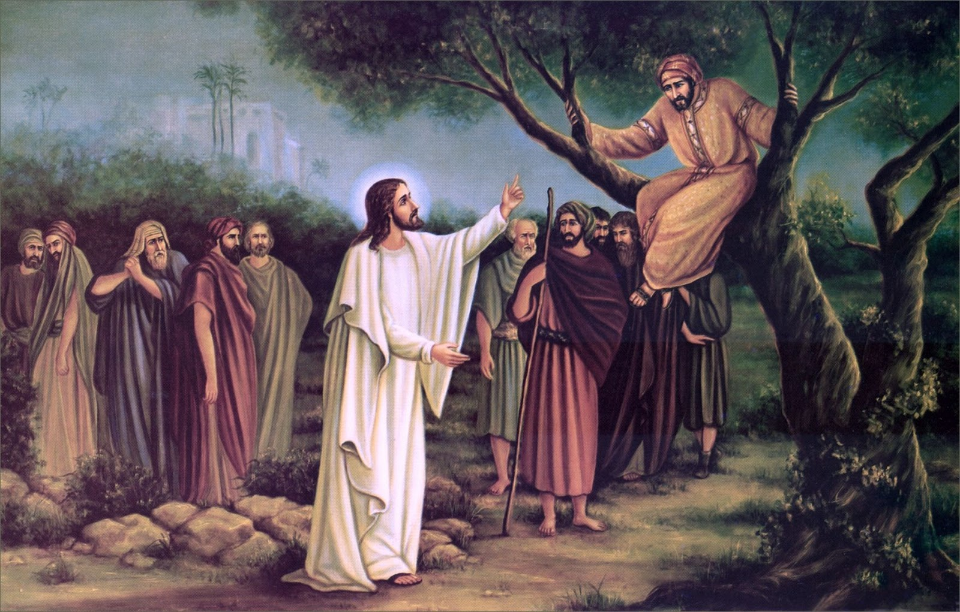

St Theresa’s Parish is committed to the safety of children, young people and vulnerable adults

