St. Theresa’s Parish Community Newsletter

Parish Priest: Fr Barry Hughes
Presbytery: 17 Drummartin St, Albion 3020
Phone: 9311 3091
email: caalbion@netspace.net.au
Mobile: 0428 533 391
Polish Chaplain: Fr Marian Szeptak
Residence: 185 William St, St Albans 3021
Phone: 9310 9057

St. Theresa’s Primary School – 9311 9070
16 Drummartin St, Albion 3020
Principal: Rob Macklin

Mother of God Primary School – 9363 1734
Blanche St, Ardeer 3022
Principal: Assunta Iacovino

“Do Small Things Well”

25th SUNDAY IN ORDINARY TIME Year A 23 & 24 SEPTEMBER 2023

THE FUTURE OF THE PARISH
If you haven’t responded yet to the two questions asked last weekend regarding the future of our Parish please do so today.

ARDEER HISTORY THROUGH KIDS AND COMMUNITY
The children of Mother of God and Ardeer Primary School are going to animate your stories. You can send your story by making a voice recording or writing it.to dgadri@mogardeer.catholic.edu.au or gwoolford@mogardeer.catholic.edu.au by 1st October 2023.

MASSES THIS WEEK  ST THERESA’S  Drummartin St, Albion  9.00am Friday  10.30am Sunday  MOTHER OF GOD  Blanche St, Ardeer  10.00am Wednesday (Pol)  9.00am Thurs  6.00pm Friday (Polish)  5.30pm Saturday  10.15am Sunday (Polish)  QUEEN OF HEAVEN  Holt St, Ardeer  8.00am Wednesday  9.00am Sunday  CHRIST’S CATHOLIC COMMUNITY  Prayer Group meets every Thursday, 7.00 - 8.30pm, at Queen of Heaven Church. All are welcome |  | CUPPA AFTER MASS Join us next weekend, on the Feast  Day of St Theresa the Patron Saint of our Parish for a cuppa and a chat. Take this opportunity to enjoy the company of your fellow parishioners, and get to know one another better? Please  bring a plate to share.  AUSTRALIAN CATHOLIC MAGAZINE  Spring Edition out now articles on Climate for change and a Fishy story  QUEEN OF HEAVEN PARISH REUNION  Cancelled due to lack of interest.  COLLECTIONS RECEIVED  Thanksgiving $658 Loose Money $549 Presbytery $531  COUNTERS 1st October  Team 4: J Camilleri, J Zammit, M Buhagiar  FEAST DAYS  St Vincent de Paul, 27 September  STS Michael, Gabriel & Raphael, Archangels, 29 October  St Jerome, 30 September  READINGS Today Next Week  Isaiah 55.6-9 MICAH 6:1a, 8  Ps 145.2-3,8-9,17-18(R.18) Psalm 131:1-3  Philippians 1.20-24,27 Colossians 3:12-17  Matthew 20.1-16 Matthew 18:1-5

SPRING MARKET BY ABBEY SOLO YOUTH COMMITTEE Sunday 1st October, 10.30am – 3.30pm at Kensington Town Hall

JOSEPH’S CORNER CHARITY GALA Saturday 7 October 2023 from 6pm
Joseph’s Corner, with the support of the Yarraville Club, 135 Stephen St Yarraville, presents the ORBISON PRESLEY Tribute Show. Please join us for a night of fun, entertainment, good food and friendship to help raise much needed funds to support families affected by addiction. See Poster for details and booking.

St Theresa’s Parish is committed to the safety of children, young people and vulnerable adults

REMEMBERING THE DECEASED IN PRAYER

I want to say a couple of things about how we pray for the deceased in the prayers of the faithful. But first, some important background about our praying for the deceased in Mass.

Remembering those who have died is a very significant aspect of our catholic faith and practice. We
pray for those who have died every time we celebrate the Eucharist. In every one of our various Eucharistic Prayers (the long prayer at the centre of Mass which includes the prayers of consecration) there is a prayer for those who have died. For example, in the Eucharistic Prayer for use in Masses for Various Needs IV (Jesus who went about doing good) we pray, “Remember our brothers and sisters who have fallen asleep in the peace of your Christ, and all the dead whose faith you alone have known. Admit them to rejoice in the light of your face, and in the resurrection give them the fullness of life.”

As in all the prayers spoken by the priest, the priest is speaking on behalf of us all. It is our prayer. As we pray this prayer we can be praying for all people, as the prayer says, and also praying for those for whom we particularly want to pray.

At our Sunday Masses we also include a prayer for those who have died in the Prayers of the Faithful. This is our opportunity to name particular people. Again, while the prayer is said by one person, it is said on behalf of all of Us. Lord hear us, Lord hear our prayer. There are a few things that need to be said about this.

When requesting that names be included in the Prayers of the Faithful, you should not write “Mass for………” or “Please offer Mass for ………...” This implies that the Mass is for that particular person alone. The Mass is for everybody. Please write something like, “Please include ………. In the prayers” or “please remember ………”

Also, please be considerate about how often you ask for someone’s name to be included. We all have loved ones who have died. If they were all mentioned frequently, we would have an impossibly long list. An anniversary or a birthday, or when someone is recently deceased, might be the appropriate time to especially mention particular people. Remember, as above, that all the deceased are prayed for in every Mass.

Father Barry

ABBY SOLO FOUNDATION

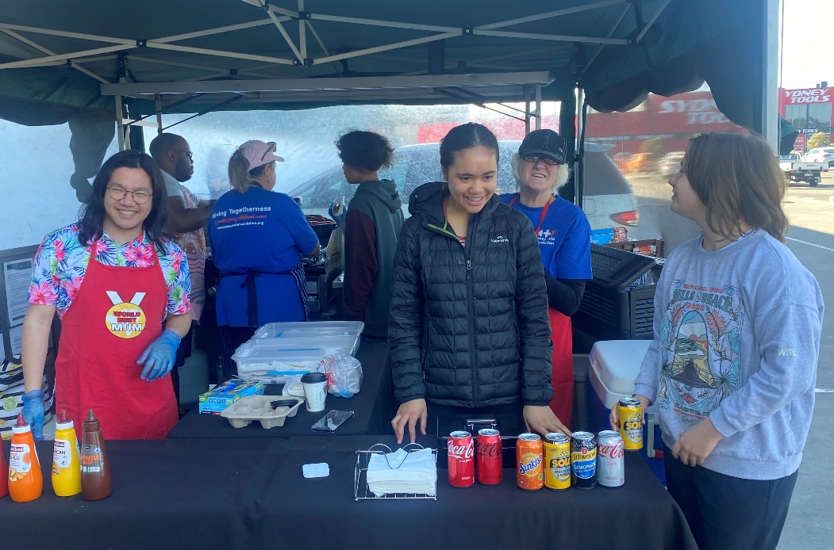
The Abbey Solo Foundation has been supporting families living with childhood cancer for nearly 8 years. Our Bunnings Sausage Sizzles are one of our major fundraisers. It was great to see Fr Barry and other parishioners last Saturday. We raised over $1500 on the day, all funds going straight to help families with practical and timely support.
Gerard

