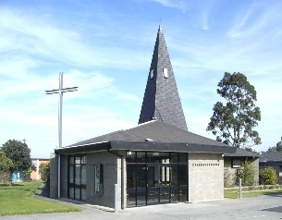](http://www.google.com.au/imgres?q=immaculate+heart+of+mary&hl=en&gbv=2&biw=1024&bih=559&tbm=isch&tbnid=B4VePAglsIHgHM:&imgrefurl=http://media.photobucket.com/image/the%2520immaculate%2520heart%2520of%2520mary/roywhrapz/SaInTs/Virgin-Mary1.png%3Fo%3D19&docid=QUuuY0-8uPEZZM&imgurl=http://i238.photobucket.com/albums/ff20/roywhrapz/SaInTs/Virgin-Mary1.png&w=330&h=400&ei=e5UPT828POySiAeVteU7&zoom=1)[A painting of a person
](http://www.google.com.au/imgres?q=immaculate+heart+of+mary&hl=en&gbv=2&biw=1024&bih=559&tbm=isch&tbnid=B4VePAglsIHgHM:&imgrefurl=http://media.photobucket.com/image/the%2520immaculate%2520heart%2520of%2520mary/roywhrapz/SaInTs/Virgin-Mary1.png%3Fo%3D19&docid=QUuuY0-8uPEZZM&imgurl=http://i238.photobucket.com/albums/ff20/roywhrapz/SaInTs/Virgin-Mary1.png&w=330&h=400&ei=e5UPT828POySiAeVteU7&zoom=1)[A painting of a person
](http://www.google.com.au/imgres?q=immaculate+heart+of+mary&hl=en&gbv=2&biw=1024&bih=559&tbm=isch&tbnid=B4VePAglsIHgHM:&imgrefurl=http://media.photobucket.com/image/the%2520immaculate%2520heart%2520of%2520mary/roywhrapz/SaInTs/Virgin-Mary1.png%3Fo%3D19&docid=QUuuY0-8uPEZZM&imgurl=http://i238.photobucket.com/albums/ff20/roywhrapz/SaInTs/Virgin-Mary1.png&w=330&h=400&ei=e5UPT828POySiAeVteU7&zoom=1)[A painting of a person
](http://www.google.com.au/imgres?q=immaculate+heart+of+mary&hl=en&gbv=2&biw=1024&bih=559&tbm=isch&tbnid=B4VePAglsIHgHM:&imgrefurl=http://media.photobucket.com/image/the%2520immaculate%2520heart%2520of%2520mary/roywhrapz/SaInTs/Virgin-Mary1.png%3Fo%3D19&docid=QUuuY0-8uPEZZM&imgurl=http://i238.photobucket.com/albums/ff20/roywhrapz/SaInTs/Virgin-Mary1.png&w=330&h=400&ei=e5UPT828POySiAeVteU7&zoom=1)**Immaculate Heart of Mary Church**

441 Bluff Road, East Hampton. VIC 3188 Australia

Parish Priest: Fr. Vittorio Ricciardi

***Tel: + 61 (03) 9598 5246***

**E-mail:** [**IHMC@optusnet.com.au**](mailto:IHMC@optusnet.com.au)

**Web:** [**www.cam.org.au/hamptoneast**](http://www.cam.org.au/hamptoneast)

**WELCOME TO THE IMMACULATE HEART OF MARY PARISH**

The Immaculate Heart of Mary is blessed with several parish groups (Rosary, Neocatechumenal Way, Legion of Mary) that our parishioners are welcome to be a part of. These voluntary groups provide an additional opportunity for spiritual enrichment and do not detract from the fundamental pastoral and sacramental activities of the Church. Everyone is invited to participate in any of or all of these groups, as often as they feel comfortable.

**SAFEGUARDING IS EVERYONE’S RESPONSIBILITY**

We consider the safety and wellbeing of all persons to be our highest priority. Please refer to our website and/or the public notices in the Narthex for further information.

**Mass Times**

**Sunday:** 9.00 am and 10.30 am

**Saturday:** 6.00 pm & 8.00 pm **(Vigil)**

**Daily Mass:** 9.00 am **(Mon – Fri)**

**First Friday:** 9.00 am **(Mass & Anointing of the Sick)**

**Reconciliation:** 10.30 am – 11.00am **(Sat or on request)**

**Rosary:** Mon-Fri after 9.00 am Mass

**Benediction and Rosary:** Fri after 9.00 am Mass till 10.45am

**Neocatechumenal Way:** Tues, Wed & Thurs 7.30 pm, and Saturday 7.30 pm

|  |  |  |  |
| --- | --- | --- | --- |
| **22nd Sunday in OT 28 Aug 2022** | **6.00 pm Mass** | **9.00 am Mass** | **10.30 am** |
| **Lector** | Angelina Robinson | Rick Thomas | Chanelle Lobo |
| **Music ministry** | Volunteers | Mary Rose | Marylou James |
| **Minister of Communion** | Body: Fr Vittorio  Wine: two or one minister will be nominated | Body: Fr Vittorio  Wine: two ministers will be nominated | Body: Fr Vittorio  Wine: two ministers will be nominated |
| **Offertory Procession** | Volunteers | Volunteers | Someone will be nominated |
| **23rd Sunday in OT 4th Sept 2022** | **6.00 pm Mass** | **9.00 am Mass** | **10.30 am** |
| **Lector** | Angelina Robinson | Rick Thomas | Freya Sheeran |
| **Music ministry** | Volunteers | Mary Rose | Marylou James |
| **Minister of Communion** | Body: Fr Vittorio  Wine: two or one minister will be nominated | Body: Fr Vittorio  Wine: two ministers will be nominated | Body: Fr Vittorio  Wine: two ministers will be nominated |
| **Offertory Procession** | Volunteers | Volunteers | Paul and Freya Sheeran |

**PRAYERS FOR THE SICK**

Angelo Molino; Chiara Mazzeo; Christian James; Filippo and Sara, Sophia, Daniel Rivalland, Georgette Kheir, Christine Banerjee, Ettore Poletta, Francesco Paolo Ricciardi; Millie D’Alton, Claire Posten, James Morrison, Catalina Morrison, Rosa Maria Santos, Ben, Mary Muscat, Patrick Lakagreagrow, Brian Tierney, Carmel Kanci, Jo Arena, Pam Montgomery, Helen Mille; Jason Denis; Rosa Nistico, Margaret Denis; Arthur Astarlis, , Lourenca Fernandes, Prithie Pereira, Madison Kelly, Pat Flarve.

**SPECIAL PRAYERS FOR THE DECEASED**

Elizabeth Clare Cropley; Desme Tickner; Marie Ratten; Anthony Devola, Doreen New, Norma Moloney**,** Mary Westhead**,** Conrad Lobo; Giovanni Lentini; Benedict Banerjee; Marie Perez; Fr James Early; Michael Wiscki, John allan & Marcia Barry; Lynette Maher; Mickey Mascarenhas**;** Vincent & Tina Giglio; Louisette Harris; Nelson Trapani; Jim Walsh; Miriam Proctor; Elva Ebdon, John Rivalland, Marie Rivalland, Douglas Gonsalves, Charlotte Godfrey, Linda D’Souza; Felix Lobo, Margaret Herbstreit; Trevor Anthony Fernandez, Pauline Burke, Rudolph D’Souza, Michelle Fowler, Sam Molino, Margherita M. La Macchia, Joan Elliot, Archimede Camba, Denzel D’Souza, Melissa D’Souza; John Noal, Lorraine Thompson, Peg Smith, Gladys DeRosario, Florencio David; Sr. Kathy Taranto, Maureen Collins, John Palamara, May Ray, Milan Lozo, Albert & Hillary D’Souza; Shannon Baker; Margaret Dowsey, Janine Capiron; George Tickner; Jack Foley; Sheila McKenna; Peter Dunne; Tony Molloy; Dulcie Jopling; Gerard Bourke, Alfred Foster, Joan Mealing; Judith Buckley; Genevieve Rodrigues Jean Allday; Gloria James; Earnie Breznik; Margaret Daveron; Patrick & Maurice Kelly; Edward Majda; Elizabeth Mary McKay; John H. Moloney; +Fr. Frank Maher; +Fr. Victor Crennan.

**Thanksgiving Collection Weekend: 14/08/2022 – $ 637.00**

**Loose Money: 14/08/2022 – $ 303.30**

**My dear Parishioner, once again, thank you for your generosity.**

***THIS WEEK***

**September is the month of**

**The Seven Sorrows of Our Lady**

**Mon: 29th Aug The Passion of St John The Baptist**

**Tue: 30th Aug St. Richard Martin**

**Wed: 31st Aug St. Aidan of Lindisfarne**

**Thu: 1st Sept St. Anna the Prophetess**

**Pray the Rosary Daily**

**Fri: 2nd Sept St. Ingrid of Sweden**

**Sat: 3rd Sept St. Gregory the Great, Pope and Doctor**

**SAFEGUARDING COMMITTEE MESSAGE**

Dear brothers and sisters,

We have been advised by the archdiocese of Melbourne that we left the expiring 2018-2021 Volunteers Safeguarding Children compliance term last December and entered the new 2022-2025 Volunteers Safeguarding Children compliance term in January this year. Immediately effective, new Code of Conduct forms need to be signed by all persons volunteering at IHM or employed by the parish.

**Please help us:** If you are serving the parish in any capacity and have not already completed and returned a 2022-2025 Safeguarding code of conduct form to Father or a committee member you can help by taking a new Safeguarding code of conduct form from the Narthex today (forms are located on the parish information table inside the front door). Please complete the form as soon as you can and return it to Father or a committee representative next week.

If it is more convenient for you to do it today, you are most welcome to stay and complete the document before you leave. We will be in the Narthex briefly after Mass to answer questions and provide assistance to anyone who requires it.

Thanks again and God Bless you.

**REFLECTION ON THE GOSPEL -THE 22nd WEEK IN ORDINARY TIME - LUKE 14:1, 7-14**

Meals played an important role in the society in which Jesus lived. More than a time for sharing nourishment, they were a time to share ideas and to model different aspects of social relationships. In Luke's Gospel, the places that a person ate (at the home of a tax collector, 5:29), the people with whom a person ate (sinners, 5:30), whether a person washed before eating (11:38), and, as is the case here, the place that a person sits while eating are all important. The narrator says Jesus tells a parable, but it is really wise advice to both guests and hosts about finding true happiness at the heavenly banquet.

Jesus warns guests to wait before taking their places at the table lest they be asked to move if someone more important arrives. This is more than just a lesson about dinner etiquette. It is advice on how to find your true place in the Kingdom of God. Jesus advises hosts not to invite people who would be expected to repay them to dinner but to invite those who could not repay the poor, the crippled, the lame, and the blind. This is where real blessings can be found.

In these sayings, Luke gives us not only advice on how to approach the end times but also on how to live according to Jesus' vision of a good society. Luke's Gospel also advises us how the Church must be part of bringing about this society. It is yet another example in Luke's Gospel of the reversal the kingdom brings about.

**NEXT WEEKEND FATHERS DAY APPEAL FOR THE PRIESTS RETIREMENT FOUNDATION**

Once again this year “Fathers’ Day” Collection will be held on Saturday the 3rd September and Sunday the 4th September. It would be most grateful if we can contribute to the Father’s Day Appeal, for our retired priests. Some donors have been supporting the Appeal since its inception in 1990 by the late Archbishop Little (RIP). This shows how much the Catholic people of Melbourne value the huge contribution made by priests who are now retired, but have cared for them in former times. Our support for our retired priests and sick priests, who have shown us deep spiritual care, is a true sign of gratitude.

**‘FLOURISH WITH MARY’S HEART’ PRAYER BOOK**

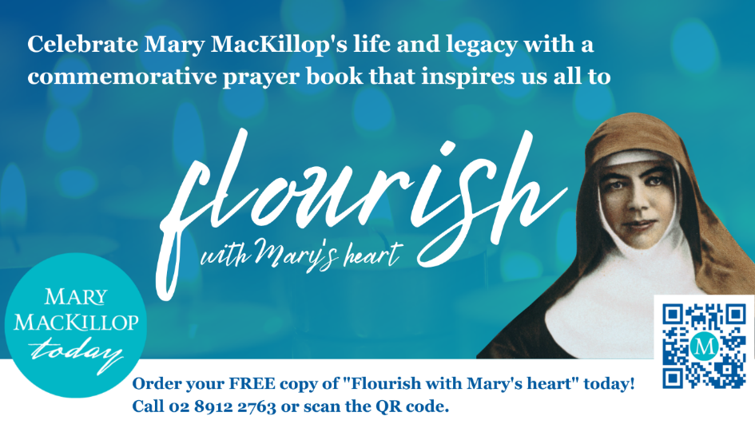Mary MacKillop Today invites us to share with a **FREE** copy of our new ‘Flourish with Mary’s heart’ prayer book.

Written by the Sisters of Saint Joseph, the dedicated prayer for each day of the week, and reflections in this booklet offer an opportunity to share in Scripture and understand the values that are key to the heart of Saint Mary of the Cross.

If you would like to receive your own copy of the Prayer Book, please register your details on our website [www.marymackilloptoday.org.au/prayer-book](https://aus01.safelinks.protection.outlook.com/?url=https%3A%2F%2Fmarymackilloptoday.cmail20.com%2Ft%2Fr-l-tyuhhuit-bdyiklhdyh-j%2F&data=05%7C01%7Champtoneast%40cam.org.au%7Cdd7b9a66d5844d7088f308da86248801%7C48ee20c7c8ea423c8b28f19801e34193%7C0%7C0%7C637969788717029937%7CUnknown%7CTWFpbGZsb3d8eyJWIjoiMC4wLjAwMDAiLCJQIjoiV2luMzIiLCJBTiI6Ik1haWwiLCJXVCI6Mn0%3D%7C3000%7C%7C%7C&sdata=AO2HQ3E%2FHuRIq6PbbdafV7jFOHBvOjqhKLifScv0kUE%3D&reserved=0)

Thank you for your support and help in carrying on the good works of Saint Mary MacKillop!