SACRAMENT OF RECONCILIATION AND EXPOSITION OF THE BLESSED SACRAMENTON ON FRIDAYS
in the future, Fr Vittorio will be available for the individual confessions every Saturday at 10.30am. There will be no Mass anymore on Saturday morning, except for important solemnities.
Furthermore, from next Friday, 15 January 2021, the exposition of the blessed sacrament after the 9.00 am Mass will be re-established as normal.
GOVERNMENT COVID-19 RESTRICTIONS AFFECTING OUR MASSES
The restrictions relating to Church gatherings as they currently affect us are:
The numbers who can attend Mass in our Church are now 4, plus the celebrant. This is based on the emergency “circuit breaker” announced by the Government on Friday 12 February 2021.
Restrictions will remain in place until 11:59pm Wednesday 17 February 2021, unless otherwise directed.
- Places of worship must remain closed with the exception of live streaming of services and funerals (with limited numbers).
- Fitted face coverings must be worn at all times (and social distancing must be observed).
- Attendance/contact rolls must be maintained as is presently the case.
Collection bowls are located in the main aisle for the Thanksgiving collection and the Presbytery collection. Thank you to all who have helped financially over this difficult year.
ASH WEDNESDAY
The current restrictions will be in place for Ash Wednesday. As a result, the imposition of Ashes may be moved to the nearest opportunity for distribution once this period of restriction is finished. Further instructions will be forthcoming.
MASS TIMES
We have now resumed all our weekday Masses (Monday to Friday at 9am, excluding Saturday morning) together with Masses on Saturday at 6pm and Sunday at 9am and 10:30am. In this time Masses will be as follows:
Saturday 13 February 6:00pm Mass 6th Sunday in Ordinary Time on zoom
Sunday 13 February 9:00am Mass 6th Sunday in Ordinary Time on zoom
Sunday 14 February 10:30am Mass 6th Sunday in Ordinary Time on zoom
Monday 15 February 9:00am Mass 6th Week in Ordinary Time on zoom
Tuesday 16 February 9:00am Mass 6th Week in Ordinary Time on zoom
Wednesday 17 February 9:00am Mass Ash Wednesday normal mass on zoom
Without imposition of ashes,
fast and abstinence will be postponed
Thursday 18 February 9.00am Mass Thursday after Ash Wednesday
Friday 19 February 9:00am Mass Friday after Ash Wednesday
and exposition of the blessed sacrament
Saturday 20 February 6:00pm Mass 1st Sunday of Lent
Sunday 21 February 9:00am Mass 1st Sunday of Lent
Sunday 21 February 10:30am Mass 1st Sunday of Lent
All Sunday Masses will still continue to be broadcast on Zoom (login via the Parish website on www.cam.org.au/hamptoneast), until the 17th of February 2021.
Follow the link on our Parish website for the liturgy and songs, including a copy of this bulletin.
All information about our Parish is on our website www.cam.org.au/hamptoneast.
ADVERTISEMENT GARDENING WANTED
Clean up Jobs are my specialty
Good Rates
20 Years of Experience
Name: John
mob. 0406913579

ASH WEDNESDAY 17TH FEBRUARY 2021 WILL BE POSTPONED
Mass will be celebrated at 9.00am and 6.00pm.
FAST & ABSTINANCE Ash Wednesday and Good Friday are obligatory days of fasting and abstinence. In addition, Fridays during Lent are obligatory days of abstinence. Fasting is obligatory from age 18 until age 59. The norms concerning abstinence from meat are binding upon members from age 14 onwards. Further information is on the letter from the Vicar General in the Narthex.
LENT PROGRAM 2021
STATIONS OF THE CROSS WILL BE HELD DURING THE SEASON OF LENT EVERY FRIDAY AT 7.00PM IN THE CHURCH
MORNING PRAYER: Just a reminder to all the parishioners that, in Lent, from Monday the 22nd of February 2021, we are going to pray the Morning Prayer of the Liturgy of the Hours, 15 minutes before the daily 9am Mass. Therefore, every day at 8.45am, excluding Saturday and Sunday, we will start the morning prayer of the Church, which will consist of the Invitatory Psalm, plus three Psalms recited, a short reading, the Benedictus, intercession, Our Father, and the final prayer.
BE MORE: PROJECT COMPASSION 2021
Project Compassion Sunday 2021
14 February 2021
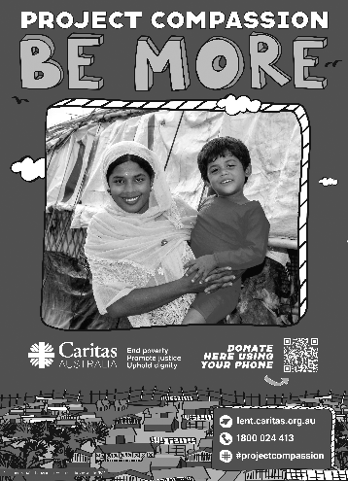
Please take home a Project Compassion box and/or a set of donation envelopes and support Caritas Australia this Lenten season themed “Be More”. Through your generosity and by aspiring to be more, you are assisting some of the world’s most vulnerable people build better futures for themselves, their families and their communities.
You can donate through Parish boxes and envelopes, or by visiting www.caritas.org.au/projectcompassion or phoning 1800 024 413.

