SACRAMENT OF RECONCILIATION
In the future, Fr Vittorio will be available for the individual confessions every Saturday at 10.30am. There will be no Mass anymore on Saturday morning, except for important solemnities.
GOVERNMENT COVID-19 RESTRICTIONS AFFECTING OUR MASSES
Following a 5-day ‘circuit - breaker’ period of lockdown, Victoria is now returning to the “COVID Safe Summer” phase, with some small areas of note.
Essentially for our Church:
- We can have up to 100 at Mass and masks are mandatory indoors or outdoors when people cannot maintain 1.5m physical distancing.
- Masses are resumed accordingly to our safe plan COVID-19.
- In any event we will need new attendance rolls to be completed in the Narthex in the usual way.
- The celebration on Zoom is terminated unless further notice will be announced.
Collection bowls are located in the main aisle for the Thanksgiving collection and the Presbytery collection. Thank you to all who have helped financially over this difficult year.
MASS TIMES
We have now resumed all our weekday Masses (Monday to Friday at 9am, excluding Saturday morning) together with Masses on Saturday at 6pm and Sunday at 9am and 10:30am. In this time Masses will be as follows:
Saturday 27 February 6:00pm Mass 2nd Sunday of Lent
Sunday 28 February 9:00am Mass 2nd Sunday of Lent
Sunday 28 February 10:30am Mass 2nd Sunday of Lent
Monday 1 March 8:45am Morning Prayer, and 9.00 Mass second week of Lent
Tuesday 2 March 8:45am Morning Prayer, and 9.00 Mass second week of Lent
Wednesday 3 March 8:45am Morning Prayer, and 9.00 Mass second week of Lent
Thursday 4 March 8:45am Morning Prayer, and 9.00 Mass second week of Lent
Friday 5 March 8:45am Morning Prayer, and 9.00 Mass second week of Lent
and exposition of the blessed sacrament
Saturday 6 March 6:00pm Mass 3rd Sunday of Lent
Sunday 7 March 9:00am Mass 3rd Sunday of Lent
Sunday 7 March 10:30am Mass 3rd Sunday of Lent
Follow the link on our Parish website for the liturgy and songs, including a copy of this bulletin.
All information about our Parish is on our website www.cam.org.au/hamptoneast.
FR VITTORIO WILL BE ABSENT FOR RETREAT
Fr Vittorio is away for Neocatechumenal retreat from Thursday evening 4th March until Sunday 7th March. Fr Stephen Hamilton will celebrate the weekend Masses on Saturday evening at 6.00pm and Sunday morning at 9.00 and 10.30pm. There will be no Mass on Friday 5th March at 9.00am, and no stations of the cross at 7.00pm. There will be no confessions for Saturday 6th March, but Fr Vittorio will be available during the week from Monday 1st March until Thursday 4th March at any time.
LENT PROGRAM 2021
STATIONS OF THE CROSS WILL BE HELD DURING THE SEASON OF LENT EVERY FRIDAY AT 7.00PM IN THE CHURCH
MORNING PRAYER: Just a reminder to all the parishioners that, in Lent, from Monday the 22nd of February 2021, we are going to pray the Morning Prayer of the Liturgy of the Hours, 15 minutes before the daily 9am Mass. Therefore, every day at 8.45am, excluding Saturday and Sunday, we will start the morning prayer of the Church, which will consist of the Invitatory Psalm, plus three Psalms recited, a short reading, the Benedictus, intercession, Our Father, and the final prayer.
BE MORE: PROJECT COMPASSION 2021
Project Compassion Sunday 2021
21 February 2021
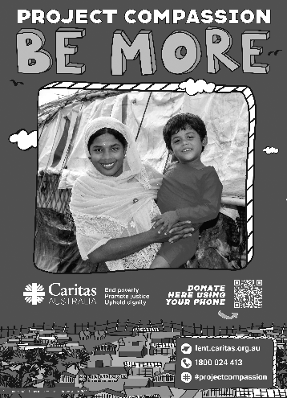
Please take home a Project Compassion box and/or a set of donation envelopes and support Caritas Australia this Lenten season themed “Be More”. Through your generosity and by aspiring to be more, you are assisting some of the world’s most vulnerable people build better futures for themselves, their families and their communities.
You can donate through Parish boxes and envelopes, or by visiting www.caritas.org.au/projectcompassion or phoning 1800 024 413.

