SACRAMENT OF RECONCILIATION
In the future, Fr Vittorio will be available for the individual confessions every Saturday at 10.30am. There will be no Mass anymore on Saturday morning, except for important solemnities.
SACRAMENT OF PENANCE FOR LENT 2021
THE SECOND RITE OF RECONCILIATION and individual confessions will be held on Tuesday 23rd of March 2021 at 7.30pm, and also on Thursday 25th of March 2021 at 7.30pm. Both celebrations will be conducted and animated by the Neocathecumenal communities. In addition to these celebrations, Fr Vittorio is avalable in Lent for individual confessions everyday by appointment.
The time of the other holy week celebrations will be communicated in due time.
GOVERNMENT COVID-19 RESTRICTIONS AFFECTING OUR MASSES
Following a 5-day ‘circuit - breaker’ period of lockdown, Victoria is now returning to the “COVID Safe Summer” phase, with some small areas of note.
Essentially for our Church:
- We can have up to 100 at Mass and masks are mandatory indoors or outdoors when people cannot maintain 1.5m physical distancing.
- Masses are resumed accordingly to our safe plan COVID-19.
- In any event we will need new attendance rolls to be completed in the Narthex in the usual way.
- The celebration on Zoom is terminated unless further notice will be announced.
Collection bowls are located in the main aisle for the Thanksgiving collection and the Presbytery collection. Thank you to all who have helped financially over this difficult year.
MASS TIMES
We have now resumed all our weekday Masses (Monday to Friday at 9am, excluding Saturday morning) together with Masses on Saturday at 6pm and Sunday at 9am and 10:30am. In this time Masses will be as follows:
Saturday 13 March 6:00pm Mass 4th Sunday of Lent
Sunday 14 March 9:00am Mass 4th Sunday of Lent
Sunday 14 March 10:30am Mass 4th Sunday of Lent
Monday 15 March 8:45am Morning Prayer, and 9.00 Mass fourth week of Lent
Tuesday 16 March 8:45am Morning Prayer, and 9.00 Mass fourth week of Lent
esday 17 March 8:45am Morning Prayer, and 9.00 Mass fourth week of Lent
Thursday 18 March 8:45am Morning Prayer, and 9.00 Mass fourth week of Lent
Friday 19 March 8:45am Morning Prayer, and 9.00 Mass fourth week of Lent
and exposition of the blessed sacrament
Saturday 20 March 6:00pm Mass 5th Sunday of Lent
Sunday 21 March 9:00am Mass 5th Sunday of Lent
Sunday 21 March 10:30am Mass 5th Sunday of Lent
Follow the link on our Parish website for the liturgy and songs, including a copy of this bulletin.
All information about our Parish is on our website www.cam.org.au/hamptoneast.
JOHN ALLAN BARRY
I received another news few days ago that also John Allan Barry, Marcia’s husband, died in Alfred Hospital on Tuesday 9th March 2021. As many will know Alan Barry was in Elanora aged care facility at Brighton Beach.
The Barry’s were long term parishioners of IHOM with Marcia being a reader among a number of roles and Alan Chairman of the Finance Committee when Fr Sagay was PP. Wonderful people and great contributors to all that was going on in the Parish until their health intervened.
The funeral is to be held in our Church on Tuesday 23rd March 2021 at 11.00.
The family is happy for John and Marcia’s death to be shared with all who knew both.
LENT PROGRAM 2021
STATIONS OF THE CROSS WILL BE HELD DURING THE SEASON OF LENT EVERY FRIDAY AT 7.00PM IN THE CHURCH
MORNING PRAYER: Just a reminder to all the parishioners that, in Lent, from Monday the 22nd of February 2021, we are going to pray the Morning Prayer of the Liturgy of the Hours, 15 minutes before the daily 9am Mass. Therefore, every day at 8.45am, excluding Saturday and Sunday, we will start the morning prayer of the Church, which will consist of the Invitatory Psalm, plus three Psalms recited, a short reading, the Benedictus, intercession, Our Father, and the final prayer.
BE MORE: PROJECT COMPASSION 2021
Project Compassion Sunday 2021
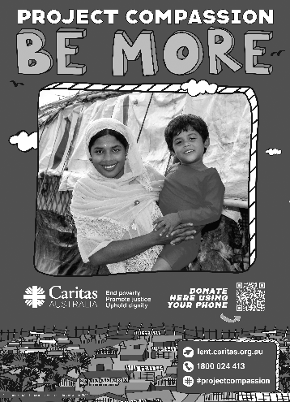
21 February 2021
Please take home a Project Compassion box and/or a set of donation envelopes and support Caritas Australia this Lenten season themed “Be More”. Through your generosity and by aspiring to be more, you are assisting some of the world’s most vulnerable people build better futures for themselves, their families and their communities.
You can donate through Parish boxes and envelopes, or by visiting www.caritas.org.au/projectcompassion or phoning 1800 024 413.

