TIMETABLE OF THE HOLY WEEK 2021
PALM SUNDAY April 13/14 | 6.00 pm Mass | 8.30 am Mass | 10.00 am Procession & Mass
Lectors (1st and 2nd reading) | Angelina Robinson | Rick Thomas | Conrad Lobo
Gospel readers
JESUS (near the altar) | Fr Vittorio | Fr Vittorio | Fr Vittorio
Narrator (near the altar) | Angelina Robinson | Rob Lyell | Conrad Lobo
One Voice (near the altar) | Kevin Pereira | Chris Lyell | Lisa Kennedy
All & Servant Girl (from their seat) | Caroline Camba | Volunteer | Paula Campbell
All & Peter (from their seat) | Benedict (or Volunteer) | Rick Thomas | Paul Kennedy
Minister of Communion | Fr Vittorio  Volunteer minister in case needed | Fr Vittorio  Volunteer minister in case needed | Fr Vittorio
 |  |  | Mattia Poletta (B)
 |  |  | Marylou James (B)
Offertory Procession | Volunteers | Colin & Kath Lewin | Victoria & Gemma Foster

HOLY MONDAY 29th March | 8.45 AM MORNING PRAYER, MASS 9.00 AM
HOLY TUESDAY 30th March | 8.45 AM MORNING PRAYER, MASS 9.00 AM –  7.30 PM CHRISM MASS IN THE CATHEDRAL
HOLY THURSDAY 1st April | (Please note NO morning Prayer and NO 9.00am Mass Thurs.)  7.00 PM EVENING MASS OF THE LORD’S SUPPER  (The washing of the feet is to be omitted)  HOLY HOUR’ FOLLOWS MASS OF THE LORD’S SUPPER
Lector | Angelina Robinson
Offertory Procession | Rick and Mary Thomas
GOOD FRIDAY 2nd April | 9.00 AM MORNING PRAYER OF THE CHURCH (Also Saturday 9.00AM)
 | 12 NOON STATIONS OF THE CROSS
* Reading at each Station.
* Please volunteer for Reading and Carrying the Cross from one Station to the next Station.
 | 3.00 PM CELEBRATION OF THE LORD’S PASSION
 | (Please note…on Good Friday there is a collection for the Holy Land)
Lector (1st and 2nd reading) | Conrad Lobo
Gospel readers
JESUS (near the altar) | Fr Vittorio
Narrator (near the altar) | Rob Lyell
One Voice (near the altar) | Rick Thomas
HOLY SATURDAY 3rd April  Lectors | 9.00 AM MORNING PRAYER OF THE CHURCH
 | 7.00 PM EASTER VIGIL | EASTER SUNDAY | 9.00am Mass | 10.30am Mass
Genesis 1.1 – 2.2 & Resp. Psalm | Cheryl Juelg | Lector | Rob Lyell | Conrad Lobo
Exodus 14:15-15.1 & Resp. Psalm | Rick Thomas
Isaiah 55:1-11 & Resp. Psalm | Marylou James
4thRead.Rom 6:3-11 & Resp. Psalm | Angelina Robinson
Offertory Procession | Rick Thomas  Marie Thomas | Offertory Procession | Chris Lyell  Rob Lyell | Georgette Kheir  Volunteer
Minister of Communion | Fr Vittorio | Minister of Communion | Fr Vittorio | Fr Vittorio
 | Marylou James |  | Volunteer | Paula Campbell
 | Marie Thomas |  | Volunteer | Conrad Lobo
 | 11.30 PM EASTER VIGIL animated by the Neocatechumenal communities
DIVINE MERCY SUNDAY 28th April | Divine Mercy Mass 10.30

GOVERNMENT COVID-19 RESTRICTIONS AFFECTING OUR MASSES
Following a 5-day ‘circuit - breaker’ period of lockdown, Victoria is now returning to the “COVID Safe Summer” phase, with some small areas of note.
Essentially for our Church:
- We can have up to 100 at Mass and masks are mandatory indoors or outdoors when people cannot maintain 1.5m physical distancing.
- Masses are resumed accordingly to our safe plan COVID-19.
- In any event we will need new attendance rolls to be completed in the Narthex in the usual way.
- The celebration on Zoom is terminated unless further notice will be announced.
Collection bowls are located in the main aisle for the Thanksgiving collection and the Presbytery collection. Thank you to all who have helped financially over this difficult year.

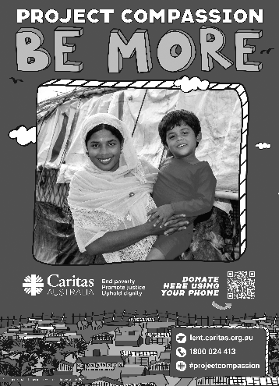
Project Compassion Sunday 2021
21 February 2021
Please take home a Project Compassion box and/or a set of donation envelopes and support Caritas Australia this Lenten season themed “Be More”. Through your generosity and by aspiring to be more, you are assisting some of the world’s most vulnerable people build better futures for themselves, their families and their communities.
You can donate through Parish boxes and envelopes, or by visiting www.caritas.org.au/projectcompassion
or phoning 1800 024 413.

