St Pius X Catholic Parish Heidelberg West acknowledges the Wurundjeri people.

Fr Wayne Edwards: St Pius X Presbytery 419 Waterdale Rd Heidelberg West 3081

Tel: 9457 5794 Fax: 9457 1036 Email: heidelbergwest@cam.org.au

Exodus Community: 273 Liberty Parade Heidelberg West Tel: 9457 7593

School Principal: Barbara Gomez Tel: 9457 3776 Email: bgomez@spxhw.catholic.edu.au

_________________________________________________________________________________________________

MASS TIMES

Sundays Saturday Vigil 7pm Sunday 9am & 11.00am

Exodus Community, 12 Noon in the shed at 273 Liberty Pde, Heidelberg West

Weekdays 9am Tuesday, Wednesday, Thursday, Friday, Saturday

CONFESSIONS & ROSARY After 9am Mass on Saturday mornings

CHURCH OPEN FOR PRAYER 8.30am – 4pm on school days only

PARISH WEBSITE - pol.org.au/heidelbergwest

St Pius X Catholic Church Heidelberg West actively works to listen to, empower and protect children, and has zero tolerance for child abuse and neglect.
SAINTS/FEAST DAYS FOR THE WEEK
- Monday 13 – St John Chrysostom
- Tuesday 14 – The Exaltation of the Holy Cross
- Wednesday 15 – Our Lady of Sorrows
- Thursday 16 – Sts Cornelius and Cyprian

Reflection: “Whoever wishes to come after me must deny himself, take up his cross, and follow me.” (Mark 8:34)
Living a stewardship lifestyle means not only being responsible for my own life, but for the lives of others as well. We realize that our gifts are not intended for ourselves, rather they are meant to be shared with others. “Taking up my cross” means doing things when someone else needs me and not when it’s convenient for me.

'TREASURING OUR LATER YEARS'- Reflection series via ZOOM
6 x Wednesdays, 22 September to 27 October 2021, 12.45pm-3pm.
Facilitated by Nicole Rotaru rsm, this series offers participants the opportunity to explore new possibilities that ageing offers daily. It will include input, conversation and the opportunity to depth and integrate reflections and learnings through personal reflection and creative expressions. Topics covered include: ageing; spirituality; relationships; meaning; gratitude; death. Cost $180 for the series, or $30 per session. Bookings: Heart of Life Centre for Spiritual & Pastoral Formation website at www.heartoflife.melbourne
For more information, contact. secretary@heartoflife.melbourne or (03) 9890 1101

Prayers for the Sick; David Tickner, Michael Hehir, Pauline Curlis, Joy Opie
For the Recently Departed: Marie Hennequin, Magdal Jansen
Anniversary of Death: Benjamin Hennequin, Sheila Todd, Louis Catherine, Kevin Steane, Mary Bongailas, Ang Ai Lian

NEXT SUNDAY’S READINGS – 25TH SUNDAY ORDINARY TIME
Wis 2:12, 17-20; James 3:16 4-3; Mk 9: 30-37

SAFEGUARDING SUNDAY SEPTEMBER 12
The Parish of St Pius X, Heidelberg West and the Diocese of Melbourne are committed to the care, wellbeing and protection of children, young people and people at risk in our community. May our message be that child protection and the dignity of every person is the responsibility of every adult. You can find out more about the Church’s work in this area at: www.catholic.org.au/safeguardingsunday
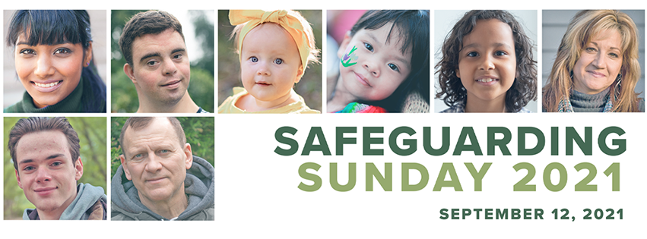
LOCKDOWN LIGHT—A WEEKLY SERIES
Lockdown Light—Week Two
Podcasts for Christian living: Unity in Marriage (Part 1)
In this podcast, Catholic counsellors, Dr Bob Schuchts and Jake Khym discuss how marriage is a union of two broken people, and yet when the love of God is invited in, unity is made possible. Listen at www.bit.ly/ChristianLiving2
Getting to know your Bible: Exploring the Gospels
As Christians, we have four accounts of the life of Jesus, called Gospels. How should we read them?
Getting started: This video by a Franciscan priest looks at how it’s possible to understand different Gospel accounts and stories about Jesus.
Watch at www.bit.ly/BibleGettingStarted2
Going deeper: This year, we are reading Mark’s Gospel at Mass. This video provides an introduction into the crafting and structure of the Gospel and the portrait of Jesus presented. View here www.bit.ly/BibleGoingDeeper2

JESUS ANSWERS HIS OWN QUESTION:
In response to Peter’s confession Jesus swears the disciples to silence, as if he does not wish to be known publicly as the Messiah. The traditional understanding of the title portrayed a spectacular figure who would accomplish victory over Israel’s oppressors by the use of military might, a conqueror who would never be touched by suffering or defeat. This understanding is a world away from Jesus’ understanding of his own role. The secret of his true identity will be revealed in his passion. The cross will uncover the truth of who he really is.

FOLLOW US ON FACEBOOK: St Pius X Catholic Parish
WEBPAGE: pol@cam.org.au/heidelbergwest

