St Pius X Catholic Parish Heidelberg West acknowledges the Wurundjeri people.

Fr Wayne Edwards: St Pius X Presbytery 419 Waterdale Rd Heidelberg West 3081

Tel: 9457 5794 Fax: 9457 1036 Email: heidelbergwest@cam.org.au

Exodus Community: 273 Liberty Parade Heidelberg West Tel: 9457 7593

School Principal: Barbara Gomez Tel: 9457 3776 Email: bgomez@spxhw.catholic.edu.au

_________________________________________________________________________________________________

MASS TIMES

Sundays Saturday Vigil 7pm Sunday 9am & 11.00am

Exodus Community, 12 Noon in the shed at 273 Liberty Pde, Heidelberg West

Weekdays 9am Tuesday, Wednesday, Thursday, Friday, Saturday

CONFESSIONS & ROSARY After 9am Mass on Saturday mornings

CHURCH OPEN FOR PRAYER 8.30am – 4pm on school days only

PARISH WEBSITE - pol.org.au/heidelbergwest

St Pius X Catholic Church Heidelberg West actively works to listen to, empower and protect children, and has zero tolerance for child abuse and neglect.
SAINTS/FEAST DAYS FOR THE WEEK
- Thursday 22nd - St Mary Magdalene
CHURCH IS CLOSED AS OF 11.59PM THURSDAY 15 JULY UNTIL 11.59PM TUESDAY 20 JULY

Reflection: “He said to them, “Come away by yourselves to a deserted place and rest a while.” MARK 6:31
Do you spend time, every day, alone and in silence listening to how God is calling you? If not, you are missing out on a wonderful opportunity to develop a more personal relationship with Him. Unless we talk and more importantly, listen to God every day, how else will we know how He is calling us? Consider making a retreat this year, spend some “alone” time with God.

Next Sunday 25th July
 | Reader
Saturday 7.00pm | Teresa Daws
Sunday 9.00am | Paul Quigley
Sunday 11.00am | Janice Tickner
NEXT SUNDAY’S READINGS – 17TH SUNDAY ORDINARY TIME
2 Kg 4:42-44; Eph 4:1-6; Jn 6:1-15

THANKSGIVING ENVELOPES – AVAILABLE IN FOYER
2021-2022 Thanksgiving envelopes are available for collection in the church foyer. PLEASE DISCARD ANY UNUSED ENVELOPES FROM THE PAST YEAR.
I urge those who are not part of our Thanksgiving program to consider regularly contributing to the upkeep and future needs and projects of St Pius X through financial stewardship and commitment.

COLLECTIONS LAST WEEKEND
Presbytery $ 344.00 | Loose $265.00 | Thanksgiving $970.00

ST VINCENT DE PAUL WINTER APPEAL
Inviting parishioners to donate non-perishable food items over the next few weeks. Your donations will be distributed to needy families by the local St Vincent De Paul Society conference. Winter woolies will also be accepted: scarves, socks, gloves, jumpers, blankets. Please place items in basket at foot of sanctuary; the basket will remain there throughout winter.

MARY MACKILLOP HERITAGE CENTRE OPEN DAY
Celebrating St Mary Mackillop’s Feast Day, Saturday 7th August 10.00am – 4.00pm, 362 Albert St, East Melbourne.
Pray in the Chapel, Museum Tour, Mass in the Chapel, Walking tours, Virtual tours and much more. Refer to www.mmhc.org.au for more information or the poster in the Church foyer.

PROPOGATION OF THE FAITH COLLECTION
Next week Catholic Mission will invite you to partner with Sister Chalaad and the Good Shepherd Sisters in Thailand as they reach out to vulnerable mothers, like Churai*, and their babies, who would have nowhere to turn when they need support, love and kindness the most. Please come with an open and generous heart. Free call: 1800 257 296 or www.catholicmission.org.au/thailand 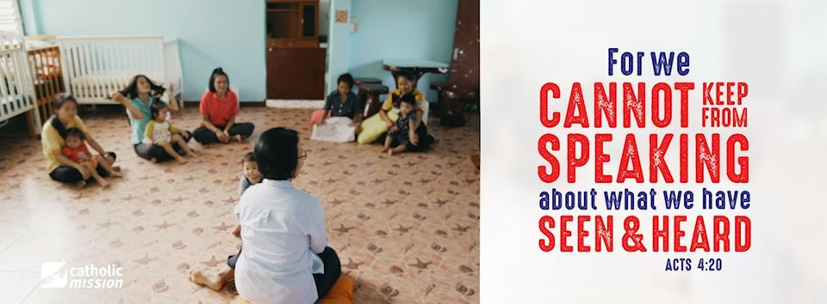

Prayers for the Sick; David Tickner, Will Anderson, Pauline Curlis, Paul Constance, Helen Owens, Michael Hehir, Barbara Coyne
For the Recently Departed: For the repose of the souls of the faithful departed
Anniversary of Death: Denise Catherine, Joe Fenech, Benjamin Hennequin, Therese Vellin, Auteline Hennequin, Gisele Hennequin, Luisa Lione, Patricia Gannan, Mario Fossella, Silvana Fossella, Francesco Fossella

SAFEGUARDING CHILDREN AND YOUNG PEOPLE
Refer to our Parish Website for all Safeguarding Children & Young People information & Resources: pol.org.au/heidelbergwest

