St Pius X Catholic Parish Heidelberg West acknowledges the Wurundjeri people.

Fr Wayne Edwards: St Pius X Presbytery 419 Waterdale Rd Heidelberg West 3081

Tel: 9457 5794 Fax: 9457 1036 Email: heidelbergwest@cam.org.au

Exodus Community: 273 Liberty Parade Heidelberg West Tel: 9457 7593

School Principal: Barbara Gomez Tel: 9457 3776 Email: bgomez@spxhw.catholic.edu.au

_________________________________________________________________________________________________

MASS TIMES

Sundays Saturday Vigil 7pm Sunday 9am & 11.00am

Exodus Community, 12 Noon in the shed at 273 Liberty Pde, Heidelberg West

Weekdays 9am Tuesday, Wednesday, Thursday, Friday, Saturday

CONFESSIONS & ROSARY After 9am Mass on Saturday mornings

CHURCH OPEN FOR PRAYER 8.30am – 4pm on school days only

PARISH WEBSITE - pol.org.au/heidelbergwest

St Pius X Catholic Church Heidelberg West actively works to listen to, empower and protect children, and has zero tolerance for child abuse and neglect.
SAINTS/FEAST DAYS FOR THE WEEK
- Monday 27 – St Vincent De Paul
- Wednesday 29 – Sts Michael, Gabriel, Raphael
- Thursday 30 – St Jerome
- Friday 1 – St Therese of the Child Jesus
- Saturday 2 – The Holy Guardian Angels

Reflection: “Anyone who gives you a cup of water to drink because you belong to Christ, amen, I say to you, will surely not lose his reward.” (Mark 9:41)
We are made in God’s image and likeness. We tend to forget this. When you look at others, do you see the face of Jesus in them? When others look at you, do they see the face of Jesus in you? When we realize that all lives matter to God, then gratitude and generosity become easier. Why? Because that’s the way we are made! We are one Body of Christ; when one of us is hurting, all of us feel the pain.

Prayers for the Sick; David Tickner, Michael Hehir, Pauline Curlis, Joy Opie
For the Recently Departed: Margaret McCutcheon
Anniversary of Death: Remo Quinzi, Henri Hennequin,

NEXT SUNDAY’S READINGS – 27TH SUNDAY ORDINARY TIME
Gen 2: 18-24; Heb 2: 9-11; Mk 10: 2-16

DAILY MASS
Live streamed daily Mass from St Patricks Cathedral Melbourne - https://melbournecatholic.org/about/our-cathedral
Masses are livestreamed daily on the Archdiocese YouTube Channel https://www.youtube.com/archmelb
On Sunday’s 11am Mass is available to view on free-to-air TV channel 31 or channel 44 on digital TV’S

NATIONAL DAY FOR MIGRANTS AND REFUGEES
Catholics across the country are being urged to consider how they can pray for and offer practical support to neighbours around the world as the Church marks the World Day of Migrants and Refugees on Sunday 26 September.

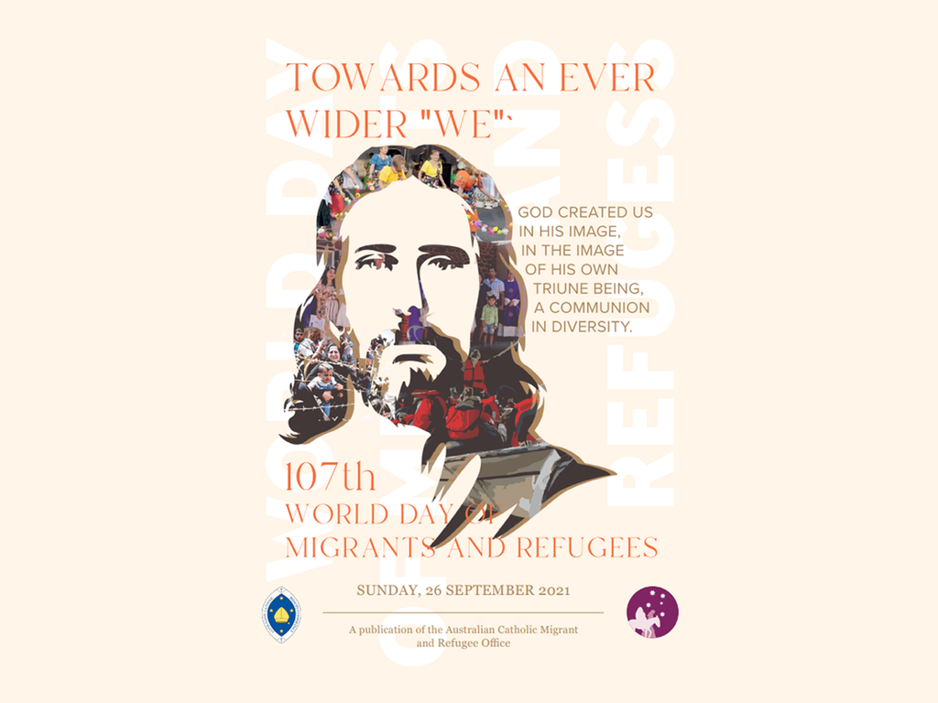

LOCKDOWN LIGHT—A WEEKLY SERIES
Lockdown Light—Week Four
Praying with Scripture – How can we use the Bible in our prayer?
Getting Started: In this short video: http://www.bit.ly/BibleGettingStarted4
Fr James Martin SJ introduces us Lectio Divina—a way of praying with the Bible that helps us listen to God.
Going Deeper: Pray as You Go is an online prayer tool: http://www.bit.ly/BibleGoingDeeper4 that provides a guided contemplation of each day’s Gospel passage. Set aside 10-15 minutes, find a comfy space and listen.
Parents of the Saints: How did they do it?
In this podcast: http://www.bit.ly/ChristianLiving4 Jason Evert speaks with author Patrick O’Hearn about his new book ‘Parents of the Saints: The Hidden Heroes behind Our Favourite Saints’. Patrick answers questions including: how did the parents of ‘wayward’ saints break through to them? What did their prayer life and family routine look like? How did the parents of saints embrace suffering to the

FOLLOW US ON FACEBOOK: St Pius X Catholic Parish
WEBPAGE: pol@cam.org.au/heidelbergwest

