St Pius X Catholic Parish Heidelberg West acknowledges the Wurundjeri people.

Fr Wayne Edwards: St Pius X Presbytery 419 Waterdale Rd Heidelberg West 3081

Tel: 9457 5794 Fax: 9457 1036 Email: heidelbergwest@cam.org.au

Exodus Community: 273 Liberty Parade Heidelberg West Tel: 9457 7593

School Principal: Barbara Gomez Tel: 9457 3776 Email: bgomez@spxhw.catholic.edu.au

_________________________________________________________________________________________________

MASS TIMES

Sundays Saturday Vigil 7pm Sunday 9am & 11.00am

Exodus Community, 12 Noon in the shed at 273 Liberty Pde, Heidelberg West

Weekdays 9am Tuesday, Wednesday, Thursday, Friday, Saturday

CONFESSIONS & ROSARY After 9am Mass on Saturday mornings

CHURCH OPEN FOR PRAYER 8.30am – 4pm on school days only

PARISH WEBSITE - pol.org.au/heidelbergwest

St Pius X Catholic Church Heidelberg West actively works to listen to, empower and protect children, and has zero tolerance for child abuse and neglect.

PLEASE LOOK AFTER YOUR CHILDREN WHILE MASS IS IN PROGRESS
SAINTS/FEAST DAYS FOR THE WEEK
- Monday 28 – St Augustine
- Tuesday 29 – The Passion of St John the Baptist

Reflection “Or who has given the Lord anything that he may be repaid?”-Romans 11:35
St. Paul reminds us of a central fact of stewardship. We cannot give God anything - He already owns it all. God made everything, including us. Since we are made in His image, we too, are called to be generous. How we use our God-given gifts becomes our gift back to Him. Gratitude for all we have been given opens our hearts to joyful generosity! And, through our generosity, we just may be the answer to someone else’s prayer.

Next Sunday: September 3
 | Reader | Special Ministers
Saturday 7:00pm | Phoebe Davies
Sunday 9:00am | Paul Quigley
Sunday 11:00am | Felicity Paolucci
NEXT SUNDAY’S READING – 22ND SUNDAY IN ORDINARY TIME
Jer 20:7-9: Ps 62:2-6, 8-9: Rom 12:1-2: Mt 16:21-27

ST VINCENT DE PAUL WINTER APPEAL
Inviting parishioners to donate non-perishable food items over the coming weeks. Your donations will be distributed to needy families by the local St Vincent De Paul Society conference. Winter woolies will also be accepted: scarves, socks, gloves, jumpers, blankets. Please place items in basket at foot of sanctuary.
PRIESTS RETIREMENT FOUNDATION COLLECTION
Next Sunday 3rd September is Father’s Day and at all Masses next weekend there will be a special collection to support our retired priests.

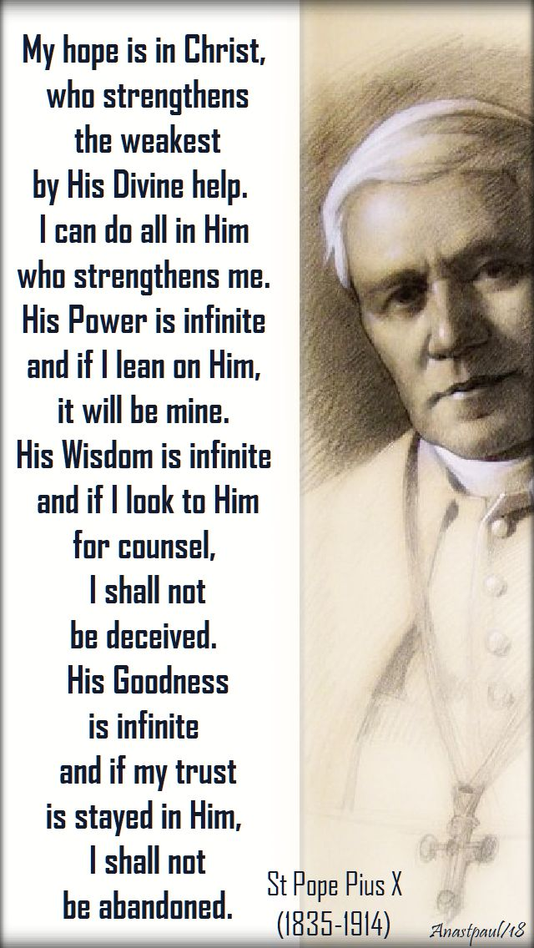
SENIORS GET TOGETHER – SEPTEMBER
All seniors (over 55) are more than welcome to join us at our monthly gatherings. Join us on Wednesday 20th September for a road trip to the Melbourne Botanical Gardens. Seats on the bus are limited so please book yours by calling the Parish office 9457 5794. All Welcome!
MARY MACKILLOP AUSTRALIAN PILGRIMAGE 17/10 /23 - 28/10/2023
The Sisters of Saint Joseph have prepared an Australian Pilgrimage, “In the Footsteps of Mary MacKillop” commencing in Melbourne on 17 October 23, journeying through Victoria and South Australia, and ending at Mary MacKillop Place, North Sydney on 28 October 2023. During the pilgrimage we visit many places associated with Mary MacKillop’s life and ministry. For more information call 8912 4818 or national.pilgrimage@mmp.org.au

SOCIAL JUSTICE SUNDAY
This Sunday is Social Justice Sunday and the title of the Social Justice Statement for 2023-24 is Listen, Learn, Love: A new engagement with Aboriginal and Torres Strait Islander Peoples. It includes experiences and views shared by the National Aboriginal and Torres Strait Islander Catholic Council (NATSICC) and calls for the Church – and society more widely – to listen to, engage and address the pain of First Nations Peoples in new ways, in order to bring an end to centuries of injustice. Copies of this year’s statement are available in the church foyer.

Prayers for the Sick: Hannah Steane
For the recently departed: For the repose of the souls of the faithful departed
Anniversary of Death: Riccardo Calati

