St Pius X Catholic Parish Heidelberg West acknowledges the Wurundjeri people.

Fr Wayne Edwards: St Pius X Presbytery 419 Waterdale Rd Heidelberg West 3081

Tel: 9457 5794 Fax: 9457 1036 Email: heidelbergwest@cam.org.au

Exodus Community: 273 Liberty Parade Heidelberg West Tel: 9457 7593

School Principal: Barbara Gomez Tel: 9457 3776 Email: bgomez@spxhw.catholic.edu.au

_________________________________________________________________________________________________

MASS TIMES

Sundays Saturday Vigil 7pm Sunday 9am & 11.00am

Exodus Community, 12 Noon in the shed at 273 Liberty Pde, Heidelberg West

Weekdays 9am Tuesday, Wednesday, Thursday, Friday, Saturday

CONFESSIONS & ROSARY After 9am Mass on Saturday mornings

CHURCH OPEN FOR PRAYER 8.30am – 4pm on school days only

PARISH WEBSITE - pol.org.au/heidelbergwest

St Pius X Catholic Church Heidelberg West actively works to listen to, empower and protect children, and has zero tolerance for child abuse and neglect.
SAINTS/FEAST DAYS FOR THE WEEK
- Wednesday 8- The Nativity of the Blessed Virgin Mary

Reflection: “Did not God choose those who are poor in the world to be rich in faith and heirs of the kingdom that he promised to those who love him?”
(James 2:5)
What is more important – being rich in faith or rich in possessions? Society tells us that possessions are most important. God teaches a different lesson. When we are rich in faith, we keep God first and experience true joy and peace. When we put possessions first, we soon realize we can never have enough and happiness is fleeting. When we put faith over possessions we truly realize it is better to give than receive.

'TREASURING OUR LATER YEARS'- Reflection series via ZOOM
6 x Wednesdays, 22 September to 27 October 2021, 12.45pm-3pm.
Facilitated by Nicole Rotaru rsm, this series offers participants the opportunity to explore new possibilities that ageing offers daily. It will include input, conversation and the opportunity to depth and integrate reflections and learnings through personal reflection and creative expressions. Topics covered include: ageing; spirituality; relationships; meaning; gratitude; death. Cost $180 for the series, or $30 per session. Bookings: Heart of Life Centre for Spiritual & Pastoral Formation website at www.heartoflife.melbourne
For more information, contact. secretary@heartoflife.melbourne or (03) 9890 1101

FATHERS DAY APPEAL
This weekend is the annual Priests Retirement Foundation appeal.
Donations can be made at the website is www.cam.org.au/foundation

AS A REFLECTION ON THE GOSPEL AND THE PARALYMPICS IN TOKYO
A handicapped person observed ‘Living as a cripple allows you to see more clearly the crippled hearts of some people whose bodies are whole and sound’.

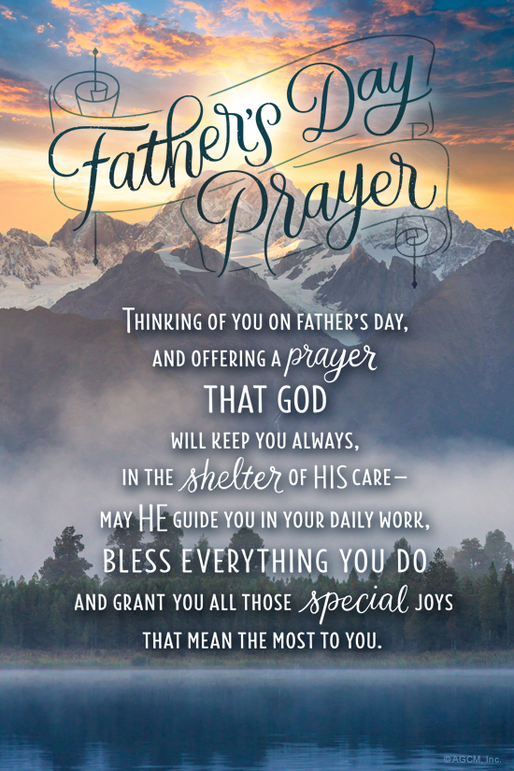
Dear Parishioners:
We are very aware of the enormous impact these past few weeks of lockdown have had on many of us. We pray that you are able to be creative, continue to pray and to support each other and your families during these times. As a parish we offer pastoral visits to the ill and most vulnerable and 'Hello R U OK' phone calls to those who would like to have a friendly chat. We realise that each of us is important and deserving of support during these difficult times. To have Fr Wayne pay you or your loved one a pastoral visit or to receive a 'Hello, R U OK' phone call please leave your name and number at the Parish House on 9457 5794. We pray that we will soon be able to gather together as a community for Mass in the not too distant future. In the meantime stay safe and well. Kind Regards Fr Wayne

Prayers for the Sick; David Tickner, Michael Hehir, Pauline Curlis, Joy Opie
For the Recently Departed: Francis Xavier Djoko Soebidjo
Anniversary of Death: Elise Mc Gorlick, Christine Mc Gorlick, Sr Jacqueline Bender, Sebastino Di Benedetto, Evelyn Street, Maria Di Benedetto, Vera Bevilacqua, Felix Scicluna

NEXT SUNDAY’S READINGS – 24TH SUNDAY ORDINARY TIME
Is 50: 5-9; James 2: 14-18; Mk 8: 27-3

LOCKDOWN LIGHT—A WEEKLY SERIES
A weekly series bringing ‘light’ to this time of lockdown …
Well and truly done with sourdough starters? Not interested in another DIY project? To help fill the void during lockdown, each week we’ll suggest some inspiring content to bring ‘light’ to this difficult time. Pop on the kettle and check out the recommendations at www.bit.ly/LockdownLight

