All aboard!
No.31 Spring 2022
All us Catholics on board together
A quarterly Newsletter of encouragement for all Catholics in the parish of Saint Pius X, Heidelberg West

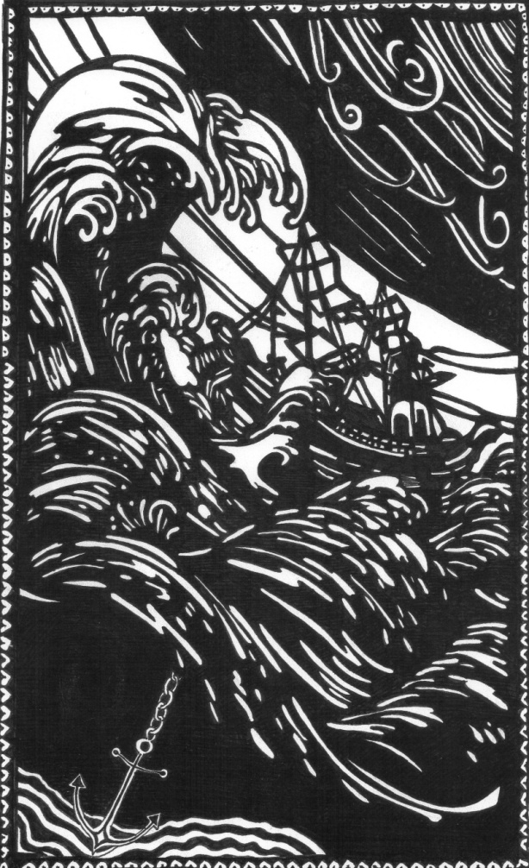
Surprise local Heidelberg West artist!

While delivering copies of All Aboard to the addresses in Heidelberg West and Heidelberg Heights, I occasionally found that the former parishioner no longer lived there. On one occasion the residence was that of a local artist and professional landscape designer and we had a great yarn together.
She gave me a copy of the accompanying lino cut of a grand old galleon struggling in a tremendous storm.
I told her that I had chosen the image of a galleon as the “Barque of Peter” as the masthead for our Newsletter.
Her image shows the ship almost swamped by the sea. But you will notice, too, in the bottom left corner an anchor.
There would be some people who might say the Catholic Church has been experiencing unprecedented turbulence in recent years. But if we think that JESUS is the anchor, we will survive and eventually come safely into port.
And in our personal lives, too. If we are tossed about severely by heartbreak and disappointment or ill-health or bereavement, then we must look to the anchor to hold on to and not go under. It would be great if this anchor was JESUS, and that we were in close touch with Him in prayer at these dark and stormy times. – Br. Barry
++++++++++++++++++++++++++++++++++++++
What’s Dolly Parton doing in a Catholic Newsletter?
Some of the younger generation may not know of the fame of Dolly Parton. And those who know of her fame will know what she is famous for. But why she is here on the front page of All Aboard is because of a particular philosophy that she says she lives by. She says:
“I wake up every day expecting it to be good, and if it’s not I set about trying to get it fixed. I try to live every day like it might be my last. I don’t want to have to wake up, face God and say, ‘Well, duh, I should have tried.’”
(She is pretty well-known for her enormous philanthropic work, too.)

Oooooooooooooooooooooooooooooooooooooooooooooooooooooooooooooooooooo
The driver was stopped by a policeman for driving without a tail-light. He became quite distressed. “Don’t take it so hard,” consoled the officer. “It’s only a minor offence.”
“That’s not it,” cried the driver. “What worries me is what happened to my boat and trailer?”

xxxxxxxxxxxxxxxxxxxxxxxxxxxxxxxxxxxxxxxxxxxxxxxxxxxxxxxxxxxxxxxxxxxxxxxxxxxxxxxxxxxxxxxxxxxxxxxxx

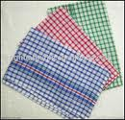
Meditation on the teatowel
Useful and humble might well describe the modest teatowel. Unsophisticated, the teatowel lives out its life with few or no accessories like embroidery or tassels.

It never needs to be told: “Make yourself useful.” ... It just always is. It remains true to its nature till worn thin with constant work and age it is laid aside to be replaced by a stronger, fresh, full-bodied towel.

The teatowel is one of the original practitioners of multitasking. Drying crockery and cutlery, while its forte, is not its only function. Insulation for lifting hot trays from the oven is no more difficult for the teatowel than soaking up moisture in the fridge door that has mysteriously wetted the bottoms of the milk and tomato sauce bottles. Grasped around tight bottle and jar lids it can be a “catalyst” to removing them – not doing the job itself but helping in a self-effacing way, only to be immediately tossed aside with neary a thank-you.

Covering warm scones is another useful function the teatowel is readily (and willingly) pressed into as well as being crammed between rattling bottles in a box in the boot of the car.

And while not made for the purpose it is uncomplaining when used to dry hands and fingers. Indeed it has been known to agree to wipe a little excess gravy from the edge of a plate to allow the presentation of a meal to be just that little bit neater and presentable.

Rare is the recourse by the Teatowel Union to a demarcation dispute.

The teatowel in modern times has, too, become a shining example of multiculturalism. While the red check and blue check patterns are truly international there are also regional or particular identities within the Broad Church of the teatowel community. While there might be scenes from the different Counties of Ireland or the islands of Greece there are also Calendars of the year decorated with fish and shells. There are recipies for Crocodile Stew or explanations of why only you and I are actually working and you’re not really pulling your weight. There are also mementos of Royal or Papal visits. All sit together happily on the same rack, sometimes this one with that and at another time swapping companions with no thought of colour, creed, or “state of origin”.

Ageism, too, has no place in teatowel life or custom. A new, sturdy, fluffy towel can be bosom companion with a weak and almost threadbare friend for months if not years.

And so the teatowel is an example to all of us: always available, ready to take on a variety of tasks and at ease in the company of different types and ages.

It’s not in the teatowel’s nature to reflect on its importance in the scheme of things and it’s place in the universe. But were it to do so it might reflect on the adage that the importance of a person in an organization can be judged by how much they are missed when they are not there. And on that criteria the teatowel scores very well. It is almost unimaginable to conceive of working in a kitchen without a teatowel.

But just as monks of old kept a skull on their desk to remind them of death and to keep things in perspective, the teatowel might be mindful that in another drawer somewhere in the house is a collection of rags … including teatowels that have exceeded their use-by dates. A sobering thought for many a teatowel.

So next when you or I see or use a teatowel let’s learn from its mute eloquence some of the mysteries of the quiet yet diligent life and try to put them into practice.

#####################################################################################
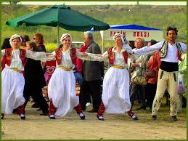
Anatolian Festival (Coburg) Each year there is a celebration of the cultures of Anatolian Alevis “Promoting love, unity and peace among human beings.” A flyer a couple of years ago promoting the festival stated: “The essence of our philosophy is that everything is done to live, share and sustain this loving path of humanism. It is love of life and living, based on tolerance, peace and sharing. Loving everything in the universe, loving people, loving life and being compassionate is at the very heart of our philosophy.”
We Catholics might be encouraged to learn of such high ideas amongst other groups.
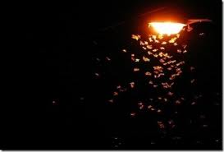
Why moths seek the light
There is a little known legend as to why moths always fly into a light. It goes back to when Jesus was born in Bethlehem in the stable. The story goes that a particular moth was out one night flying here and there when he saw a bright golden light coming from a humble farmer’s shed. Curious, the moth fluttered over to have a look. Getting closer he was able to see inside and saw a newly-born baby that seemed to glow with a delightful dazzling light. Excitedly he wanted to tell his family of moths so that they could come and enjoy this amazing sight, and he flew off as fast as he could to tell them. “Come quickly,” he told them, “There’s an amazing thing to see! There’s a baby child and it’s surrounded by this amazing light. It’s very lovely. You must see it!” So the excited moth headed off followed by the others and they fluttered up and down the streets and alleys of Bethlehem, but couldn’t find the way to the brightly lit scene of a human birth that had been reported. And the legend goes that since that time, moths have continued to look for the place where Jesus was being born by checking out every possible light.
……………………………………………………………………………………………………………………………………………………………………………………
GUIDE FOR TROUBLES
We cannot choose our challenges,
For most times they choose us.
We cannot pick the easy ones
That cause no fret or fuss.
And sometimes we meet troubles
That seem to overwhelm;
We feel adrift in stormy seas,
No hand upon the helm.
Yet somewhere in the darkness
A steady light shines clear,
To warn us of the danger,
To show which way to steer.
So though we may feel helpless,
And small and weak inside,
Remember, just by asking,
We’ll always find a Guide.

Attributed to St Francis
Lord, make me an instrument of your peace.
Where there is hatred, let me sow love;
Where there is injury, pardon’
Where there is doubt, faith;
Where there is despair, hope;
Where there is darkness, light;
Where there is sadness, joy.

O Divine Master, grant me that I may not so
much seek to be consoled, as to console;
Nor so much to be understood as to understand;
not so much to be loved as to love.
For it is in giving that we receive; it is in pardoning that
we are pardoned; it is dying that we awake to eternal life.
Oooooooooooooooooooooooooooooooooooooooooooooooooooooo

For all you gardeners … some thoughtful quotes

“If you would be happy all your life – plant a garden.”

“The best place to find God is in a garden. You can dig for him there.” -- George Bernard Shaw

“Let your prayers for a good crop be short – and your hoeing be long.” -- Albanian proverb

“The vineyard does not require prayers, but a hoe.”
“Harvest comes not every day, though it comes every year.”

“He that hath a good harvest may be content with some thistles.”

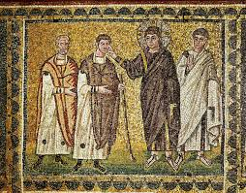
Real blindness or symbolic blindness?
As we read this part of Chapter 20 of St. Matthew’s Gospel we might think whether we might ask Jesus to heal us from blindness!

“As they left Jericho a large crowd followed him.
And now there were two blind men sitting at the side of the road. When they heard that it was Jesus who was passing by, they shouted, 'Lord! Have pity on us, son of David.'
And the crowd scolded them and told them to keep quiet, but they only shouted the louder, 'Lord! Have pity on us, son of David.' Jesus stopped, called them over and said, 'What do you want me to do for you?' They said to him, 'Lord, let us have our sight back.' Jesus felt pity for them and touched their eyes, and at once their sight returned and they followed him.”

[What am I blind to? The goodness of others? An addiction that I have? A fault that I don’t want to admit? And maybe a good aspect of my character that I play down and don’t give myself enough credit for?]
………………………………………………………………………………………………………………………………………………………………………………

Thought-provoking remarks from Father De Mello
(He’s talking about “enlightenment”! … Very interesting!)

“I chop wood!”
When the Zen Master attained Enlightenment he wrote the following lines to celebrate it:
“Oh wonderous marvel: I chop wood! I draw water from the well!”

After enlightenment nothing really changes. The tree is still a tree; people are just what they were before; and so are you. You may continue to be moody or even-tempered, as wise or foolish. The one difference is that you see things with a different eye. You are more detatched from it all now. And your heart is full of wonder.

That is the essence of Contemplation: the Sense of Wonder.

Contemplation is different from ecstasy in that ecstasy leads to withdrawal. The enlightened contemplative continues to chop wood and draw water from the well. Contemplation is different from the perception of beauty in that the perception of beauty (a painting or a sunset) produces aesthetic delight, whereas contemplation produces wonder – no matter what it observes, a sunset or a stone.

That is the prerogative of children. They are often in a state of wonder. So they easily slip into the Kingdom.

Contacts: St Pius X Catholic Parish Heidelberg West
Father Wayne Edwards: St Pius X Presbytery 419 Waterdale Rd., Heidelberg West 3081
Tel: 9457 5794; Email: stpiusvic@bigpond.com

Exodus Community: 273 Liberty Parade, Heidelberg West, Tel: 9457 7593
School Principal: Barbara Gomez, Tel: 9457 3776 principal@spheidelbergwest.catholic.edu.au
Mass times: Saturday evening Vigil – 7.00pm; Sunday: 9.00am & 11,00 am, (12 noon, Exodus community, 273 Liberty Parade).
Weekdays: 9.00am Tuesday, Wednesday, Thursday, Friday and Saturday
Confessions and Rosary: After 9.00am Mass Saturday mornings
Church open for prayer: 8.30am – 4.00pm on school days only
Taize Prayer: Last Friday of the Month, 6.00-7.00pm
All Aboard editor/compiler: Brother Barry Lamb at barrylamb@hotmail.com or 9456 9641

