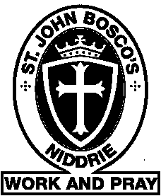
St John Bosco’s Parish Hall - Booking Form
Event Details
Type of event: | Number of people attending:
Date of event:
Start time: | Finish time:

Event organiser
Name:
Address:
Contact Number:
Email Address:
Are you a parishioner at SJB? Yes/No
Fees and charges
The hall fee is $100 per hour with a maximum of 5 hours.
Deposit of 20% of the fee and $100 bond must be paid to secure your booking date and time.
Hire agreement conditions –
- The hirer is required to return the room to its original set up after event.
- The hirer is required to ensure the room is left clean and tidy or the bond maybe kept for cleaning charge.
- The hirer is liable for any repair or damage, or replacement of equipment caused during the event.
- The hirer must ensure that guest do not enter the school grounds, except for children to play on playground (only during daylight hours). Children must be always supervised by an adult/s. In the event of any damage to school property, the hirer will be liable for clean/repair costs.
- In the event of your event finishing past 9:30pm, please be mindful of noise for neighbours particularly as guests leave the venue.
- Notification of cancellation of event less then 48hours prior will mean a loss of deposit. Bond will be reimbursed.
Name : Date:

Signed:

Office use
Notes:

