HOLY WEEK – HOLY THURSDAY

“Jesus surrenders to His Passion
The Last Super...
The Washing of Feet...”
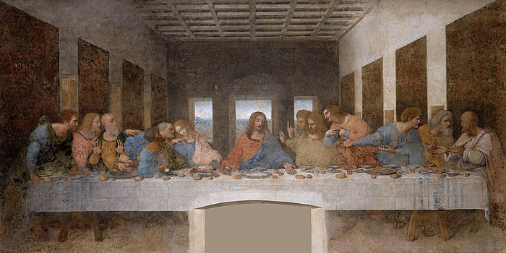

Biblical Readings:
- Philippians 2: 1-4
- Hebrew 5: 7-9
- Luke 22: 1-13
- Luke 22: 14-20
- John 13: 1-20
- Psalm 55

Today is the Feast of Unleavened Bread, the day for sacrificing the Passover Lamb. I, in spirit, am in the guest-room with Jesus and his disciples. I look at Jesus’ face. He seems to be a bit tense and sad. He knows his earthly life is coming to an end. Therefore, with an act of deep love to his disciples who are so dear to him, he says: “I have eagerly desired to eat this Passover with you before I suffer; for I tell you, I will not eat it until it is fulfilled in the kingdom of God.” (Lk 22: 15-16). What deep love is in the heart of Jesus!

After these words, he establishes the Sacrament of the Eucharist in which he transforms the Bread and the Wine into his Body and his Blood so as to be with his disciples and the whole world. How holy and sacred is the moment when he gives up himself for his disciples and the world!

After the Supper, in an act of humility, he kneels down to wash the disciples’ feet and dries them with the towel around his waist. How humble is this act of love!

Asking for a Grace:

Lord Jesus,
What can I say now?
I witnessed everything and I know one thing that you deeply love your disciples whom you chose.

Because of that, through your act of love and humility,
you taught them how to love and to be humble;
you let them know one important thing, that it is only love and humility that can bring humanity close to God and which can win the heart of humanity.

Lord, once again, grant that I may live my life with a deep love and humility in the way you did. Amen.
