21st Sunday in Ordinary Time
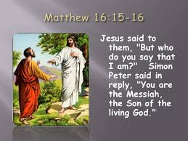

1st Reading: Isaiah 22:19-23
Thus says the Lord to Shebna, the master of the palace: “I will thrust you from your office, and you will be pulled down from your post. On that day I will call my servant Eliakim son of Hilkiah, and will clothe him with your robe and bind your sash on him. I will commit your authority to his hand, and he shall be a father to the inhabitants of Jerusalem and to the house of Judah. I will place on his shoulder the key of the house of David; he shall open, and no one shall shut; he shall shut, and no one shall open. I will fasten him like a peg in a secure place, and he will become a throne of honour to his ancestral house.

Responsorial: Psalm 137:1-3, 6, 8
Response: Lord, your love is eternal; do not forsake the work of your hands.
I thank you, Lord, with all my heart,
you have heard the words of my mouth.
Before the angels I will bless you,
I will adore before your holy temple. Resp:
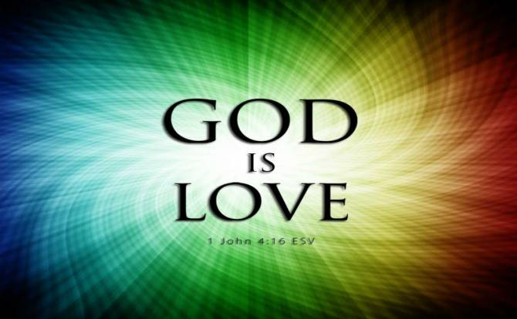
I thank you for your faithfulness and love
which excel all we ever knew of you.
On the day I called, you answered;
you increased the strength of my soul. Resp:
The Lord is high yet he looks on the lowly
and the haughty he knows from afar.
Your love, O Lord, is eternal,
discard not the work of your hands. Resp:

2nd Reading: Romans 11:33-36
O the depth of the riches and wisdom and knowledge of God! How unsearchable are his judgments and how inscrutable his ways! “For who has known the mind of the Lord? Or who has been his counsellor?” “Or who has given a gift to him, to receive a gift in return?” For from him and through him and to him are all things. To him be the glory forever. Amen.

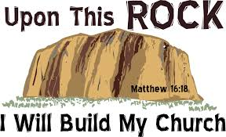
Gospel Acclamation:
Alleluia, Alleluia!
You are Peter, the rock on which I will build my Church
The gates of hell will not hold against it.

Alleluia!

Gospel: Matthew 16:13-20
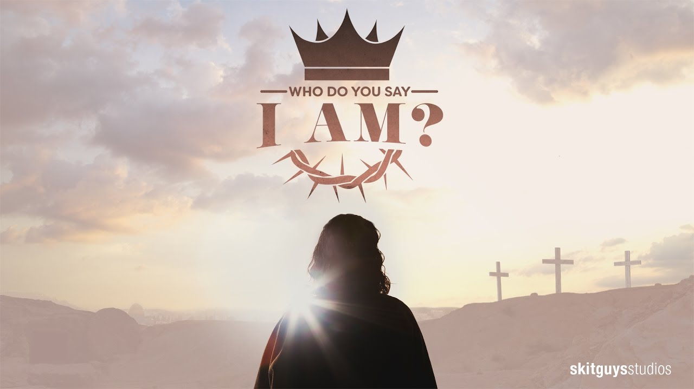

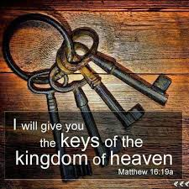
Now when Jesus came into the district of Caesarea Philippi, he asked his disciples, “Who do people say that the Son of Man is?” And they said, “Some say John the Baptist, but others Elijah, and still others Jeremiah or one of the prophets.” He said to them, “But who do you say that I am?” Simon Peter answered, “You are the Messiah, the Son of the living God.” And Jesus answered him, “Blessed are you, Simon son of Jonah! For flesh and blood has not revealed this to you, but my Father in heaven. And I tell you, you are Peter, and on this rock I will build my church, and the gates of Hades will not prevail against it. I will give you the keys of the kingdom of heaven, and whatever you bind on earth will be bound in heaven, and whatever you loose on earth will be loosed in heaven.” Then he sternly ordered the disciples not to tell anyone that he was the Messiah.
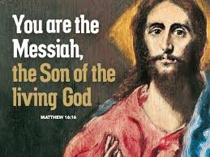

REFLECTIONS:
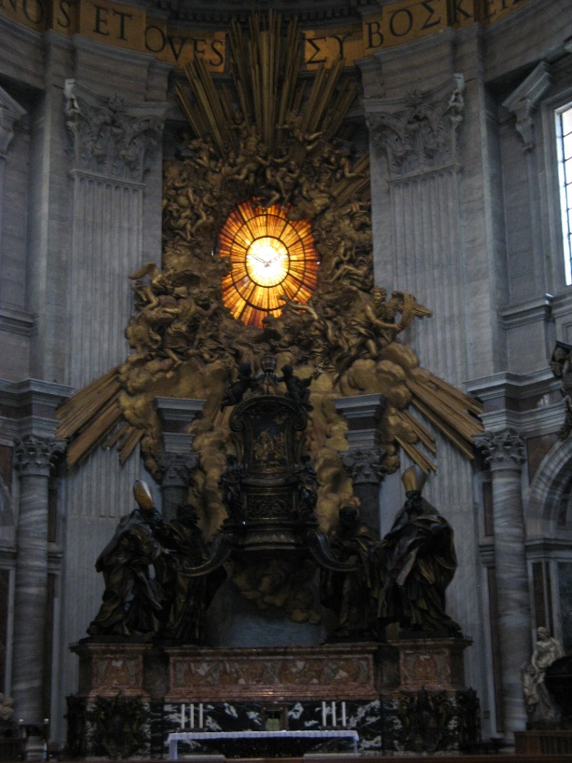
Above the sanctuary of Saint Peter’s basilica in Rome, written in huge lettering of gold mosaic, is this promise of Jesus to his chief apostle: “Thou art Peter, and upon this rock I will build my church. I will give to you the keys of the kingdom of heaven.” These words are held by Catholics as the basis for the papacy, applying to the bishop of Rome as the successor to Peter, to be the chief spokesman for the church’s living faith, and wielder of the spiritual power of the keys.
We must not be too simplistic in how we apply those words to the original Peter and even more so to his successors. Non-catholic Christians, our brothers and sisters in the Protestant churches, do not accept that there could be any succession, in the full sense, to the position held by Saint Peter. They find any claims to juridical and absolute authority for the papacy, under titles like “apostolic jurisdiction” or “the power of the keys” to be out of harmony with the Gospel message. They interpret differently what today’s Gospel means for leadership in the Church. We need not insist that the Roman way is the only way of taking Christ’s words. Still, this Gospel deserves close attention for what it says about faith, enlightenment and leadership, and guidance for our own lives.
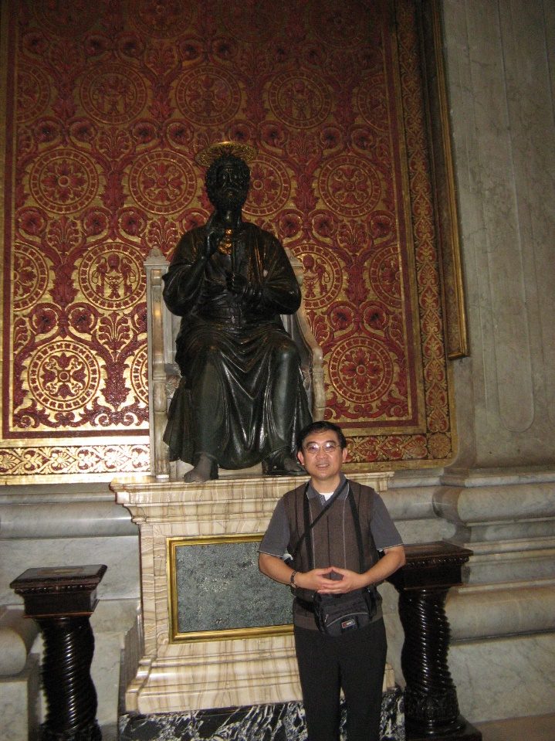
Each must make a personal answer to Our Lord’s question: “Who do you say that I am?’ although Peter’s credo is a solid basis from which to begin. Notice the beautiful phrase: “Son of the Living God,” expressing more richly what “Christ” means. Peter’s worshipful faith comes to him as gift from above, not from any mere logic or ingenuity. Why was the blessing given to him in particular? Perhaps because his humble and contrite spirit made him best prepared to receive it? Or because God chooses whom He wills, irrespective of their merits? It is to this Peter that Jesus entrusts whatever is meant by the keys of the Kingdom of Heaven. Upon his solid, dedicated faith the Church will always rely, for unity and encouragement. Keys are mainly for opening; many doors lock by themselves. We could reflect further on Peter’s task, as seen in other Gospel passages (Mat. 14:28ff; 17:24ff; Lk. 22:32; Jn. 21:15-17), and in the Acts (1:1 5ff, 2: 14ff; 3:1 2ff).
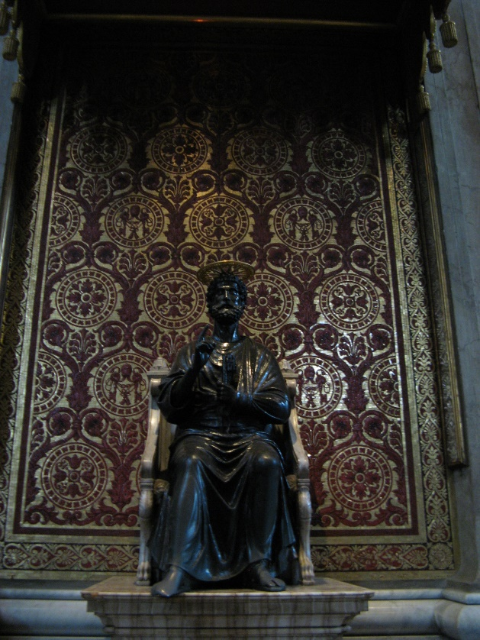
While he is appointed to “feed the lambs and sheep” of Christ, to “confirm his brothers and sisters,” and welcome the first pagan convert into the Church, Peter is no plaster saint. Weakness of faith (when he began to sink), rash self-confidence and eventual denial are also portrayed by him. But these serve only to underline the grandeur of his conversion, when with a new clarity of self-knowledge he turns and says to Jesus: “You know that I love you.” The task is not one of stern domination, or merely of the efficient organisation of Christ’s Church. Pastor and penitent at once, convert and the support for other converted sinners, he leads the faithful by witness and example. This pastoral understanding of authority finds a lovely echo in the first epistle of Peter. Elders or leaders are asked to “tend the flock of God, not as domineering over those in your charge, but being examples to the flock” (5:13.) Just so, Peter tended the early church by sharing his deep faith in Christ the Risen Lord. So, he kept them united in a community of mutual love, and in faithful obedience to the Gospel. Such an ideal situation of harmony in the Church is briefly sketched for us in the Acts (2:42ff; 4:32f.)
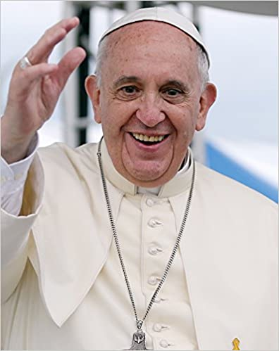
What of today’s Church, spread in all continents, united under the leadership of pope Francis? How can this work of teaching, encouraging and uniting so many millions of baptised believers be carried on? Jesus remains at the centre, as the Christ, Son of the Living God, and he continues to be the Church’s true Rock. We today, just as much as in the time of St Peter, need the ministry of faithful apostles, entrusted by Christ to build up his people, witness to the faith, and provide leadership in Christian love. Pope, bishops, priests and other ministries exist in order to serve. But in some sense, we get the service that we deserve. It is for us to make known to our pastors both our appreciation and our loyal criticisms; especially to pray for them, for their courage and perseverance. Today we particularly remember the present successor of Peter, our Pope; that God may establish him in faith and wisdom; that being strong in himself, he may confirm the brethren; and that as Chief Shepherd he may help us on our way to the Kingdom.
