27th Sunday in Ordinary Time
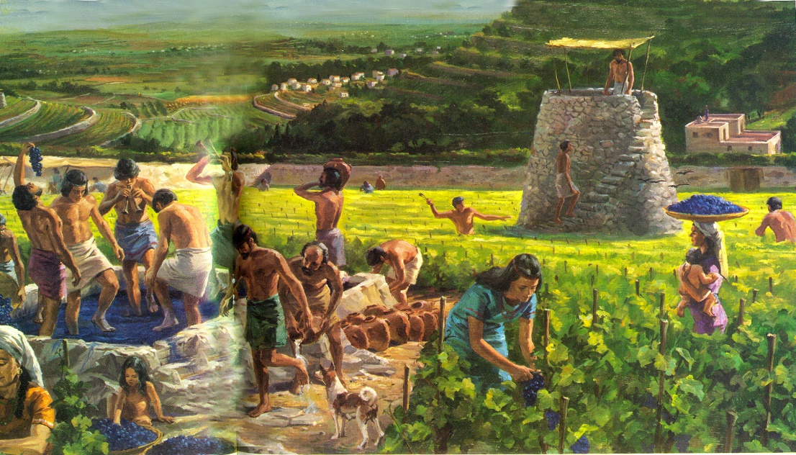

1st Reading: Isaiah 5:1-7
Israel is the vineyard God has tended. It is expected to bear fruits of holiness
Let me sing for my beloved my love-song concerning his vineyard:
My beloved had a vineyard on a very fertile hill. He dug it and cleared it of stones, and planted it with choice vines;
he built a watchtower in the midst of it, and hewed out a wine vat in it;
he expected it to yield grapes, but it yielded wild grapes. And now, inhabitants of Jerusalem and people of Judah, judge between me and my vineyard. What more was there to do for my vineyard that I have not done in it?
When I expected it to yield grapes, why did it yield wild grapes?
And now I will tell you what I will do to my vineyard.
I will remove its hedge, and it shall be devoured;
I will break down its wall, and it shall be trampled down. I will make it a waste; it shall not be pruned or hoed,
and it shall be overgrown with briers and thorns
I will also command the clouds that they rain no rain upon it. For the vineyard of the Lord of hosts is the house of Israel,
and the people of Judah are his pleasant planting;
he expected justice, but saw bloodshed
righteousness, but heard a cry!
Responsorial: Psalm 79:9, 12-16, 19-20
Response: The vineyard of the Lord is the house of Israel.
You brought a vine out of Egypt;
to plant it you drove out the nations.
It stretched out its branches to the sea,
to the Great River it stretched out its shoots. Resp:
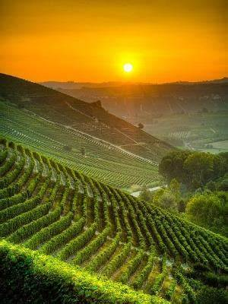
Then why have you broken down its walls?
It is plucked by all who pass by.
It is ravaged by the boar of the forest,
devoured by the beasts of the field. Resp:
God of hosts, turn again, we implore,
look down from heaven and see.
Visit this vine and protect it,
the vine your right hand has planted. Resp:
And we shall never forsake you again:
give us life that we may call upon your name.
God of hosts, bring us back;
let your face shine on us and we shall be saved. Resp:
2nd Reading: Philippians 4:6-9
We should do whatever is true, honourable, just and right
Do not worry about anything, but in everything by prayer and supplication with thanksgiving let your requests be made known to God. And the peace of God, which surpasses all understanding, will guard your hearts and your minds in Christ Jesus.
Finally, beloved, whatever is true, whatever is honourable, whatever is just, whatever is pure, whatever is pleasing, whatever is commendable, if there is any excellence and if there is anything worthy of praise, think about these things. Keep on doing the things that you have learned and received and heard and seen in me, and the God of peace will be with you.
Gospel Acclamation:
Alleluia, Alleluia!
I call you friends, say the Lord,
Because I have made known to you
everything I have learn from my Father.
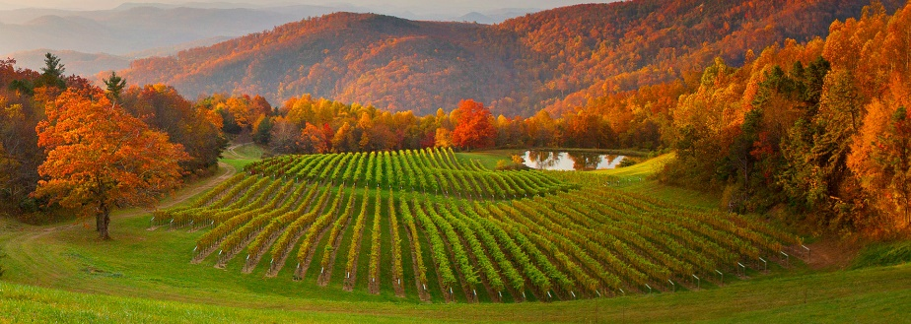
Alleluia!

Gospel: Matthew 21:33-43
God is master of the vineyard and expects a proper return from the tenants
Jesus said to the chief priests and elders: “Listen to another parable. There was a land-owner who planted a vineyard, put a fence around it, dug a wine press in it, and built a watch-tower. Then he leased it to tenants and went to another country. When the harvest time had come, he sent his slaves to the tenants to collect his produce. But the tenants seized his slaves and beat one, killed another, and stoned another. Again he sent other slaves, more than the first; and they treated them in the same way. Finally he sent his son to them, saying, ‘They will respect my son.’ But when the tenants saw the son, they said to themselves, ‘This is the heir; come, let us kill him and get his inheritance.” So they seized him, threw him out of the vineyard, and killed him. Now when the owner of the vineyard comes, what will he do to those tenants?” They said to him, “He will put those wretches to a miserable death, and lease the vineyard to other tenants who will give him the produce at the harvest time.” Jesus said to them, “Have you never read in the scriptures: ‘The stone that the builders rejected has become the cornerstone; this was the Lord’s doing, and it is amazing in our eyes’? Therefore I tell you, the kingdom of God will be taken away from you and given to a people that produces its fruit.”
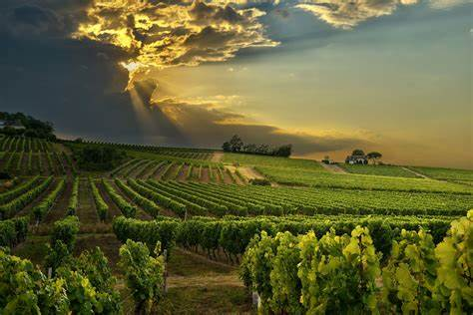

Reflections:
Our God is a God who trusts his workers. Just as the land-owner gave the tenants a fully equipped vineyard in which to work and produce, God creates the possibilities for work, fruitfulness and success for us too. He provides us with opportunities and resources and trusts that we will make the most of these. Our own, personal vineyards are completely unique. Do we recognise how our lives are moulded by God? Do we recognise the opportunities and resources that God has given us? Have we experienced the freedom and trust that God gives us? Have we responded responsibly or have we responded similar to the tenants at times?
The first reading from Isaiah echoes this truth. The friend of Isaiah owns a fertile hillside, he spades it, he clears it of stones, plants the choicest vines, builds the traditional watch-tower, installs the typical wine press and then anticipates an excellent and abundant harvest. What he gets instead are wild grapes. We feel the pain of unrequited love in the second half of the reading of Isaiah. We feel the pain of a broken heart acting out in anger – an earthy, anthropomorphic illustration of the disappointment God feels in his people who have not acted justly and with compassion to the lowly and oppressed.
From this feeling, we read the parable from the Gospel today in the social context of the time. Jesus does not necessarily approve of what people do in his stories. John J Pilch, in The Cultural World of Jesus, writes: “The parable reflects a reality familiar to all peasants, namely, the extortion practiced by hard-nosed absentee land-owners. Modern scholars have pieced together bits and pieces of information to gain a better understanding of the situation of tenant farmers based on what is known about peasant free-holders, that is, peasants who were fortunate enough to own and farm their own land. Some of the crop would have to be used for trade to gain other necessities of life. There were also social dues (gifts), religious tithes, and taxes adding up to about 35 or 40%. About 20% of the annual produce would be left to feed the family and livestock of a free-holding peasant. Far less would be left to tenant farmers who also owed land rent.”
In addition to this, in the story the land-owner shows little concern for his slaves and even for his own son and heir: he too in a different way is dispossessed. All are losers.
And yet the story describes a reality, then and now. Injustice leads to desperation, desperation to violence, and violence to yet more violence. The more we have, the more we have to protect. There is a strong message here for society today – and for the church and its leaders. Who delivers the fruit?
With so much violence in the news, our mind could be overcome with the powers of evil. We need what St Paul says in his letter to the Philippians from the Second Reading: “Beloved, whatever is true, whatever is honourable, whatever is just, whatever is pure, whatever is pleasing, whatever is commendable, if there is any excellence and if there is anything worthy of praise, think about these things.” Amen.
