EASTER
THE RESURRECTION JESUS CHRIST
THE EMPTY TOMB
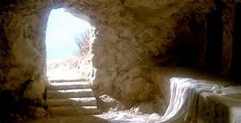

“Jesus is Alive!
He is with us”

Biblical Readings:
- Lk 24: 13-35
- Jn 20: 19-23; 24-29

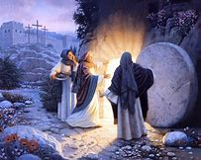
Suddenly, on the first day of the week, early in the morning, the news spread among the disciples and those who had been close to Jesus that he had disappeared from the tomb.

Everyone was dismayed. Some did not believe in what was said by Mary Magdalene that is, Jesus was alive. However, together with John, Peter rushed to the tomb and he was the first one who entered the tomb and witnessed the disappearance of Jesus (Jn 20: 1-9). A big question in Peter’s head was: Where is Jesus? He was dead and couldn’t run away from the tomb! Before his death, he was tortured terribly. He was nailed and hung on the cross. How could he survive those horrible wounds? Moreover, a lance was thrust into his heart by a soldier to make sure that he died. All these things confirmed that he was dead.

But now, where was Jesus? Peter reflected deeply and searched for a response.... He thought somebody had possibly come to steal his body?! Why steal the body and what for? That was not a strong answer! Peter knew that none of the disciples dared to come into the tomb to take Jesus’ body away.

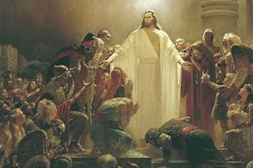
However, on the evening of that first day of the week, the disciples called a meeting amongst themselves in a room to discuss the news. All doors were locked for fear of the Jews (Jn 20: 19). Suddenly, Jesus appeared (Jn 20: 19). Everybody in the room was surprised and could not believe their eyes. Jesus appeared like a normal and strong man, except that the wounds in his hands, his feet and his side were still fresh. How could an ordinary man come back to life three days after being tortured and wounded badly? Everyone was so happy to see Jesus back alive, sound and safe! Nothing could describe their emotion, happiness and joy!

After that historical evening, Jesus appeared to two disciples going home on the road of Emmaus, to Thomas and many others. All witnessed his appearances in deep faith and believed that he had risen after three days in the tomb as he had said.

Asking for a Grace:

Lord Jesus,
I believe in you.
I believe that you have died, you are risen and you are God forever.
Grant that I have a deep joy in your RESURRECTION.
Amen.

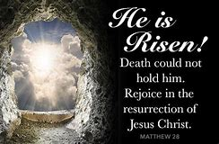

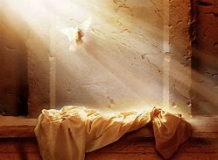

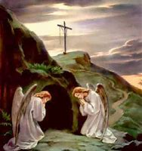

HE IS RISEN!
ALLELUIA! ALLELUIA! ALLELUIA!

