4th Sunday of Easter
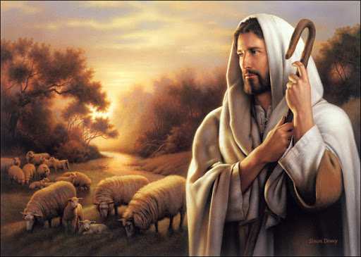

First Reading: (Acts 2:14a, 36b-41)
When the day of Pentecost had come, Peter, standing with the eleven, raised his voice and addressed the crowd. "Let the entire house of Israel know with certainty that God has made him both Lord and Christ, this Jesus whom you crucified.
Now when the people heard this, they were cut to the heart and said to Peter and to the other Apostles, "Brothers, what should we do?" Peter said to them, "Repent, and be baptized every one of you in the name of Jesus Christ so that your sins may be forgiven; and you will receive the gift of the Holy Spirit. For the promise is for you, for your children, and for all who are far away, everyone whom the Lord our God calls to him."
And he testified with many other arguments, and exhorted them, saying, 'Save yourselves from this corrupt generation.' So those who welcomed his message were baptized, and that day were added about three thousand souls.
Responsorial Psalm
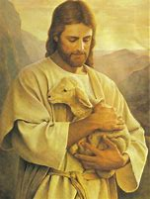
Response: The Lord is my Shepherd; there is nothing I shall want.
The Lord is my shepherd;
there is nothing I shall want.
Fresh and green are the pastures
where he gives me repose.
Near restful waters he leads me,
to revive my drooping spirit.
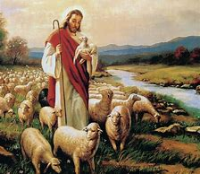
He guides me along the right path;
he is true to his name.
If I should walk in the valley of darkness
no evil would I fear.
You are there with your crook and your staff;
with these you give me comfort.
You have prepared a banquet for me
in the sight of my foes.
My head you have anointed with oil;
my cup is overflowing.
Surely goodness and kindness shall follow me
all the days of my life.
In the Lord’s own house shall I dwell
for ever and ever.

Second Reading: (1 Peter 2:20b-25)
Brothers: If you endure when you do right and suffer for it, you have God's approval. For to this you have been called, because Christ also suffered for you, leaving you an example, so that you should follow in his steps. "He committed no sin, and no deceit was found in his mouth." When he was abused, he did not return abuse; when he suffered, he did not threaten, but he entrusted himself to the one who judges justly.
Christ Himself bore our sins in His body on the cross, so that, free from sins, we might live for righteousness; by His wounds you have been healed. For you were going astray like sheep, but now you have returned to the shepherd and guardian of your souls.

Gospel: (Jn. 10:1-10)
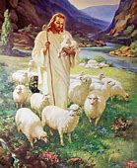
Jesus said: 'Very truly, I tell you, anyone who does not enter the sheepfold by the gate but climbs in by another way is a thief and a bandit.' The one who enters by the gate is the shepherd of the sheep. The gatekeeper opens the gate for him, and the sheep hear his voice. He calls his own sheep by name and leads them out. When he has brought out all his own, he goes ahead of them, and the sheep follow him because they know his voice. They will not follow a stranger, but they will run from him because they do not know the voice of strangers.
Jesus used this figure of speech with them, but they did not understand what he was saying to them. So again Jesus said to them, "Very truly, I tell you, I am the gate for the sheep. All who came before me are thieves and bandits; but the sheep did not listen to them. I am the gate. Whoever enters by me will be saved, and will come in and go out and find pasture. The thief comes only to steal and kill and destroy. I came that they may have life, and have it abundantly.
**********
Reflections:
If today, we open the Holy Bible to look for a beautiful way of living for our life, we can discover it in the Psalm 23: 1-4:
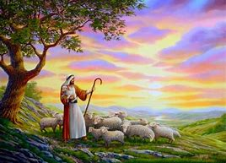
The Lord is my shepherd; I shall not want.
In verdant pastures he gives me repose;
Beside restful waters he leads me;
He refreshes my soul.
He guides me in right paths
For his name’s sake.
Even though I walk in the dark valley
I fear no evil; for you are at my side
with your rod and your staff
that give me courage. (Ps 23:1-4)
That is a beautiful way to live, a way that leads to life, peace and true happiness.
We have celebrated Jesus’ death and resurrection. Jesus had to die to himself to live his new life. Jesus has shown us how to live life to the full, we must die to ourselves in order to rise to new life. Our secularized world thinks it has the answer to our needs but what it offers only leads us into deeper despair.
Only dying to ourselves - as we follow Jesus - will lead us to the happiness we seek. Jesus teaches us that the way to happiness lies not in filling up each of our wants and needs and desires. The way to happiness lies in a very different choice of life; the way to happiness may be found in sacrificing and taking up our cross with Jesus, reproducing the life of Jesus in our own lives. And so Jesus says,
I am the gate. Anyone who enters through me will be safe: he will go freely in and out and be sure of finding pasture… (John 10:9)
I have come so that they may have life and have it to the full. (John 10:10)
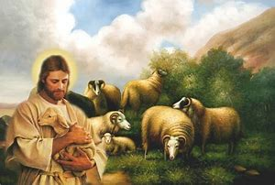
Jesus often used the imagery of shepherds and sheep to show his care for others. He, the Good Shepherd, now developes the relationship between the shepherd and the sheep. The imagery is old but the message is still relevant to us. By our trust in Jesus, our relationship with him is alive and personal, like the love that unites Jesus himself with the Father. Our whole faith is founded on God’s love and faithfulness.
To share in eternal life we must listen to Jesus and obey him. To put this in audio terms, we need to tune our minds to the sound of his voice. Self-centredness can intervene to make us deaf to the voice of Jesus. We can be drawn to follow an easier path than the one he has traced. Pressures to abandon our principles come and go. But we trust that our faithful Shepherd will not let us be tempted beyond our strength; nothing can tear us away from him. The same God who upheld Jesus and raised him from the dead will also keep us by his care.
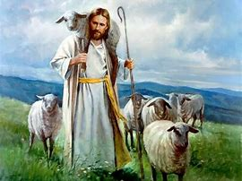
Paul and Barnabas ‘spoke out boldly’ and made an impact. A suitable sharing of the gospel in our times can be as fruitful now as it was then. All the baptized faithful need to play their part in spreading the message of Jesus. All of us, laity as well as priests and religious are called to serve the Risen Lord and take some part in evangelising others. Too many evils persist in our society just because good people say and do nothing about them. A breviary hymn for Eastertide (no.25) spells out what is expected of us: “Now he bids us tell abroad/ How the lost may be restored/ How the penitent forgiven/ How we too may enter heaven.”
“Good Shepherd Sunday” prompts us to think and pray about how our church will fare for priests in the future. In Australia right now priests are an ageing and diminishing group that it’s clear we need to re-think the conditions for ordination and re-imagine how to recruit Eucharistic celebrants for the future.
In an email sent to all priests of the Northern Region a few days ago, Bishop Terry Curtin shared a reality of pastoral mission in our Archdiocese and particularly in the Northern Region: “Currently twelve parishes in the archdiocese are without their own parish priest, and nine of our number (eight priests and one auxiliary bishop) are close to turning seventy-five.”
As we contemplate Jesus the Good Shepherd today, Saint John Paul II declared the fourth Sunday of Easter a Day of Prayer for Vocations. We pray that many may listen to the voice of Jesus as he calls, that they may enter the sheepfold through him and be safe and have life and live it to the fullest.
This week, let us reflect upon vocations to the priesthood and religious life, and remember our obligation to foster vocations in our home. Let us remember Jesus' Words to Peter, "Follow me, and I will make you fishers of men." (Mt. 4:19).
