5th Sunday of Easter
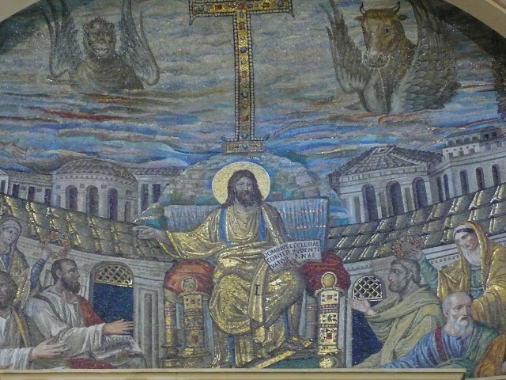

First Reading: Acts 6: 1-7
"Now during those days, when the disciples were increasing in number, the Hellenists complained against the Hebrews because their widows were being neglected in the daily distribution of food. And the twelve called together the whole community of the disciples and said, 'It is not right that we should neglect the word of God in order to wait on tables. Therefore, brothers, select from among yourselves seven men of good standing, full of the Spirit and of wisdom, whom we may appoint to this task, while we, for our part, will devote ourselves to prayer and to serving the word.'
What they said pleased the whole community, and they chose Stephen, a man full of faith and the Holy Spirit, together with Philip, Prochorus, Nicanor, Timon, Permenas, and Nicolaus, a convert of Antioch. They had these men stand before the Apostles, who prayed and laid their hands on them.
The word of God continued to spread; the number of the disciples increased greatly in Jerusalem, and a great number of the priests became obedient to the faith." (Acts 6:1-7)
Resposorial Psalm
Response: Lord, let your mercy be on us, as we place our trust in you
Ring out your joy to the Lord, O you just;
for praise is fitting for loyal hearts.
Give thanks to the Lord upon the harp,
with a ten-stringed lute sing him songs. Resp.
For the word of the Lord is faithful
and all his works to be trusted.
The Lord loves justice and right
and fills the earth with his love. Resp.
The Lord looks on those who revere him,
on those who hope in his love,
to rescue their souls from death,
to keep them alive in famine. Resp.

Second Reading: 1Pet 2: 4-9
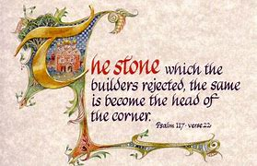
"Beloved" Come to the Lord, a living stone, though rejected by human beings yet chosen and precious in God's sight. Like living stones, let yourselves be built into a spiritual house, to be a holy priesthood, to offer spiritual sacrifices acceptable to God through Jesus Christ.
For it stands in Scripture: 'See, I am laying in Zion a stone, a cornerstone chosen and precious; and whoever believes in him will not be put to shame.' To you then who believe, he is precious; but for those who do not believe, 'The stone that the builders rejected has become the very head of the corner.' and 'A stone that makes them stumble, and a rock that makes them fall.' They stumble because they disobey the word, as they were destined to do.
But you are a chosen race, a royal priesthood, a holy nation. God's own people, in order that you may proclaim the mighty acts of him who called you out of darkness into his marvellous light." (1 Pet. 2:4-9)
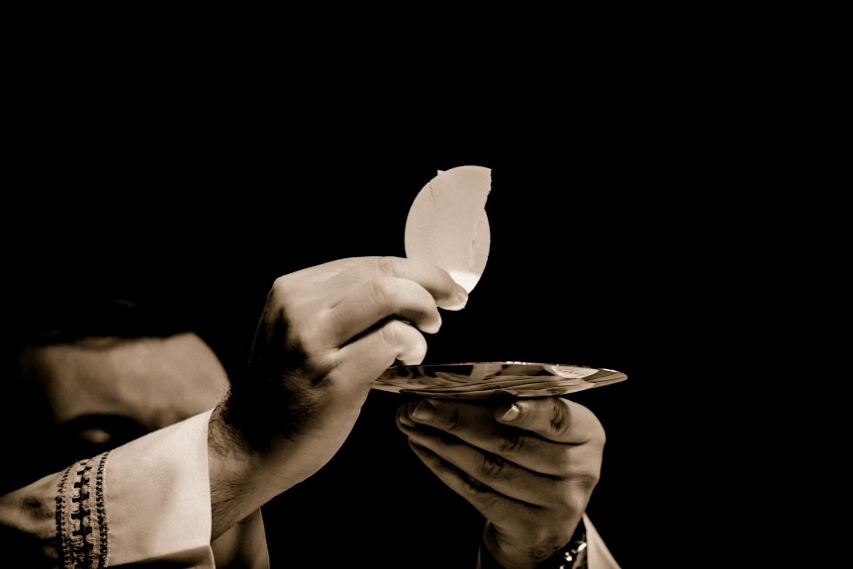

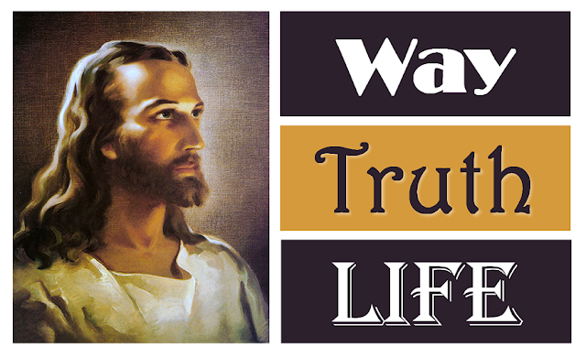
Gospel Acclamation:
Alleluia, alleluia!
I am the way, the truth and the life, says the Lord;
No one comes to the Father, except through me.

Alleluia!

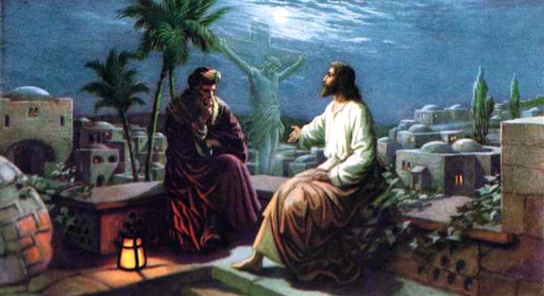
Gospel Reading: Jn 14: 1-12

"Jesus said to his disciples: 'Do not let your hearts be troubled. Believe in God, believe also in me. In my Father's house there are many dwelling places. If it were not so, would I have told you that I go to prepare a place for you? And if I go and prepare a place for you, I will come again and will take you to myself, so that where I am, there you may be also. And you know the way to the place where I am going.'
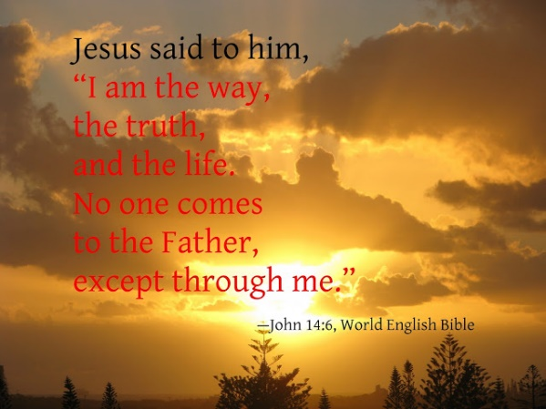
Thomas said to him, 'Lord, we do not know where you are going. How can we know the way?'
Jesus said to him, 'I am the way, and the truth, and the life. No one comes to the Father except through me. If you know me, you will know my Father also. From now on you do know him and have seen him.'
Philip said to him, 'Lord, show us the Father, and we will be satisfied.' Jesus said to him, 'Have I been with you all this time, Philip, and you still do not know me? Whoever has seen me has seen the Father. how can you say, 'Show us the Father'? Do you not believe that I am in the Father and the Father is in me? The words that I say to you I do not speak on my own; but the Father who dwells in me does his works. Believe me that I am in the Father and the Father is in me; but if you do not, then believe me because of the works themselves. Very truly, I tell you, the one who believes in me will also do the works that I do and, in fact, will do greater works than these, because I am going to the Father.'"(Jn. 14:1-12)
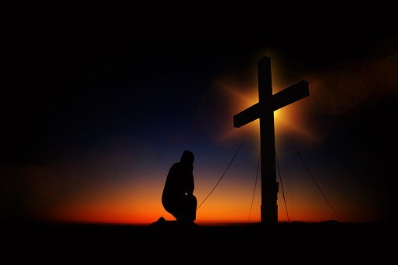
Reflections:

The story from the Acts of the Apostles shows how needed changes were introduced, in the church’s early days. The Hellenists (converts whose main language was Greek), complained that their widows were not getting a fair share of the Jerusalem sommunity’s social services. The apostles’ solution to the problem shows how some changes are vitally needed for the health of the church.
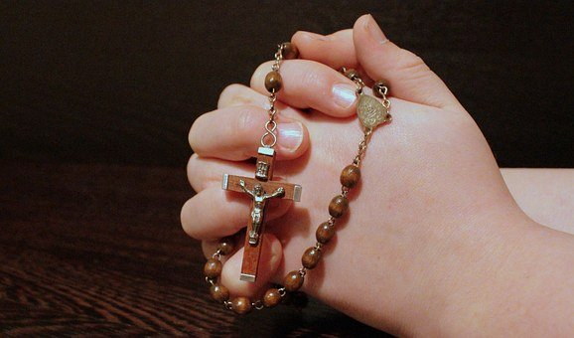
Their solution has two sides: prayer and service; and our Christian vocation requires a balance between the two. Each of us is called to prayer, to personally worship our God; and we are also called to service. No matter what we do in life, we should be of some service to our neighbours; and no task we do for others is a menial task. Prayer and preaching were the primary duties of the apostles; but service to the widows and the needy in the community was also vital, so they appointed seven trusted men to attend to it, and initiated them by an ordination ceremony, the laying-on of hands.
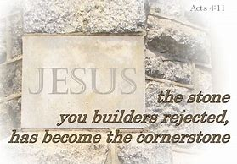
Partly due to this good change, the disciples in Jerusalem increased in numbers. We may wonder how this kind of growth in the church could be revived in our day. Is the word of the Lord still spreading or the number of disciples increasing? In St Peter’s letter, the church is imagined as a spiritual temple, with ourselves as living stones making up a living house of God. Every time we say the Lord’s Prayer we say ‘thy kingdom come.’ This implies taking on our responsibility for spreading the word and doing something to build up the church. We can work for God’s kingdom by our daily conduct and attitudes.
The cornerstone of our church is Jesus himself, and he offers us encouragement even today. If he is going away, it is to prepare a place for us in his Father’s house, which has many rooms.
If many people today regard faith as irrelevant it is because they have a faulty or distorted notion of God. For a true picture of what God is like, we should recall how Jesus said “I am in the Father and the Father is in me.” He shows what the invisible Father is like: concerned for all, interested in all, respecting everyone, calling us back home. This welcoming God is the one our church worships, and we renew our trust in Him.
