THE ASCENSION OF THE LORD
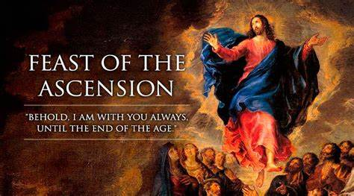

1st Reading: Acts 1:1-11
In the first book, Theophilus, I wrote about all that Jesus did and taught from the beginning until the day when he was taken up to heaven, after giving instructions through the Holy Spirit to the apostles whom he had chosen. After his suffering he presented himself alive to them by many convincing proofs, appearing to them during forty days and speaking about the kingdom of God.
While staying with them, he ordered them not to leave Jerusalem, but to wait there for the promise of the Father. “This,” he said, “is what you have heard from me; for John baptized with water, but you will be baptized with the Holy Spirit not many days from now.”
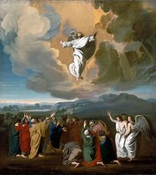
So when they had come together, they asked him, “Lord, is this the time when you will restore the kingdom to Israel?” He replied, “It is not for you to know the times or periods that the Father has set by his own authority. But you will receive power when the Holy Spirit has come upon you; and you will be my witnesses in Jerusalem, in all Judea and Samaria, and to the ends of the earth.”
When he had said this, as they were watching, he was lifted up, and a cloud took him out of their sight. While he was going and they were gazing up toward heaven, suddenly two men in white robes stood by them. They said, “Men of Galilee, why do you stand looking up toward heaven? This Jesus, who has been taken up from you into heaven, will come in the same way as you saw him go into heaven.”
Responsorial: Psalm 47

Response: God goes up with shouts of joy, the Lord goes up with trumpet blast

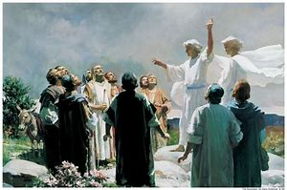
All you peoples, clap your hands,
shout to God with cries of gladness.
For the Lord, the Most High, the awesome,
is the great king over all the earth. Resp:
God mounts his throne amid shouts of joy;
the Lord, amid trumpet blasts.
Sing praise to God, sing praise;
sing praise to our king, sing praise. Resp:
For king of all the earth is God;
sing hymns of praise.
God reigns over the nations,
God sits upon his holy throne. Resp:

2nd Reading: Ephesians 1:17-23
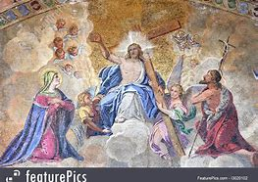
Brothers and sisters: I pray that the God of our Lord Jesus Christ, the Father of glory, may give you a spirit of wisdom and revelation as you come to know him, so that, with the eyes of your heart enlightened, you may know what is the hope to which he has called you, what are the riches of his glorious inheritance among the saints, and what is the immeasurable greatness of his power for us who believe, according to the working of his great power. God put this power to work in Christ when he raised him from the dead and seated him at his right hand in the heavenly places, far above all rule and authority and power and dominion, and above every name that is named, not only in this age but also in the age to come. And he has put all things under his feet and has made him the head over all things for the church, which is his body, the fullness of him who fills all in all.

Gospel Acclamation:
Alleluia, Alleluia!
Go and teach all people my gospel.
I am always with you, until the end of the world.

Alleluia!

Gospel: Matthew 28:16-20
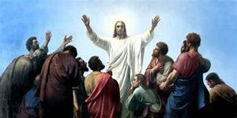
The eleven disciples set out for Galilee, to the mountain where Jesus had arranged to meet them. When they saw him they fell down before him, though some hesitated. Jesus came up and spoke to them. He said, “All authority in heaven and on earth has been given to me. Go, therefore, and make disciples of all the nations, baptise them in the name of the Father and of the Son and of the Holy Spirit, and teach them to obseve all the commands I gave you. And know that I am with you always; yes, to the end of time.”

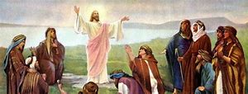
Reflections
In the gospel we have just heard Our Lord’s final instructions, his Last Will and Testament. Just before leaving them, he reminds them of what he expects of them. Earlier he had sent them out to spread the Kingdom of God. Those who go in his name, do so with his authority. The authority goes with the mission, so to speak. In Matthew’s version he now adds this great promise, “I am with you always, even to the end of the age.” Mark says that the Lord worked with them and confirmed the message by the signs that accompanied it”. And Luke emphasises that they will be “clothed with power from on high”, that is, with the inspiration of the Holy Spirit.
Jesus is very definite about what he has to say. Like any gathering of people, the feelings of his disciples were varied. But he sends them out to speak and act in his name.
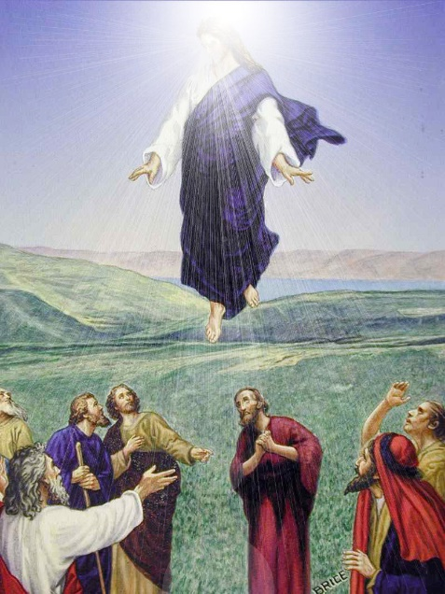
Their mission was both easy and hard: easy to understand but hard to carry out. It was to teach others all that he had taught them. Just as he asked them to follow his way, they were to ask that others should follow that way too.
Has a doctor ever put you on a course of antibiotics. The most basic guidance about antibiotics is to complete the course. Even if the patient starts to feel well after a few days, to discontinue taking the medicine can let their condition grow worse.
Similarly, the message of salvation must continue to be shared until the end of time. With all the changes in the church and in society, neither Jesus nor his message have changed. His Gospel remains a call to live our lives to the full.
He is with us always. This can be a real help against loneliness. Being alone is not the same as being lonely. One can feel lonely in a crowded street; or alternatively, like Cicero, never less alone than when alone. This applies especially to those who believe the promise, “I am with you always.” Talking with him doesn’t even need words. If we are open to His presence in our heart, and treasure it, we can experience fully that “Joy of the Gospel” so warmly described for us by our good Pope Francis.
