PENTECOST SUNDAY
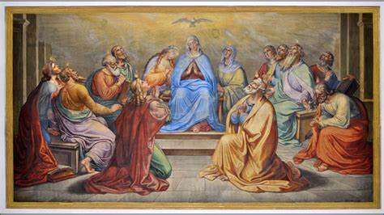

1st Reading: Acts 2:1-11
When the day of Pentecost had come, they were all together in one place. And suddenly from heaven there came a sound like the rush of a violent wind, and it filled the entire house where they were sitting. Divided tongues, as of fire, appeared among them, and a tongue rested on each of them. All of them were filled with the Holy Spirit and began to speak in other languages, as the Spirit gave them ability.
Now there were devout Jews from every nation under heaven living in Jerusalem. And at this sound the crowd gathered and was bewildered, because each one heard them speaking in the native language of each.
Amazed and astonished, they asked, “Are not all these who are speaking Galileans? And how is it that we hear, each of us, in our own native language? Parthians, Medes, Elamites, and residents of Mesopotamia, Judea and Cappadocia, Pontus and Asia, Phrygia and Pamphylia, Egypt and the parts of Libya belonging to Cyrene, and visitors from Rome, both Jews and proselytes, Cretans and Arabs-in our own languages we hear them speaking about God’s deeds of power.”
Responsorial: Psalm 103: 1, 24, 29-31, 34
Response: Lord, send out your Spirit and renew the face of the earth
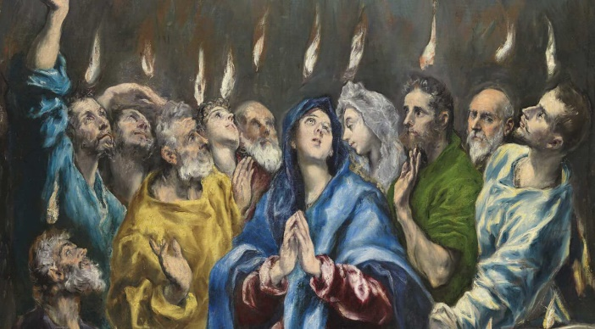
Bless the Lord, my soul!
Lord God, how great you are,
How many are your works, O Lord!
The earth is full of your riches. Resp:
You take back your spirit, they die,
returning to the dust from which they came.
You send forth your spirit, they are created;
and you renew the face of the earth. Resp:
May the glory of the Lord last for ever!
May the Lord rejoice in his works!
May my thoughts be pleasing to him.
I find my joy in the Lord.
Lord, send out your Spirit and renew the face of the earth. Resp:

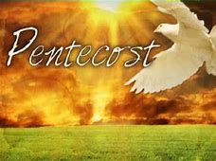
2nd Reading: 1 Corinthians 12:3-7, 12-13
No one can say “Jesus is Lord” except by the Holy Spirit. Now there are varieties of gifts, but the same Spirit; and there are varieties of service, but the same Lord; and there are varieties of working, but it is the same God who inspires them all in every one. To each is given the manifestation of the Spirit for the common good. For just as the body is one and has many members, and all the members of the body, though many, are one body, so it is with Christ. For by one Spirit we were all baptized into one body-Jews or Greeks, slaves or free-and all were made to drink of one Spirit.
Sequence:
Holy Spirit, Lord of Light,
From the clear celestial height.
Thy pure beaming radiance give.
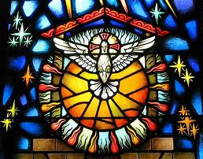
Come, thou Father of the poor,
Come, with treasures which endure;
Come, thou Light of all that live!
Thou, of all consolers best,
Thou, the soul's delightful guest,
Dost refreshing peace bestow.
Thou in toil art comfort sweet;
Pleasant coolness in the heat;
Solace in the midst of woe.
Light immortal, Light divine,
Visit thou these hearts of thine,
And our inmost being fill.
If thou take thy grace away,
Nothing pure in man will stay;
All his good is turned to ill.
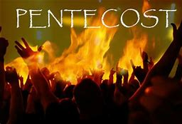
Heal our wounds, our strength renew;
On our dryness pour thy dew,
Wash the stains of guilt away.
Bend the stubborn heart and will;
Melt the frozen, warm the chill;
Guide the steps that go astray.
Thou, on us who evermore
Thee confess and thee adore,
With thy sevenfold gifts descend.
Give us comfort when we die;
Give us life with thee on high;
Give us joys that never end.
Amen. Alleluia.
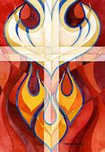
Gospel Acclamation:
Alleluia, Alleluia!
Come, Holy Spirit, fill the hearts of your faithful
And kindle in them the fire of your love.

Alleluia!

Gospel: John 14:15-16; 23-26
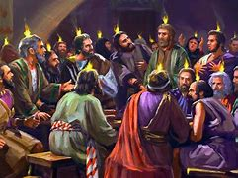
It was evening on the day Jesus rose from the dead, the first day of the week, and the doors of the house where the disciples had met were locked for fear of the Jews. Jesus came and stood among them and said, ‘Peace be with you.’ After he said this, he showed them his hands and his side. Then the disciples rejoiced when they saw the Lord.
Jesus said to them again, ‘Peace be with you.’
‘As the Father has sent me, so I send you.’

When He had said this, He breathed on them and said to them,
‘Receive the Holy Spirit. If you forgive the sins of any, they are forgiven them; if you retain the sins of any, they are retained.’
Reflections:
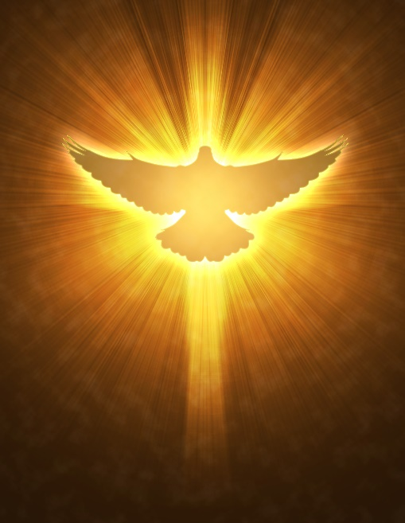
In our churches there is no shortage of images, mostly statues, paintings or stained glass. They are mostly of the Lord Jesus, Blessed Virgin Mary and the saints. The Holy Spirit, whose feast we celebrate on Pentecost, does not lend itself easily to imagery. The traditional image of the dove is drawn from the scene of the baptism of Jesus. But the language in that passage is rather vague; the Holy Spirit descended like a dove, or in the way that a dove might descend. There are two other images of the Holy Spirit in today’s reading from the Acts of the Apostles. Luke says that all who gathered in one room heard what sounded like a powerful wind from heaven; he goes on to say that something appeared to them that seemed like tongues of fire. Just as the evangelists do not portray an actual dove at the baptism of Jesus, Luke does not say that the wind and fire at Pentecost were tangible phenomena. The Holy Spirit is impossible to visualise, because the Spirit cannot be seen as such. Yet the Holy Spirit is profoundly real.
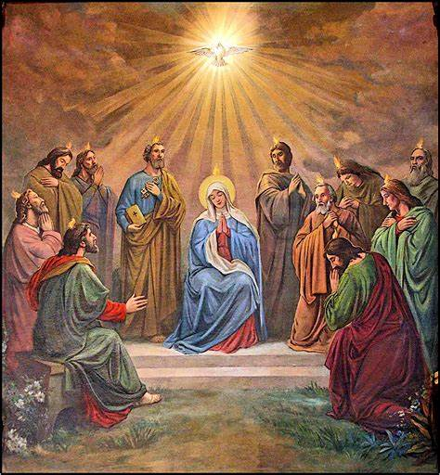
Many things in our universe are real even though invisible to the naked eye. What we see with our eyes is only a fraction of our physical world. The Holy Spirit belongs to the spiritual world, and it naturally cannot see the Spirit with our eyes. Yet, there are helpful ways of imagining the Holy Spirit. St Paul uses an image drawn nature when he says that the Spirit bears fruit. He means the visible effect of the Spirit on one’s life. We may not be able to see the Holy Spirit, but we can see the effect of the Spirit in our life, just as we cannot see the wind but can see the effect of the wind on people and objects of various kinds.
St. Paul is saying that wherever we find love, joy, peace, patience, kindness, goodness, trustfulness, gentleness and self-control, the Spirit is there at work. The Spirit becomes visible in and through these qualities and virtues. The person who most of all had those qualities was the Lord Jesus because he was full of the Holy Spirit, full of the life of God.
In his letter to the Romans St. Paul has the wonderful statement, ‘God’s love has been poured into our hearts through the Holy Spirit that has been given to us’. He also indicates in today’s 2nd Reading (1 Cor) that the Spirit is at work in our lives, to make us more like the Lord Jesus. The good things people do are all manifestations of the Spirit of God. The spiritual is not something other-worldly; it is humanity at its best.
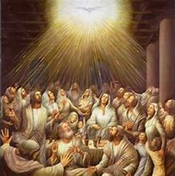
In the Pentecost story, humanity appears at its best, united and sharing in wisdom. Pentecost brought about a wonderful bonding of people from all over the Roman Empire. They were united in admiring and praising the marvels of God. In spite of differences of language and culture there was a real communion among them. Wherever communion of heart and mind exist among people of different backgrounds, the Holy Spirit is at work. Unity in diversity is the mark of the Spirit. The Lord Jesus points out another manifestation of the Spirit: the pursuit of truth. Only the Spirit can lead us to the complete truth. If someone is genuinely seeking for truth, and willing to engage in good works with others, there the Spirit is at work. Fullness of truth and love is always beyond us; but the Spirit is given to lead us towards the complete truth and love, in all its height and depth.
