SOLEMNITY OF THE MOST HOLY BODY
and BLOOD OF CHRIST.
- CORPUS CHRISTI -
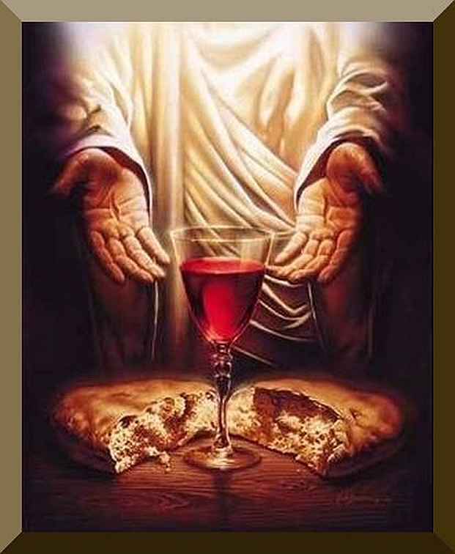

First Reading Deuteronomy 8:2-3, 14-16
Moses said to the people: ‘Remember how the Lord your God led you for forty years in the wilderness, to humble you, to test you and know your inmost heart — whether you would keep his commandments or not. He humbled you, he made you feel hunger, he fed you with manna which neither you nor your fathers had known, to make you understand that man does not live on bread alone but that man lives on everything that comes from the mouth of the Lord.
‘Do not then forget the Lord your God who brought you out of the land of Egypt, out of the house of slavery: who guided you through this vast and dreadful wilderness, a land of fiery serpents, scorpions, thirst; who in this waterless place brought you water from the hardest rock; who in this wilderness fed you with manna that your fathers had not known.’
Responsorial Psalm: Psalm 147:12-15, 19-20
Response: Praise the Lord, Jerusalem
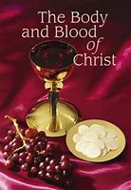
O praise the Lord, Jerusalem!
Zion, praise your God!
He has strengthened the bars of your gates,
he has blessed the children within you. Resp.
He established peace on your borders,
he feeds you with finest wheat.
He sends out his word to the earth
and swiftly runs his command. Resp.
He makes his word known to Jacob,
to Israel his laws and decrees.
He has not dealt thus with other nations;
he has not taught them his decrees. Resp.

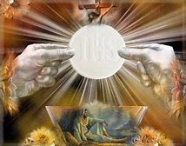
Second Reading: 1 Corinthians 10:16-17
The blessing-cup that we bless is a communion with the blood of Christ, and the bread that we break is a communion with the body of Christ. The fact that there is only one loaf means that, though there are many of us, we form a single body because we all have a share in this one loaf.

Alleluia, Alleluia!
I am the living Bread from Heaven, says the Lord;
Whoever eats this bread will live forever.
Alleluia!
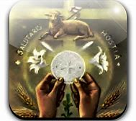

Gospel: John 6:51-58
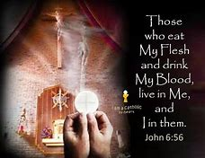
Jesus said to the Jews:
‘I am the living bread which has come down from heaven.
Anyone who eats this bread will live for ever;
and the bread that I shall give is my flesh, for the life of the world.’
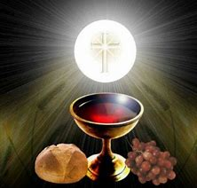
Then the Jews started arguing with one another: ‘How can this man give us his flesh to eat?’ they said. Jesus replied:
‘I tell you most solemnly,
if you do not eat the flesh of the Son of Man
and drink his blood,
you will not have life in you.
Anyone who does eat my flesh
and drink my blood has eternal life,
and I shall raise him up on the last day.
For my flesh is real food
and my blood is real drink.
He who eats my flesh and drinks my blood
lives in me and I live in him.
As I, who am sent by the living Father,
myself draw life from the Father,
so whoever eats me will draw life from me.
This is the bread come down from heaven;
not like the bread our ancestors ate:
they are dead,
but anyone who eats this bread will live for ever.’

Reflections:
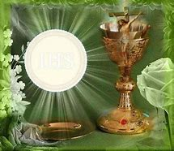
Sitting together for a meal can generate a special feeling of togetherness. Each of us will have our own memories of table companionship or fellowship. Many of these will be happy experiences of celebration and laughter, of love received and shared. Some memories of table fellowship may be sad, times when we were more aware of one who was absent than of those who were present. Jesus shared table many times with his disciples. It is likely that, when sharing food with his disciples, he also shared with them his vision of God’s kingdom . At table, the disciples imbibed something of Jesus’ mind and heart and spirit. Of all the meals he shared with them, the meal that stayed in their memory more than any other was their last meal together, what came to be known as the Last Supper. Today’s Gospel gives us St. Mark’s account, his word-picture, of that Last Supper.
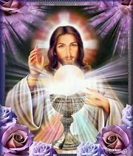
This last meal Jesus shared with his disciples stood out in their memory, capturing the imagination of generations of disciples right up to ourselves. He did more than share his vision with the disciples; he gave them himself in a way he had never done before, and in a way that anticipated the death he would die for them and for all, on the following day. In giving himself in the form of the bread and wine of the meal, he was declaring himself to be their food and drink. In calling on them to take and eat, to take and drink, he was asking them to take their stand with him, to give themselves to him as he was giving himself to them.
It was because of that supper and of what went on there that we are here in this church today. Jesus intended his Last Supper to be a beginning rather than an end. It was the First Eucharist. Ever since that meal, the church has gathered regularly in his name, to do and say what he did and said at that Last Supper — taking bread and wine, blessing both, breaking the bread and giving both for disciples to eat and drink.
Jesus continues to give himself as food and drink to his followers. He also continues to put it up to his followers to take their stand with him, to take in all he stands for, living by his values, walking in his way, even if that means the cross. Whenever we come to Mass and receive the Eucharist, we are making a number of important statements. We are acknowledging the Lord Jesus as our bread of life, as the one who alone can satisfy our deepest hungers. We are also declaring that we will throw in our lot with him, as it were, that we will follow in his way and be faithful to him all our lives, in response to his faithfulness to us. In that sense, celebrating the Eucharist is not something we do lightly. Our familiarity with the Mass and the frequency with which we celebrate it can dull our senses to the full significance of what we are doing. Every time we gather for the Eucharist, we find ourselves once more in that Upper Room with the first disciples, and the Last Supper with all it signified is present again to us.

