Kilmore – St Patrick  Broadford – Our Lady Help of Christians  Wallan - Our Lady of the Way  Wandong – St Michael | 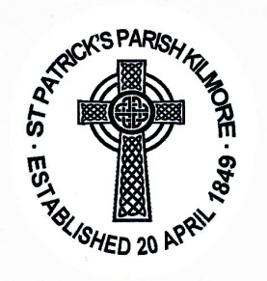 | Post: 37 Sutherland St, Kilmore, Vic 3764  Phone: 5782 1084  Email: kilmore@cam.org.au  Website: http://pol.org.au/kilmore  Parish Priest: Fr Prakash Cutinha  Parish Secretary: Caterina Bosevski  Bookkeeper: Lorraine Nagle
PARISH CENSUS OF KILMORE, BEVERIDGE, BROADFORD,
DARRAWEIT GUIM, PYALONG, WALLAN, WANDONG ……

This information is confidential within the parish and is not to be released.

Thanksgiving envelope No: ……...

Family name: | ……………………………………………………………………….
Home address: | ………………………………………………………………………  ………………………………………………………………………
Home phone : | ………………………………………………………………………
Mr: | ………………………………………………………………………
Email: | ………………………………………………………………………
Miss / Mrs / Ms: | ………………………………………………………………………
Mobile: | ………………………………………………………………………
Email: | ………………………………………………………………………
Children’s names Sex |  | Baptised? | Date of birth
……………………………………… …………. |  | Yes/no | ……………………
……………………………………… …………. |  | Yes/no | ……………………
……………………………………… …………. |  | Yes/no | ……………………
……………………………………… …………. |  | Yes/no | ……………………
……………………………………… …………. |  | Yes/no | ……………………
……………………………………… …………. |  | Yes/no | ……………………
……………………………………… …………. |  | Yes/no | ……………………
……………………………………… …………. Yes/no ………..…………

