
MANSFIELD Parish

Weekly NEWSLETTER
25th/26th January 2020

3rd SUNDAY IN ORDINARY TIME YEAR A
AUSTRALIA DAY

The Mansfield Catholic Parish is committed to the safety of children and vulnerable adults

PRIEST ADMINISTRATOR: Fr George Feliciouz PARISH MANAGER: Nance Rutley
PARISH CENTRE: 54 Hunter St Mansfield 3722 PO Box 288 MANSFIELD 3724
Phone: 5775 2005 Email: Mansfield @cam.org.au Wednesday & Friday 9am – 3.30 pm
St Mary’s Primary School – Principal & Parish Safety Officer – Mrs Trish Etcell 5775 2670
_______________________________________________________________________________________
- ENTRANCE ANTIPHON: (Used only when there is no Entrance Hymn)
I will praise you, Lord, among the peoples, among the nations sing psalms to you, for your mercy reaches to the heavens, and your truth to the skies.

- FIRST READING: Isaiah 32: 15-18

- RESPONSORIAL PSALM:
R. The Lord speaks of peace to his people.
I will hear what the Lord God has to say,
A voice that speaks of peace.
His help is near for those who fear him
And his glory will dwell in our land.

Mercy and faithfulness have met;
Justice and peace have embraced.
Faithfulness shall spring from the earth
and justice look down from heaven.

The Lord will make us prosper
and our earth shall yield its fruit.
Justice shall march before him
and peace shall follow his steps.
R. The Lord speaks of peace to his people.

- SECOND READING: 1st Corinthians 12: 4-11
The grace and peace of God our Father and the Lord Jesus Christ be with you.

- GOSPEL ACCLAMATION:
Alleluia, alleluia!
Happy the peacemakers: they shall be called children of God.
Alleluia!

- GOSPEL: Matthew 5: 2-12

- THE MYSTERY OF FAITH:
We proclaim your Death, O Lord and profess your Resurrection until you come again.

- COMMUNION ANTIPHON: (Used only when there is no Communion Hymn)
Bless the Lord, my soul, and never forget all his benefits.

Prayers for those who are sick: Edna Murphy, Jim Ryan, Patricia Lawson, Paul Nolan, Bernie Carroll,
David & Pat Arbuthnot, Margaret Ramma, Tom and Bernard Read

Readings for next Sunday:
The Presentation of the Lord, Year A
1st Reading: Malachi 3: 1-4 Resp. Psalm: Ps 23: 7-10
2nd Reading: Hebrews 2: 14-18 Gospel: Luke 2: 22-40

PARISH PRAYER
Heavenly Father,
we the people of Mansfield Parish entrust you with our prayers, our needs and our hopes.
We thank you for giving us your Son as our Saviour, our life and our inspiration.
Help us to work as one in the Spirit building up the Body of Christ and bringing peace through forgiveness to the world.
May our patrons: St Francis Xavier, St John the Apostle, St Patrick, St Joseph, St John and Mary Help of Christians, pray for us and guide us in the ways of Jesus. AMEN.

EUCHARISTIC CELEBRATIONS – Mansfield

27th January – 1st February

Monday Rosary 8.45am, Mass 9.15am
Tuesday Rosary 8.45am, Mass 9.15am
Wednesday Rosary 8.45am, Mass 9.15am
Thursday Rosary 8.45am, Mass 9.15am
Friday Rosary 8.45am, Mass 9.15am
Saturday Rosary 8.45am, Mass 9.15am followed
By Reconciliation
MASSES NEXT WEEKEND–1st/2nd February

Saturday 6.00pm St Francis Xavier’s Mansfield
Sunday 9.00am St Francis Xavier’s Mansfield
11am St John the Apostle Jamieson
6pm St Patrick’s Bonnie Doon

COLLECTIONS: Last weekend 18th/19th January
Thanksgiving $451.50 Loose $220.95
Presbytery $818.70
THANK YOU FOR YOUR CONTRIBUTION!!
ROSTERS for 1st/2nd February
SATURDAY 1st February:
Reader: Anna McKenzie
Commentator: Mark Henry
Special Minister: Rita Riley
Hospitality: Roma Revell

SUNDAY 2nd February:
Reader: Mike O’Halloran
Commentator: Val Kirley
Special Minister: Margaret Elliott
Hospitality: ** Vacant **

Communion to the Sick:
Margaret Elliott & Kathleen Bock

Counters:
John Berry & George D’Arcy

Flowers for February: Kathleen Bock

Cleaners: 27/1 – 8/2 Griffin Girls
Maintenance:
27/1 – 8/2 Brendan Griffin Front of Church
27/1 – 8/2 John Rutley Back of Church & back of Father George’s residence

THE CONTINUING JOURNEY OF THE PLENARY COUNCIL OF THE CATHOLIC CHURCH IN AUSTRALIA:
To follow the progress go to the following links:
https://plenarycouncil.catholic.org.au/
https://www.facebook.com/PlenaryCouncil2020
NEWS AROUND OUR PARISH

OUR PARISH

A DATE FOR YOUR DIARY: Professional Standards Unit is running Effective Safeguarding Committee training ( Child and Vulnerable Safety) at the Seymour Parish on Saturday 1 February 1:00-3:30pm.

This training will involve discussing the role of the Parish Safeguarding Committee; the National Catholic Safeguarding Standards; preparing for an audit; and becoming a parish that is truly safe and welcoming for children.

If you are able to attend please contact Nance at the Parish Office or leave a message at the office. Transport will be provided.

WELCOME all school teachers who will be returning to school this coming Tuesday 28th. There will be a Mass for the teachers at 11am.

LEAVING COLLECTION: There is a leaving collection for the Bushfire Appeal this weekend.

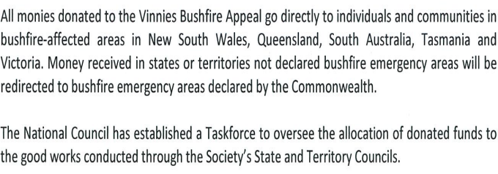
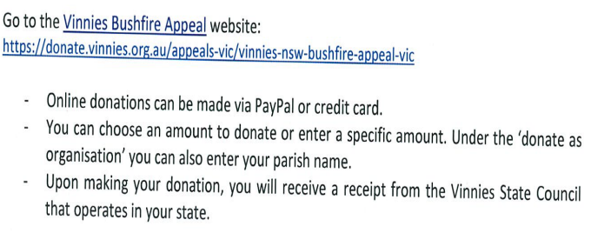
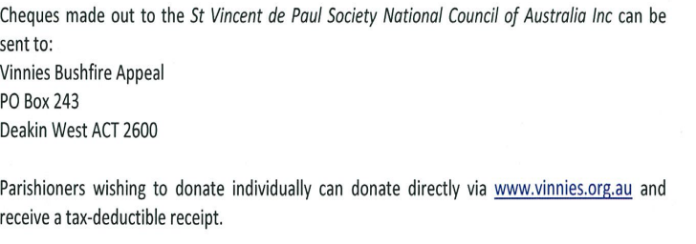

Mansfield Catholic Parish



