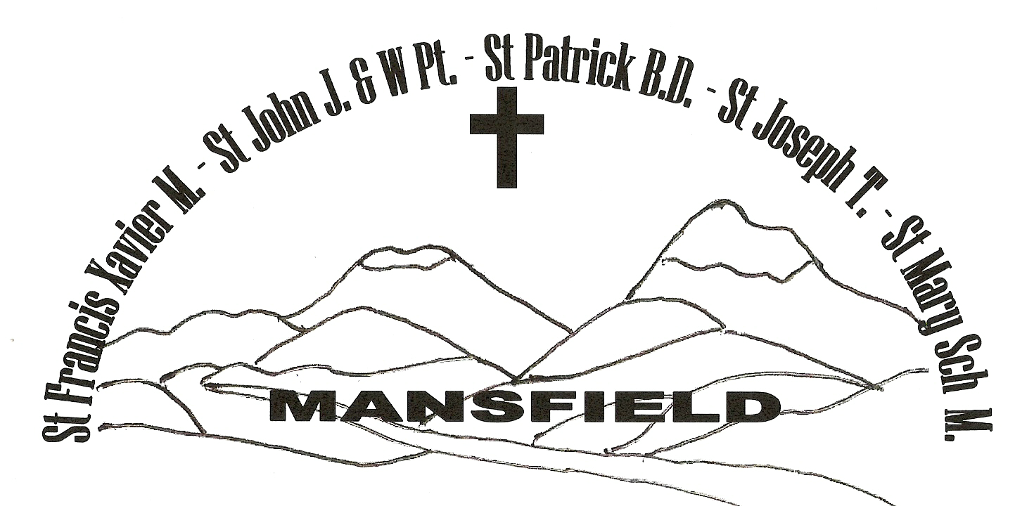
MANSFIELD Parish

Weekly NEWSLETTER
15th /16th February 2020

6th SUNDAY IN ORDINARY TIME YEAR A

The Mansfield Catholic Parish is committed to the safety of children and vulnerable adults

PRIEST ADMINISTRATOR: Fr George Feliciouz PARISH MANAGER: Nance Rutley
PARISH CENTRE: 54 Hunter St Mansfield 3722 PO Box 288 MANSFIELD 3724
Phone: 5775 2005 Email: Mansfield @cam.org.au Wednesday & Friday 9am – 3.30 pm

St Mary’s Primary School – Principal & Parish Safety Officer – Mrs Trish Etcell 5775 2670
_______________________________________________________________________________________
- ENTRANCE ANTIPHON: (Used only when there is no Entrance Hymn)
Be my protector, O God, a mighty stronghold to save me. For you are my rock, my stronghold! Lead me, guide me, for the sake of your name.

- RESPONSORIAL PSALM:
R. Happy are they who follow the law of the Lord!

They are happy whose life is blameless, who follow God's law !
They are happy those who do his will, seeking him with all their hearts.

You laid down your precepts to be obeyed with care.
May my footsteps be firm to obey your statutes.

Bless your servant and I shall live and obey your word.
Open my eyes that I may consider the wonders of your law.

Teach me the demands of your statutes and I will keep them to the end.
Train me to observe your law, to keep it with my heart.
R. Happy are they who follow the law of the Lord!

- GOSPEL ACCLAMATION:
Alleluia, Alleluia.
Blessed are you Father, Lord of heaven and earth;
You have revealed to the little ones
the mysteries of the kingdom.
Alleluia!

- THE MYSTERY OF FAITH:
When we eat this bread and drink this cup, we proclaim your death, O Lord, until you come again.

- COMMUNION ANTIPHON: (Used only when there is no Communion Hymn)
They ate and had their fill and what they craved the Lord gave them; they were not disappointed in what they craved.

Prayers for those who are sick: Enzo Robinson, Edna Murphy, Jim Ryan, Patricia Lawson, Paul Nolan, Bernie Carroll, David & Pat Arbuthnot, Margaret Ramma, Tom and Bernard Read
Readings for next Sunday:
7th Sunday in Ordinary Time, Year A
1st Reading: Leviticus 19: 1-2, 17-18 Resp. Psalm: Ps 102: 1-4, 8, 10, 12-13
2nd Reading: 1 Corinthians 3: 16-23 Gospel: Matthew 5: 38-48

To book St Mary’s Hall please call Greg Hogarth on 0408 618 135
St Vincent de Paul (St Mary’s Hall) Tuesday & Friday 1pm – 3pm 5775 3156
President: Zaldah Kirley on 0427 500 260

PARISH PRAYER
Heavenly Father,
we the people of Mansfield Parish entrust you with our prayers, our needs and our hopes.
We thank you for giving us your Son as our Saviour, our life and our inspiration.
Help us to work as one in the Spirit building up the Body of Christ and bringing peace through forgiveness to the world.
May our patrons: St Francis Xavier, St John the Apostle, St Patrick, St Joseph, St John and Mary Help of Christians, pray for us and guide us in the ways of Jesus. AMEN.

EUCHARISTIC CELEBRATIONS – Mansfield

17th – 22nd February

Monday NO Mass
Tuesday NO Mass
Wednesday NO Mass
Thursday NO Mass
Friday Rosary 8.45am, Mass 9.15am
School Mass 1pm
Saturday Reconciliation at 9.45am

MASSES NEXT WEEKEND–15th/16th February

Saturday 6.00pm St Francis Xavier’s Mansfield
Sunday 9.00am St Francis Xavier’s Mansfield
11am St John the Apostle Jamieson
6pm St Patrick’s Bonnie Doon

COLLECTIONS: Last weekend 1st/2nd February
Thanksgiving $318.50 Loose $216.25
Presbytery $451.65
THANK YOU FOR YOUR CONTRIBUTION!!

ROSTERS for 22nd/ 23rd February
SATURDAY 22nd February:
Reader: ** Vacant **
Commentator: Mark Henry
Special Minister: Helen Mullins
Hospitality: Roma Revell

SUNDAY 23rd February:
Reader: Griffin Family
Commentator: ** Vacant **
Special Minister: Margaret Elliott
Hospitality: Mike & Jane O’Halloran

Communion to the Sick:
Margaret Elliott & Kathleen Bock

Counters:
David Bock & Ray Close

Flowers for February: Kathleen Bock

Cleaners: 10/2 - 22/2 Kevin Murphy

THE CONTINUING JOURNEY OF THE PLENARY COUNCIL OF THE CATHOLIC CHURCH IN AUSTRALIA:
To follow the progress go to the following links:
https://plenarycouncil.catholic.org.au/
https://www.facebook.com/PlenaryCouncil2020

NEWS AROUND OUR PARISH

OUR PARISH

LENT IS FAST APPROACHING!!
On Ash Wednesday, there will be 2 Masses – 9.15am and 7pm.
Thursdays in Lent - Reflection and Meditation after morning Mass.
Fridays in Lent – Stations of the Cross at 7pm followed by Mass.
Individual Reconciliation will be available on Fridays at 6.30pm and also after Mass.
Please note: There will be no morning Mass on Fridays in Lent.

FATHER GEORGE will be on retreat this week from Sunday night until Thursday night. Please keep him in your prayers.

CONVIVIAL CUPPA: Every second Sunday there will be a cuppa in Fr George’s garage after 9am Mass. If you are able to stay for awhile it is a good opportunity to catch up with fellow parishioners. The next cuppa is 23rd February.

Mansfield Catholic Parish



