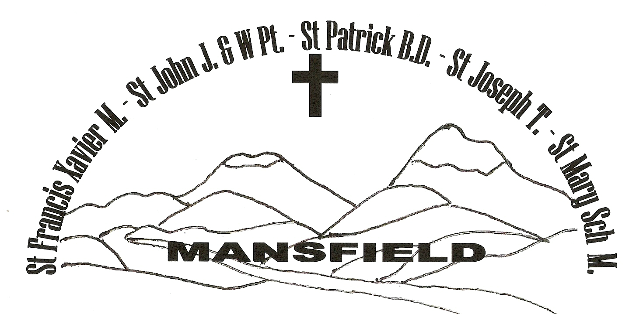
MANSFIELD Parish

Weekly NEWSLETTER
10th/11th July 2021
15th SUNDAY IN ORDINARY TIME YEAR B

The Mansfield Catholic Parish is committed to the safety of children and vulnerable adults

PARISH PRIEST: Fr George Feliciouz OFFICE MANAGER: Nance Rutley
PARISH CENTRE: 54 Hunter St Mansfield 3722 PO Box 288 MANSFIELD 3724
Phone: 5775 2005 Email: Mansfield @cam.org.au Friday 9am - 3.30 pm (this week)

St Mary’s Primary School – Principal & Parish Safety Officer – Mrs Trish Etcell 5775 2670
_______________________________________________________________________________________

- ENTRANCE ANTIPHON: (Used only when there is no Entrance Hymn)
As for me, in justice I shall behold your face; I shall be filled with the vision of your glory.

- RESPONSORIAL PSALM:
R. Lord, show us your mercy and love, and grant us your salvation.
I will hear what the Lord God has to say, a voice that speaks of peace, peace for his people. His help is near for those who fear him and his glory will dwell in our land.
Mercy and faithfulness have met; justice and peace have embraced. Faithfulness shall spring from the earth and justice look down from heaven.
The Lord will make us prosper and our earth shall yield its fruit. Justice shall march before him and peace shall follow his steps.
R. Lord, show us your mercy and love, and grant us your salvation.

- GOSPEL ACCLAMATION:
Alleluia, alleluia! May the Father of our Lord Jesus Christ enlighten the eyes of our heart that we might see how great is the hope to which we are called. Alleluia!

- THE MYSTERY OF FAITH:
When we eat this bread and drink this cup, we proclaim your death, O Lord, until you come again.

- COMMUNION ANTIPHON: (Used only when there is no Communion Hymn)
Whoever eats my flesh and drinks my blood remains in me and I in him, says the Lord.

Anniversary Prayers: Margaret Kirley

Prayers for those who are sick:
Noel Waters. Amy, Shirley Scanlon, George D’Arcy, Amy Duckworth, Logan, Alma O’Brien,
Enzo Robinson, Patricia Lawson, Bernie Carroll, David Arbuthnot, Margaret Ramma, Tom and Bernard Read

To book St Mary’s Hall please call Greg Hogarth on 0408 618 135

St Vincent de Paul (St Mary’s Hall) Tuesday & Friday 1pm – 3pm 5775 3156
President: Zaldah Kirley on 0427 500 260

PARISH PRAYER
Heavenly Father,
We the people of Mansfield Parish entrust you with our prayers, our needs and our hopes.
We thank you for giving us your Son as our Saviour, our life and our inspiration.
Help us to work as one in the Spirit building up the Body of Christ and bringing peace through forgiveness to the world.
May our patrons: St Francis Xavier, St John the Apostle, St Patrick, St Joseph, St John and Mary Help of Christians, pray for us and guide us in the ways of Jesus. AMEN.

EUCHARISTIC CELEBRATIONS – Mansfield

13th - 16th July
Tuesday 6pm Mass
Wednesday 9am Rosary 9.30am Mass
Thursday 9am Rosary 9.30am Mass
Friday 9am Rosary 9.30am Mass
First Fridays 9am Exposition of the Blessed Sacrament

MASSES NEXT SUNDAY 17th/18th July
Saturday 6pm Mansfield
Sunday 9am Mansfield
5pm Bonnie Doon

1st & 3rd Sunday 5.00 pm Bonnie Doon
2nd & 4th Sunday 11.00 am Jamieson
5th Sunday of the Month 11.00 am Tolmie

ROSTERS for 17th/18th July
SATURDAY 17th July:
Reader: Mark Henry
Prayers: Anna McKenzie
Special Minister: Helen Mullins

SUNDAY 18th July:
Reader: Mike O’Halloran
Prayers: Val Kirley
Special Minister: Jan Berry

Counters: David Bock & Ray Close

Church Cleaning: 5/7 – 17/7 Griffin Girls

SACRAMENTS IN THE MANSFIELD PARISH
BAPTISMS
Please call the Parish Office on 5775 2005

MARRIAGES
Please contact the Parish Office on 5775 2005
PLEASE NOTE: 3 months’ notice is required before a wedding.

RECONCILIATION
Saturdays 9.45am & 5.30pm

Sacramental information evening for confirmation candidates and parents - 8th September at 5.30pm
Confirmation - Friday 5th November at 6pm
For further information, please contact the Parish Office.

After the reign of King Solomon, the twelve tribes of Israel were divided into two kingdoms; the northern kingdom of Israel (consisting of ten tribes) and the southern kingdom of Judah (tribes of Judah and Benjamin). The Jerusalem Temple was the religious centre of the southern kingdom of Judah and for the northern kingdom, Bethel was one of the main cult centres. The prophet Amos was from Judah (south) and is seen as a foreigner interfering with the Israelite (northern) religious and political affairs. Amos was chosen by Yahweh to prophesy to the northern kingdom of Israel and did fulfil that mission in spite of rejection. The gospel of Mark this weekend, gives us the account of Jesus sending out his disciple to preach the good news. We have been chosen by the Lord to be, as the psalmist says, a prophetic ‘voice’ of ‘peace, mercy and justice’ even in the face of rejection.
Fr George

The Episcopal Ordinations of Mgr Anthony Ireland and Fr Martin Ashe as Auxiliary Bishops of Melbourne will be held on Saturday, 31 July 2021 at St Patrick’s Cathedral. Please keep them in your prayers.

CHILD SAFETY MEETINGS FOR VOLUNTEERS: Father George will be conducting 2 meetings for all volunteers who are on the rosters on Saturday 31st July at 10.30am and 12noon. Kindly let Nance know which meeting you will be able to attend.

Celebration of Life Fair' on Saturday 23rd October 2021 10.00 am to 2.00 pm
The Mansfield community has passed through difficult times with the bush fires in 2020 and COVID restrictions. The fair is “A community celebration of life, diversity and talents” with Mansfield Ecumenical Christian Community - MECC (Five churches of Mansfield) and the wider community. The Fair will be held on the grounds of the Anglican Church, Catholic Church and Uniting Church.

A DATE FOR YOUR DIARY: There will be a bush dance on Saturday 7th August 2021 7.30pm – 10.30pm in St. Mary's Hall, $25 per family, $10 for singles. Live music and dance calls by the Griffin Family (plus some special guests). BYO Supper and alcohol free event. Tea and coffee will be provided. Numbers will be subject to COVID restrictions so please RSVP by 30th July.
This is an Ecumenical Church event and all profits will go towards the upcoming Mansfield Ecumenical Christian Community (M.E.C.C.) Fair. Contact Bridget on 0437 219 046 or Maja 0403 000 693 for more information.

Mansfield Catholic Parish


