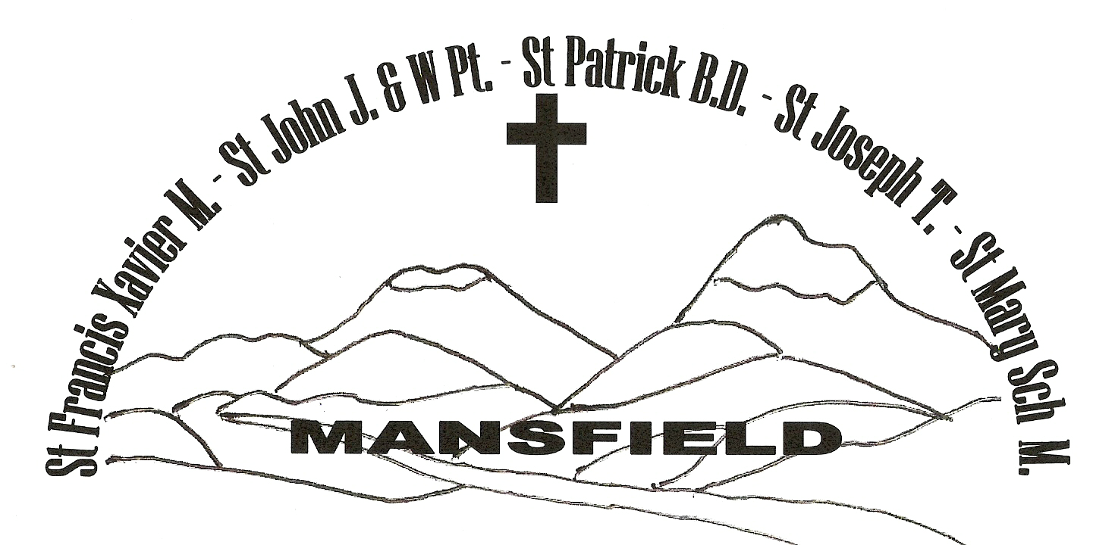
MANSFIELD Parish

Weekly NEWSLETTER
14th/15th August 2021
THE ASSUMPTION OF THE BLESSED VIRGIN MARY
YEAR B

The Mansfield Catholic Parish is committed to the safety of children and vulnerable adults

PARISH PRIEST: Fr George Feliciouz OFFICE MANAGER: Nance Rutley
PARISH CENTRE: 54 Hunter St Mansfield 3722 PO Box 288 MANSFIELD 3724
Phone: 5775 2005 Email: Mansfield @cam.org.au
Office Hours: Wednesday & Friday 9am – 3.30pm. Rather than visit, we would prefer that you call or email Nance.

St Mary’s Primary School – Principal & Parish Safety Officer – Mrs Trish Etcell 5775 2670
_______________________________________________________________________________________

- ENTRANCE ANTIPHON: (Used only when there is no Entrance Hymn)
A great sign appeared in heaven: a woman clothed with the sun, and the moon beneath her feet, and on her head a crown of twelve stars.

- RESPONSORIAL PSALM:
R. The queen stands at your right hand, arrayed in gold.
The daughters of kings are among your loved ones. On your right stands the queen in gold of Ophir. Listen, O daughter, give ear to my words: forget your own people and your father’s house.
So will the king desire your beauty: He is your lord, pay homage to him. They are escorted amid gladness and joy; they are escorted amid gladness and joy; they pass within the palace of the king.
R. The queen stands at your right hand, arrayed in gold.

- GOSPEL ACCLAMATION:
Alleluia, alleluia! Mary is taken up to heaven, and the angels of God shout for joy. Alleluia!

- THE MYSTERY OF FAITH:
Save us, Saviour of the world, for by your Cross and Resurrection you have set us free.

- COMMUNION ANTIPHON: (Used only when there is no Communion Hymn)
All generations will call me blessed, for he who is mighty has done great things for me.

Prayers for those who have died: Noel Waters

Anniversary prayers: Anne Develin and Terry Kirley

Prayers for those who are sick:
Amy, George D’Arcy, Amy Duckworth, Logan, Alma O’Brien, Enzo Robinson, Patricia Lawson, Bernie Carroll, David Arbuthnot, Margaret Ramma, Tom and Bernard Read

To book St Mary’s Hall please call Greg Hogarth on 0408 618 135

St Vincent de Paul (St Mary’s Hall) Tuesday & Friday 1pm – 3pm 5775 3156
President: Zaldah Kirley on 0427 500 260

PARISH PRAYER
Heavenly Father,
We the people of Mansfield Parish entrust you with our prayers, our needs and our hopes.
We thank you for giving us your Son as our Saviour, our life and our inspiration.
Help us to work as one in the Spirit building up the Body of Christ and bringing peace through forgiveness to the world.
May our patrons: St Francis Xavier, St John the Apostle, St Patrick, St Joseph, St John and Mary Help of Christians, pray for us and guide us in the ways of Jesus. AMEN.

EUCHARISTIC CELEBRATIONS – Mansfield

17th – 20th August
Tuesday 9am Rosary 9.30am Mass
Wednesday 9am Rosary 9.30am Mass
Thursday 9am Rosary 9.30am Mass
Friday 9am Rosary 9.30am Mass
First Fridays 9am Exposition of the Blessed Sacrament

MASSES NEXT SUNDAY 21st /22nd August
Saturday 6pm Mansfield
Sunday 9am Mansfield
5pm Bonnie Doon
1st & 3rd Sunday 5.00 pm Bonnie Doon
2nd & 4th Sunday 11.00 am Jamieson

29th August 11.00 am Tolmie

ROSTERS for 21st/22nd August
SATURDAY 21st August:
Reader: Mark Henry
Prayers: Anna McKenzie
Special Minister: Rita Riley

SUNDAY 22nd August:
Reader: Val Kirley
Prayers: Mike O’Halloran
Special Minister: Zaldah Kirley

Counters: Pat Gardiner & John Berry

Church Cleaning: 16/8 – 28/8 Griffin Girls
Maintenance:
16/8 – 28/8 David Bock Front of Church
16/8 – 28/8 Greg Hogarth Back of Church & back of Father George’s residence

SACRAMENTS IN THE MANSFIELD PARISH
BAPTISMS
Please call the Parish Office on 5775 2005

MARRIAGES
Please contact the Parish Office on 5775 2005
PLEASE NOTE: 3 months’ notice is required before a wedding.

RECONCILIATION
Saturdays 9.45am & 5.30pm

Sacramental information evening for confirmation candidates and parents - 8th September at 5.30pm
Confirmation - Friday 5th November at 6pm
For further information, please contact the Parish Office.

The Assumption and Queenship of Our Lady
In the Davidic monarchy, the queen-mother, or gevirah (“lady” feminine form of gevir “lord”) played an important role. This was the kings' way of fulfilling the Commandment to honour their mothers. This tradition is consistent with God's command “Honour you father and mother” (Ex 20:12). He could not honour his father, who was dead, so he honoured his mother by enthroning her next to him and giving her a share in his reign. Each time the Bible records a king of Judah, it mentions his mother because she was the gevirah, and so had a special place in his court. The prophet Jeremiah sends a warning to both the king and his mother (Jer 13:18), and the Babylonians took both King Jeconiah and his mother away into captivity (2 Kings 24:15; Jer 29:2). In the Davidic kingdom, it was the mother of the king who ruled as queen, not the king’s wife.
In his gospel, Matthew mentions “the child and his mother” (Matthew 1:18; 2:11, 13, 14, 20, 21) five times in chapter two alone. Its recurrence has “a Davidic resonance” that brings to mind the way the Book of Kings repeatedly introduces each new Davidic king alongside the queen mother. The angel announces to Mary in Luke 1: 32-33 that the ‘child will be the son of David’, fulfilling God’s promise to David in 2 Samuel 7: 12-14. Hence, Mary as mother of the Davidic King, Jesus Christ, is the queen mother of her royal son. Mary’s Assumption and Queenship has been expressed in the Church’s Tradition and magisterial pronouncements throughout the centuries. Early Church Father Origen (c.184- c.253) viewed Elizabeth’s greeting Mary with words “mother of my Lord” as honouring her with royal dignity.
In 1950, 1st November, All Saints Day, through the apostolic constitution Munificenttisimus Deus, Pope Piux XII proclaimed this traditional belief of the Assumption and Queenship of Mary as official Dogma in the Catholic Church.…….’We pronounce, declare, and define it to be a divinely revealed dogma: that the Immaculate Mother of God, the ever Virgin Mary, having completed the course of her earthly life, was assumed body and soul into heavenly glory……. as Queen, she sits in splendour at the right hand of her Son, the immortal King of the Ages.’

Fr George

A DATE FOR YOUR DIARY: A Sacramental information evening for confirmation candidates and parents will be held on 8th September at 5.30pm in St Francis Xavier’s Church

CONCERT POSTPONMENT: The RAR sponsored concert has been postponed until Sunday, December 5 at 3.00pm.

CATHOLICCARE APPEAL: CatholicCare Victoria delivers counselling and mental health services, homelessness support and pastoral care. Donations from our parish community will help support them. You can donate to this worthy cause at www.catholiccarevic.org.au, by direct deposit to CatholicCare Victoria BSB 083 347 Acct no 171 551 421 Bank NAB or call 9287 5513.

Mansfield Catholic Parish


