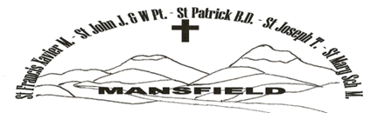
MANSFIELD CTHOLIC PARISH COVID SAFE PLAN
Hygiene Requirements:

Hand sanitiser stations in church entrances and St Mary’s Hall.

Wear face masks indoors and if 1.5 metres distance cannot be maintained.
In areas or where it is required, ensure all wear a face mask unless a lawful exception applies.

Physical distancing and increasing ventilation.

Minimise prolonged face-to-face contact.

Musical instruments must be wiped with a disinfectant wipe between uses.

Avoid sharing of food and drink (does not apply if catered in accordance with COVID safety regulations).

Where possible, enhance airflow (opening windows and adjusting air conditioning).

Sanitizing and Cleaning:

Ensure surfaces are cleaned and disinfected regularly.

Cleaning and disinfection of any shared equipment or furniture between groups (where use cannot be avoided).

Practice good hygiene – Sanitize hands.

After each service sanitize the pews or furniture used with the sanitizing napkins provided in the churches/buildings.
Physical distancing:

Configure areas - no more than one individual per two square metres of enclosed areas spaced at least 1.5 metres apart.

Consider installing barriers.

Apply density quotients (in churches and buildings).

Avoid carpooling where possible (unless with members of same household).
Record keeping:

Records – Using the Victoria QR Code all people who enter the churches and church halls to enter their names and phone numbers for contact tracing purposes.
Or
A contacting tracing register for names and phone numbers.

This includes ALL visitors, employees, contractors, clergy, volunteers, and parishioners.

