St Francis of Assisi, Mill Park
Child Safety Code of Conduct

01/01/2017

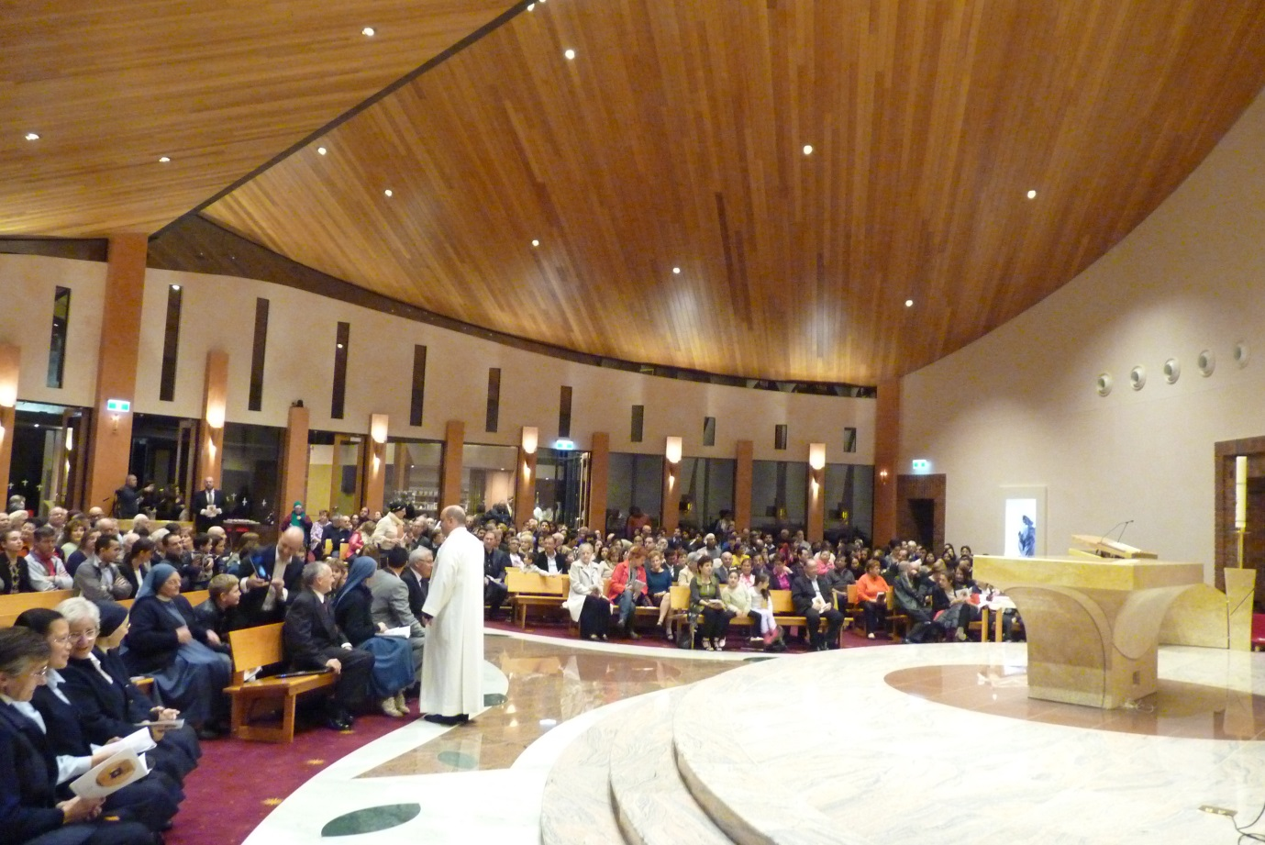
Date of policy: 1/1/2017
Date of last major review: 21/12/2016
Date of next major review: 1/12/2017
Safeguarding Children and Young People
Code of Conduct
St Francis of Assisi Parish, Mill Park,
01/01/2017
Central to the mission of St Francis of Assisi Parish, Mill Park, is an unequivocal commitment to fostering the dignity, self-esteem and integrity of children and young people and providing them with a safe, supportive and enriching environment to develop spiritually, physically, intellectually, emotionally and socially.
Purpose
This Code of Conduct has a specific focus on safeguarding children and young people at St Francis of Assisi Parish, Mill Park, against sexual, physical, psychological and emotional abuse or neglect. It is intended to complement child protection legislation and the Catholic Archdiocese of Melbourne’s “Code of Conduct for Caring for Children, May our children flourish”.
All staff, volunteers, contractors, clergy and parish council members at St Francis of Assisi Parish, Mill Park, are expected to actively contribute to a parish culture that respects the dignity of its members and affirms the Gospel values of love, care for others, compassion and justice. They are required to observe child-safe principles and expectations for appropriate behaviour towards and in the company of children, as noted below.
Acceptable behaviours
All staff, volunteers, contractors, clergy and parish council members are responsible for supporting the safety of children by:
- adhering to the parish Child Safe Policy and upholding the parish’s Statement of Commitment to child safety at all times
- taking all reasonable steps to protect children from abuse and harm
- treating everyone in the parish community with respect (modelling positive and respectful relationships and acting in a manner that sustains a safe pastoral environment)
- listening and responding to the views and concerns of children, particularly if they are telling you that they or another child have been abused or that they are worried about their safety/the safety of another child
- promoting the cultural safety, participation and empowerment of Aboriginal and Torres Strait Islander children (for example, by never questioning an Aboriginal and Torres Strait Islander child’s self-identification)
- promoting the cultural safety, participation and empowerment of children with culturally and/or linguistically diverse backgrounds (for example, by having a zero tolerance policy towards discrimination)
- promoting the safety, participation and empowerment of children with a disability (for example, by ensuring reasonable care is taken to cater for any additional needs being faced)
- ensuring as far as practicable that an adult is not alone with a child
- reporting any allegations of child abuse to the police
- understanding and complying with all reporting obligations as they relate to mandatory reporting and reporting under the Crimes Act 1958 (Vic.)
- reporting any child safety concerns to the parish priest or the Vicar General if the concern relates to the parish priest (or child safety officer if the parish has appointed someone to this role)
- if an allegation of child abuse is made, ensuring as quickly as possible that the child(ren) are safe.
Unacceptable behaviours
Staff, volunteers, contractors, clergy and parish council members must not:
- ignore or disregard any suspected or disclosed child abuse
- develop any ‘special’ relationships with children that could be seen as favouritism (for example, the offering of gifts or special treatment for specific children)
- exhibit behaviours with children which may be construed as unnecessarily physical (for example, inappropriate sitting on laps)
- put children at risk of abuse (for example, by locking doors or being alone with a child with no good cause)
- initiate unnecessary physical contact with children or do things of a personal nature that a child can do for themselves, such as toileting or changing clothes
- manage disruptive or unsafe behaviour by degrading or isolating a child; corporal punishment is never acceptable. Physical restraint should only be used as a last resort or in an emergency
- engage in open discussions of a mature or adult nature in the presence of children (for example, personal details or social activities)
- use inappropriate language in the presence of children
- express personal views on cultures, race or sexuality in the presence of children
- discriminate against any child because of age, gender, race, culture, vulnerability, sexuality, ethnicity or disability
- have contact with a child or their family who is/are not socially related outside of the pastoral duties reasonably associated with the role description of the person’s position in the parish without the parish priest’s or child safety officer’s (if the parish has appointed someone to this role) knowledge and/or consent (other than accidental contact, such as seeing people in the street)
- have any online contact (including by social media, email, instant messaging etc.) with a child or their family who is/are not family or socially related (unless necessary e.g. by providing families with e-newsletters)
- use any personal communication channels/device such as a personal email account to conduct parish communications
- exchange personal contact details such as phone number, social networking sites or email addresses with a child or their family who is/are not family or socially related
- photograph or video a child without the consent of the parent or guardians
- work with children while under the influence of alcohol or illegal drugs
- consume drugs on parish premises or at parish events.

