Monty & Eltham
The Catholic Parishes of
St Francis Xavier & Our Lady Help of Christians

SAFEGUARDING CHILDREN AND YOUNG PEOPLE

Risk Management Strategy

Date of policy: 1 March 2021 Version 4

PURPOSE
The purpose of this strategy is to eliminate and minimise risk to child safety to ensure the safety and well-being of all children at St Francis Xavier Montmorency and Our Lady Help of Christians Eltham Parishes.

SCOPE
Children, full-time, part-time and casual employees of the parishes, Parish Leadership Group members, as well as contractors, volunteers, people undertaking work experience or vocational placements and any person regularly on church grounds, are responsible for acting in compliance with this Risk Management Strategy and related policies and procedures.

COMMITMENT OF THE PARISHES
St Francis Xavier Montmorency and Our Lady Help of Christians Eltham Parishes.is committed to the safety and wellbeing of all children in our parish communities. In accordance with the Victorian Child Safe Standards and relevant legislative requirements within the state of Victoria and Catholic Archdiocese of Melbourne Safeguarding Children and Young People Framework. St Francis Xavier Montmorency and Our Lady Help of Christians Eltham Parishes are dedicated to eliminating and minimising risks to children.
The Parishes will endeavour to provide a safe and supportive environment for children and young people through maintaining a positive culture and appropriate services to meet the needs of our children.

IMPLEMENTATION
The risk management process summarised in this Strategy has been adapted from Managing Risk in Catholic Organisations (Catholic Church Insurance n.d.), which is aligned with the national standard for risk management, AS/NZS ISO 31000: 2009 Risk management – principles and guidelines.
Figure 1 illustrates each stage of the risk management process. The risk management processes detailed below focuses specifically on child safety risks, illustrated with relevant examples.
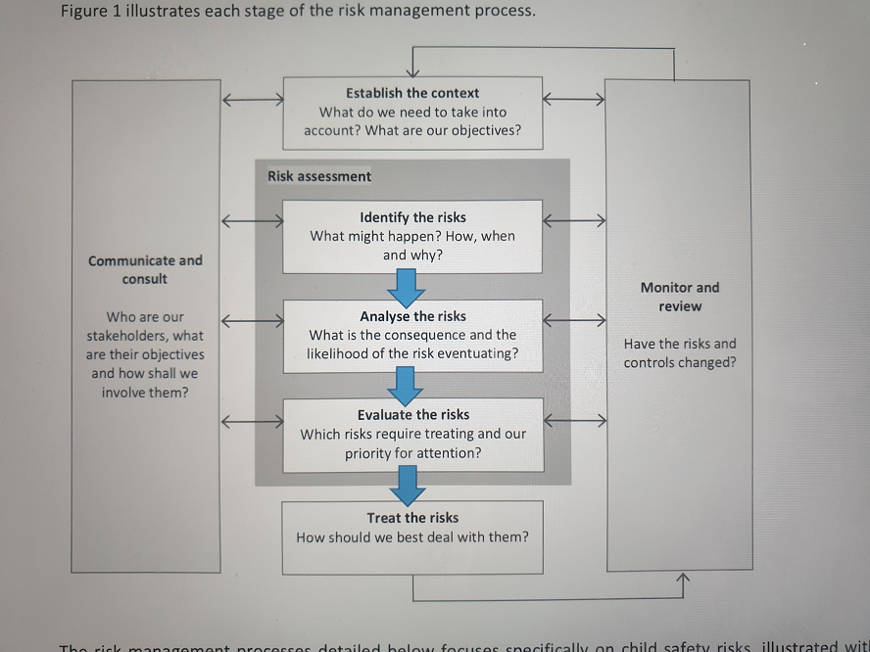

STEP 1: CONSULT WITH STAKEHOLDERS
Consultation with stakeholders within both parishes is a necessary component to ensure a comprehensive and relevant response to risk. This is because stakeholders will be aware of the possible risks associated with programs, activities and events and know the vulnerabilities within the organisation.
Consultation increases the likelihood of identifying all potential risks that might result in harm to children and young people. Consultation is also beneficial for other reasons:
• It demonstrates that an organisation is taking a proactive approach to child safety.
• It reinforces the openness of the organisation to talking about child safety and listening to stakeholders.
- It acknowledges that child safety is everyone’s responsibility.
- It provides an opportunity for stakeholders to contribute their views on keeping children and young people safe.
Children and young people as participants of programs, activities and events are key stakeholders and will often provide valuable insights from their unique perspective. See INFORMATION SHEET: Consulting with Children and Young People in the CAM Safeguarding Children and Young People Framework.
STEP 2: ESTABLISH THE CONTEXT
Understanding the context of the parishes, as a whole, and of specific programs, activities or events is important in identifying and evaluating potential risks.
A range of contextual factors impact on the risk assessment process, including:
• the mission and objective of the parish, agency or entity
• the key objectives of programs, activities and events
• the needs of particular children including Aboriginal and Torres Strait Islander children, culturally and linguistically diverse children and children with a disability
• the needs and characteristics of the community in which the parish, agency or entity operates
• the needs and expectations of stakeholders (e.g. clergy, employees, volunteers, parishioners, clients, parents, children and young people)
• resources (e.g. staffing, expertise, equipment, venues)
• the physical environment
• regulatory requirements (e.g. work, health and safety legislation, Victorian Child Safe Standards)
• understanding of key risk factors for child abuse within the organisational environment.
When assessing and evaluating child safety risk in relation to children and young people in a parish, agency or entity, each unique context provides valuable insight into potential risks.
STEP 3: RISK ASSESSMENT – IDENTIFY, ANALYSE AND EVALUATE RISK
When undertaking risk assessment, it is useful to begin by identifying child safety risks from the ‘overall’ perspective of the parishes. Implementing risk management strategies at the ‘overall’ parish, level will significantly reduce child safety risks at the program, activity and event level. For example, the implementation of our robust and thorough selection and recruitment strategy has increased the likelihood of suitable employees and volunteers working with and delivering appropriate services to children and young people.

FOUR DIMENSIONS OF RISK Further, Parkinson and Cashmore (2017), in research commissioned by the Royal Commission into Institutional Responses to Child Sexual Abuse, identified four dimensions of risk within an organisational setting that contribute to child sexual abuse.
- SITUATIONAL RISK refers to opportunities for abuse to occur in organisational environments (e.g. nature of activities, physical facilities/environments, opportunities to be alone with a child, to engage in grooming behaviour, to cross boundaries and to engage in abuse). Child safety can be improved when organisations proactively minimise situational risks. See INFORMATION SHEET: Situational Crime Prevention. CAM Safeguarding Children and Young People Framework.

- VULNERABILITY RISK relates to characteristics of children and young people which may increase the risk of abuse. All children and young people are inherently vulnerable to abuse, however additional factors, such as disability, age, language barriers, lack of parental supervision/support, previous experience of abuse and cultural background, may increase a child or young person’s vulnerability to abuse.

- PROPENSITY RISK is characterised by an increased probability of some adults to engage in behaviours that may pose a risk to children and young people (e.g. those who have a sexual interest in children, those with anti-social tendencies, those who have previously engaged in sexual misconduct or abuse).

- INSTITUTIONAL RISK refers to characteristics of an organisation (as distinct from the activities that it runs) that impede prevention efforts, where child safety is not prioritised and where organisational culture (or structures) contribute to or promote misconduct (e.g. an organisational culture that turns a ‘blind eye’ or condones abuse).

STEP 3A: IDENTIFY POTENTIAL RISKS TO CHILDREN AND YOUNG PEOPLE
Exploring risk at the program, activity and event level provides an opportunity to identify risks that may be specific to a program, activity or event. When planning an activity, consider the possible risks associated with the activity and how likely those risks are to eventuate. Consider what actions you can take or how you can structure the activity to minimise those risks and, if a situation should arise, how to manage it effectively.
Relevant questions to identify possible risks at the program, activity or event level are:
• What is the program, activity or event?
• What is the purpose of the program, activity or event?
• What could go wrong?
• How might a child or young person be harmed?
• What are the elements of the activity or event from start to finish?
• Where is the program, activity or event being held?
• What are the ‘red flag’ areas of concern?
• Are there any characteristics of the physical environment that may pose a risk to children and young people?
• Who is involved in the activity?
• Are there any workplace health and safety risks that might impact children and young people?
STEP 3B: IDENTIFY AND EVALUATE RISK CONTROLS
Once risks have been identified, it is important to assess the risk controls that are currently in place to manage or mitigate a risk.
“A risk control is any measure designed to modify or reduce a risk and might include current policies and procedures, safety systems, training programs and governance practices. Catholic Church Insurance n.d., p. 10”
STEP 3C: EVALUATE THE CONSEQUENCES
Once the effectiveness of the control has been assessed, it is helpful to analyse the consequences if the risk were to occur using the Consequence Rating table contained within CAM Safeguarding Children and Young People Framework.

STEP 3D: EVALUATE THE LIKELIHOOD
Once we have determined the possible consequences of a risk occurring, it is useful to determine the likelihood of each consequence occurring. Likelihood can be assessed according the categories listed in the CAM Safeguarding Children and Young People Framework.

STEP 4: DEVELOP A RISK TREATMENT ACTION PLAN
The overall risk ratings assist in prioritising risks that need to be addressed to effectively safeguard children and young people. In exploring possible treatment options for the risks that have been identified, consideration needs to be given to the following questions:
• Which risks are acceptable?
• Do existing risk treatment strategies sufficiently address the risk?
• What is practical and/or possible given available resources (e.g. financial, staffing, physical environment)?
• What is the cost-benefit of treatment measures?
• What is the relationship of each risk to other risks? Is it possible to implement one treatment strategy that addresses a range of risks? e.g. using the Safeguarding Children and Young People Policy and Code of Conduct as part of the induction process for volunteers helps to establish expectations with regard to the appropriate treatment of children, supervision, and appropriate role boundaries.

STEP 5: REGULAR REVIEW BY THE PARISH SAFEGUARDING COMMITTEE

Regular review ensures that risks are reviewed, that control measures have been implemented and that control measures are assessed for their effectiveness. Reviews may be conducted at regular intervals, or they may be prompted by a new program, activity or event, a change in the operating context of either or both parishes. Alternately a review may be in response to a new risk that has emerged or an incident that has taken place.
All reasonable attempts will be made to communicate and consult with stakeholders about reviews of child safety to demonstrate the ongoing and proactive stance of the parishes, and to seek feedback from stakeholders.

COMPLIANCE AND MONITORING

St Francis Xavier Montmorency and Our Lady Help of Christians Parishes is committed to the regular review of this strategy.

History of Updates to Policy

Date | Comment (e.g. major review, minor review)
November 2016 | Development of original documentation
March 2017 | Review to amend gaps and inaccuracies.
September 2017 | Review to amend gaps, inaccuracies and inclusion of the 7 Child Safety Standards, as an attachment.
October 2019 | Rewrite of Policy to harmonise with revised National and Archdiocesan Policies
March 2021 | Rewrite of Policy to harmonise with revised Archdiocesan Policies

