SQUARES FOR RUGS.

Any colours (bright are preferred) 8 ply wool (or nylon or combinations) and using size 4.00 (8 in the old scale) knitting needles. When you have enough squares they can be sewn up or crotched together and then work a shell crotch stitch around the whole rug to help keep it firm.
Knitted Squares – Method 1
Cast on 40 stitches.
Knit each row plain (garter stitch).
Knit until work measures a square (about 80 rows) – lift bottom left hand corner to top right-hand corner and when cast on edge meets right side edge you have a square).
Cast off.
Squares can be striped but make sure that you start each new colour on the front side of the square.

Knitted Squares – Method 2 (For more experienced knitters) Corner to Corner

Draw a 15cm or 20cm square onto a piece of cardboard. This will be your template to ensure that the square will end up either 15cm or 20cm.
Tie on one stitch.
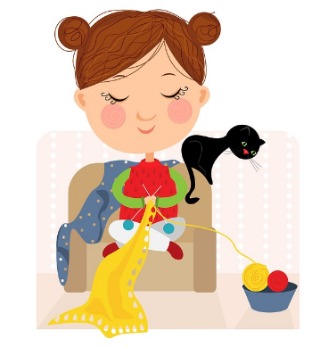
1st Row: Increase in first stitch, knit one.
2nd Row: Increase in first stitch, knit two.
3rd Row: Increase in first stitch, knit three.
Continue in this way increasing at the start of each new row until work measures inside of your template. Then continue in the flowing way:

Next Row: Knit to last two stitches, knit last two stitches together.
Next Row: Knit to last two stitches, knit last two stitches together.
Next Row: Knit to last two stitches, knit last two stitches together.
Continue in this way decreasing at the end of each new row until you have three stitches left.
Last Row: slip one, knit two together, pass slip stitch over.
Break off wool (leaving about 30cm) and thread through remaining loop and pull tight.

Knitted Squares – Method 3 Corner to Corner

Cast on three stitches.
1st Row: Knit 1: make 1 into the next stitch. Knit to end of row.
Continue like this at the start of each row until 70 stitches are on the needle.
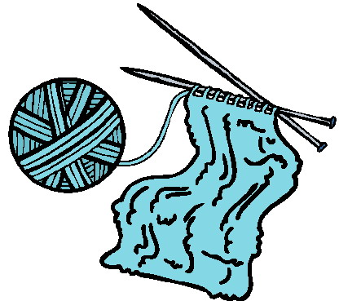
Next Row: start decreasing: knit 1, knit 2 tog on next stitch. Knit to end of row.
Continue like this until 3 stitches remain.
Cast off.
This will make a nice border on every square.

