Moving locally stored profile items to a new server
SOLUTION (Steps to resolve with clear screen shots included):
- Whilst logged in to your existing POL session. We are going to copy your local information to store on a server
(We do this so we can move to any pc & your information becomes portable, for example, website links to CDF, documents, signatures and any items you may have saved on your POL desktop.)
- Navigate to your Y drive via File Explorer and right click on the white space.
- Select “New Folder” and call it POL Desktop.
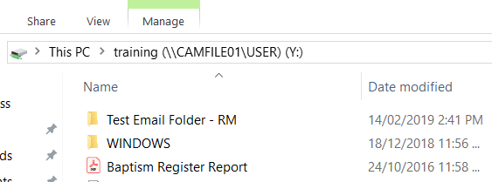
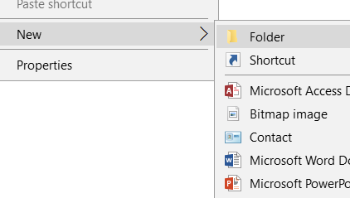
- In File Explorer, navigate to C Drive – Users – find your login name and double click on it. A screen like the below will appear:
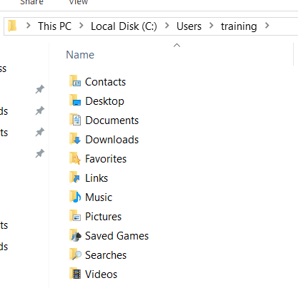
- Press Control + A to select all items.
- Right click and select CUT. Move then into the New Folder you created in step 3.
- Log on to your new server.
- Retrieve these items from your Y Drive and paste them to the C Drive – Users – username – replace what is already in the folder.

If you have trouble at any stage, please email new.work@cam.org.au.

