Turn on the debtors module to enable invoicing
- Go to Maintenance
- Setup
- Parish tab
- Put a Tick in Enable Debtors Module.
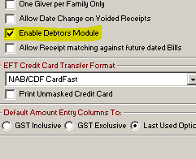
- This will then show you extra menu items under ‘Receipts’
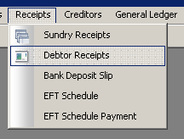
- This will change the options on your member tab too. It will now show a Debtors Tick. It will make three additional tabs on the far right hand side available – Payment, Accounts, Schedule. I can also add in an opening balance on this page.
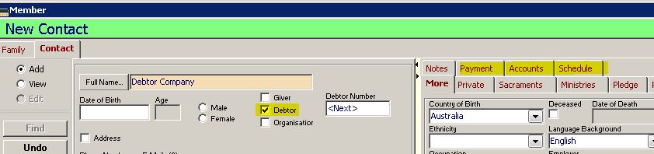
- You can select your debtor once you have added them into the system.
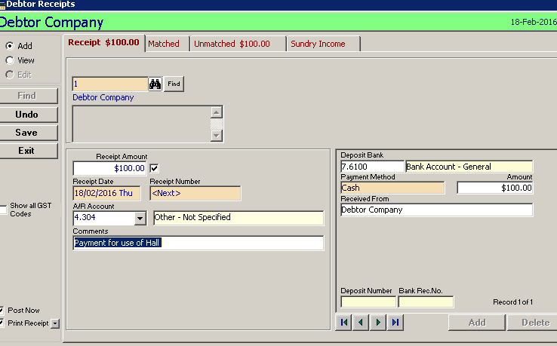
- Once saved, you can then generate a Debtor receipt.
- To use your own letterhead –please see quick answer 53 in POL Online Help.

