**Sacred Heart Parish Yea – 28th July 2024**

**17th Sunday of Ordinary Time**

**Recently Deceased**: We keep in our prayers all recently deceased, and those who’s anniversaries occur around this time, that they dwell for ever in God’s loving embrace. And we pray for the sick. Lord, hear us.

**Anniversaries**: Catherine Williams, Ken Hard, Bridget Walsh, Jack McLeod, Fr John Wallis, Dan Wentworth, and Catherine Harnett

|  |  |  |  |  |
| --- | --- | --- | --- | --- |
| **Collections last Sunday** | | |  |  |
| Presbytery Account | | $365.00 | Direct Credit | $.00 |
| Church Account  Special Collection | | $242.50  $0.00 | Direct Credit | $700.00 |
| **Church Deposits by Direct Credit** | | | |  |
| **Presbytery Account –** for the welfare of bishops and priests | | | | |
| **Sacred Heart Presbytery Account** | | | |  |
| BSB | 633 000 | | Account number | 150 264 992 |
| **Church Account –** for our parish, its mission, welfare and maintenance: | | | | |
| **Sacred Heart Church Account** | | | |  |
| BSB | 633 000 | | Account number | 150 264 778 |

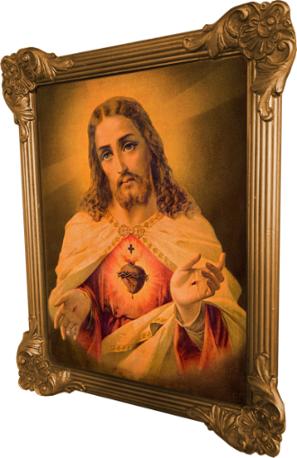**Prayers for those who are sick:** Sue Noble, Kate Pittle, Barbara O’Donnell, Rod McKenzie, Michael Tomlinson, Tony Dwyer, Julie Mahony, Len Regan, David Heath and Monika Matteo.

***We welcome the members of the Missionary Sisters of Service to our Mass this morning.***

***All are welcome to join the Morning Tea in the Presbytery after Mass this morning.***

**Peter’s Pence Appeal –** Thank-you for your generous contributions. $116.50 was raised to donate to the works of the Peter’s Pence Appeal for 2024.

**World Day for Grandparents and the Elderly:**

**On Sunday July 28, we celebrate the fourth World Day of Grandparents and the Elderly. The date is chosen to coincide with the Feast of Saints Joachim and Anne (grandparents of Jesus) during the week.  
  
Pope Francis has chosen the theme "Do not cast me off in my old age" (cf. Psalm 71:9)**

**SAINTS FOR THIS WEEK: ST JOACHIM & ST ANNE**

Saints Joachim and Anne, are the parents of the Virgin Mary. There are no mentions of them in the Bible or Gospels, what we know comes from Catholic legend and the Gospel of James, which is an unsanctioned, apocryphal writing from the second century AD. This manuscript tells the story that Mary was promised to Joachim and Anne by an angel, was consecrated to God, and she remained a virgin all her life. Mary had good, faithful parents who raised her with a love and devotion to God like none other except Jesus Christ Himself. Joachim and Anne serve as role models for parents, and both deserve to be honoured and emulated for their devotion to God and Our Lady Mary, the Mother of God.

|  |  |  |  |  |  |
| --- | --- | --- | --- | --- | --- |
| **Roster** | **Readers** | | **Prayers** | **Counter** | **Flowers** |
| 21st June 2024 | Z. Taylor, J. Anderson | M. Lockhart | | A. O’Leary | H. Hauser |
| 28th July 2024 | M. Lockhart. J. Forde | C. Rattray | | E. McAleer | M. LockhartP |

**Sacred Heart Parish Yea**

Established 1890

Email: [yea@cam.org.au](mailto:yea@cam.org.au)

Phone: (03) 5899 9128

P.O. Box 61 YEA 3717

Website: www.shyea.catholic.edu.au

**Holy Mass Times**

Yea –Sunday 10:45am, Tuesday 5:00pm and Rosary, Thursday 9:00am

Alexandra – Sunday 8:45am, Wednesday 9:30am, Friday 9:00am

Parish Priest:

**Fr Jose Mathew** 0459 402 547

Secretary:   
**Sacred Heart Primary School**  
Principal: Kathryn Stuart

03 5797 2723

Reconciliation: **Fr Jose Mathew** 0459 402 547

Yea – Tuesday before Mass from 4:30pm and Sunday after Holy Mass approximately at 11:45am

Alexandra – Friday before Holy Mass and before Sunday Holy Mass from 8am