**+**

**St. Luke the Evangelist Catholic Church**

|  |  |  |
| --- | --- | --- |
| **22 July 2017**  **16th Sunday**  **in Ordinary Time**  **Year A** | **Parish Administrator: *Fr. Dishan Candappa***  **Priest in Residence*: Fr. Zaher Mhanna***  **School Principal: *Mrs Jackie Purcell***  **Parish Secretary: *Miss Marilyn Robert*** | **46 ORCHARD GROVE**  **PO BOX 2140**  BLACKBURN SOUTH 3130  Email: BlackburnSouth@cam.org.au  *PARISH Phone No: 9877 2292*  *SCHOOL Phone No: 98774023* |

## 

## **MASS TIMES**

**Week Days**

|  |  |  |
| --- | --- | --- |
| Monday | 9.00 AM | Mass |
| Tuesday | 11.00 AM | Mass |
| Wednesday | 9.00 AM | Mass |
| Wednesday | 7.30PM | Mass |
| Thursday | 9.00 AM | Mass |
| Friday | 9.00 AM | Mass |
| Saturday | 9.00 AM | Mass |

**Sundays**

Saturday Night Vigil Mass 6.00 PM

Sunday Mass 8.30 AM & 10.30 AM

**Reconciliation**

Saturday 9:30 AM / 5:30 PM

Wednesday – 6.30PM

Or by Appointment

**Adoration**

Wednesday – 6.30PM to 7.30pm

**Novena – Our Lady of Perpetual Help**

Wednesday – 7.00PM

## **COMMUNION MINISTERS ROSTER**

|  |  |  |  |  |  |  |
| --- | --- | --- | --- | --- | --- | --- |
|  |  | **22 and 23 July** | **29 and 30 July** | **22 and 23 July** | **1 and 2 July** | **17 and 18 June** |
| Saturday | 6:00 PM | Olive Hammill | Terry Wells | Olive Hammill | Olive Hammill | Monica Hodder |
| Sunday | 8:30 AM | Kana Chelliah | Beryl Chelliah | Kana Chelliah | Godfrey Thong | Beryl Chelliah |
|  | 10:30 AM | Margaret Yore | Sonya O’Farrell | Margaret Yore | Lizzie Dixon | Lynda Kilroe-Smith |

## **MINISTERS OF THE WORD ROSTER**

|  |  |  |  |
| --- | --- | --- | --- |
| Saturday | 6:00 PM | Mia Perang | Melina Barcellona |
| Sunday | 8:30 AM | Beryl Chelliah | Kana Chelliah |
|  | 10:30 AM | Margaret Gearon | Marg Yore |
|  |  |  |  |

## **WELCOME ROSTER**

|  |  |  |  |
| --- | --- | --- | --- |
| Saturday | 6:00 PM | Terry Wells | Greg Grant |
| Sunday | 8:30 AM | Marie Pekish | Joe Brogno |
|  | 10:30 AM | Debbie Brown | Dixon Family |
|  |  |  |  |

**SLIDE OPERATION**

|  |  |  |  |
| --- | --- | --- | --- |
| Saturday | 6:00 PM | David Prabha | Tony Lobo |
| Sunday | 8:30 AM | Rosemary Donaldson | Mary White |
| **CHURCH FLOWERS**  29/7 – Lesley Cormick & Toni  Plevier  5/8 – Joan McHugh | | **CHURCH CLEANING**  29/7 – Team 1  (Val’s Team)  5/8 – Team 2  (Monica’s Team) | **MAINTENANCE**  29/7 – Team 1  (Bob Dimmattina & Steve Kilroe-Smith) |

## 

[Type a quote from the document or the summary of an interesting point. You can position the text box anywhere in the document. Use the Drawing Tools tab to change the formatting of the pull quote text box.]

[Type a quote from the document or the summary of an interesting point. You can position the text box anywhere in the document. Use the Drawing Tools tab to change the formatting of the pull quote text box.]

**3.** **Special Collection this week – July 22/23 July**

**PROPOGATION of the FAITH – CATHOLIC MISSION**

Thank you for your ongoing support of the parish on behalf of the missionaries and communities around the world who benefit directly from your contribution. This year, we focus on our partnership with the parish of Bujuni in Uganda.

Thank you for your kind and generous contribution.

**FEAST DAYS DURING THE WEEK**

**Tuesday, 25 July – FEAST - St. James, apostle**

**Wednesday, 26 July – MEMORIAL – Sts Joachim and Anne**

**Saturday, 29 July – MEMORIAL – St. Martha**

**NOTICES**

1. **Thank you for Prayers & Support – Fr. Dishan**

My family and I would like to thank each and every one of you for your prayers & support and for attending the funeral of my Dad.

1. **Post World Youth Day Youth joining us for Mass next week - 10.30AM Mass.**

A few youth from the World Youth Day will be joining us for Mass next Sunday at the 10.30AM Mass.

**PLEASE CHECK T**HE NOTICEBOARD FOR ANY INFORMATION THAT MAY BE OF INTEREST TO YOU

*[Kindly do not place* ***any material on the Notice Board/Foyer Table without first asking permission]***

For Hall hire & inquiries phone –

9877 2292

Please send **NEWSLETTER NOTICES**

to the following e-mail address by ***Wednesday 5pm*** –

**BlackburnSouth@cam.org.au**

**Year of Mercy**

Pope Francis said he goes to confession every two weeks, knowing that God never tires of forgiving those who repent, but also knowing that having a priest say “I absolve you” reinforces belief in God’s mercy.

Using the literal Italian translation of a Spanish saying, “It’s better to turn red once than yellow a thousand times,” Pope Francis said he knows some people are embarrassed to confess their sins to a priest, but it is the best path to spiritual healing and health.

The only people God will not forgive are those who do not want God’s forgiveness, just like only those who stand in the shade are not warmed on a sunny day, Pope Francis said.

**16th Sunday in Ordinary Time – Year A**

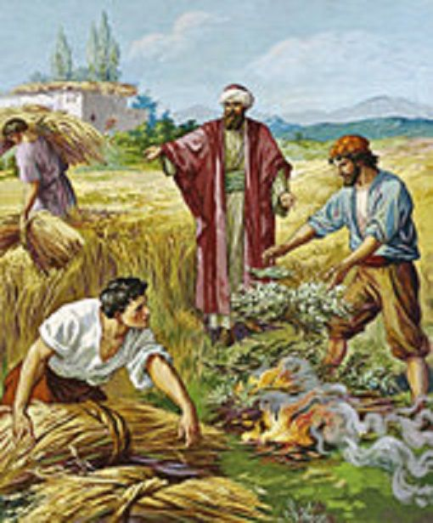

**Weeds among wheat**

The key words in today’s parable are ‘darnel’ and ‘weeds’. Jesus new that his listeners, who were mostly people from the agricultural world, would listen and understand the subtle danger of weeds. There are certain weeds that look like wheat when it is growing. These weeds would tangle themselves with the wheat and slowly destroy the plant.

What does this parable mean to me ? Many times, we look at a group of people in church or in a parish group or in our own community and we try to ‘help’ God to identify the weeds that He might have missed out.

Let us admit it – we love to judge and point our finger at anyone who does not measure up to our standards. We want to keep our family, our community, workplace and social group ‘weed-free’. We think that we know who the weeds and wheat are. Looking at ourselves, we have no problem in recognising the weeds of anger, lust, laziness, pride, jealousy, etc within us. We are eager to get rid of the weeds and we want ourselves to be ‘weed-free’ so that we can be flawless and perfect. Today, Jesus invites us to be patient and open ourselves to allow God to prune away any obstacle/weeds that can prevent the good seeds of His Word to grow in our lives. However, we ned to let God work in His own time and in His own way! Who knows that the ‘weeds’ we see around us and in us might be in our life for the purpose of leading us to deeper growth, deeper trust and deeper experience of God’s merciful love!

Reflection: **What strikes me in this time of prayer ?**

*Source: ‘Prayer for Living-The Word of God for Daily Prayer Year A’, Sr. Sandra Seow, Verbum dei Missionaries, 2016.*

**Saturday, 26 July – MEMORIAL – St Joachim & St. Anne**

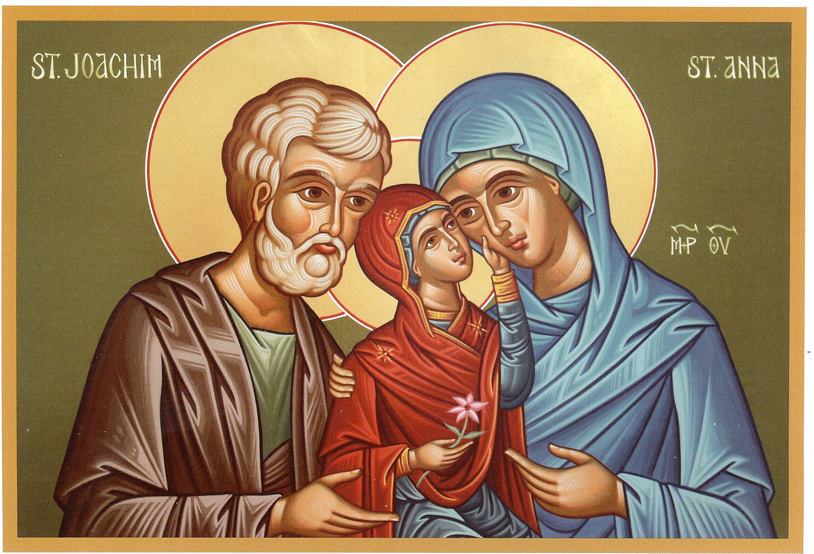

By tradition Joachim and Anne are considered to be the names of the [parents](http://www.catholic.org/encyclopedia/view.php?id=8984) of Mary, the Mother of God. We must focus on why they are honoured by the church. The [truth](http://www.catholic.org/encyclopedia/view.php?id=11728) is that it was the [parents](http://www.catholic.org/encyclopedia/view.php?id=8984) of [Mary](http://www.catholic.org/bookstore/?category=19) who nurtured Mary, taught her, brought her up to be a worthy Mother of God. It was their teaching that led her to respond to God's request with faith, "Let it be done to me as you will." It was their example of parenting that [Mary](http://www.catholic.org/bookstore/?category=19) must have followed as she brought up her own son, Jesus. It was their [faith](http://www.catholic.org/encyclopedia/view.php?id=4554) that laid the [foundation](http://www.catholic.org/encyclopedia/view.php?id=4807) of courage and [strength](http://www.catholic.org/prayers/prayer.php?p=2917) that allowed her to stand by the cross as her son was crucified and still believe.

*http://www.catholic.org/saints/saint.php?saint_id=83*

**Entrance Antiphon**

See, I have God for my help.

The Lord sustains my soul.

I will sacrifice to you with willing heart,

And praise your name, O Lord, for it is good.

**Responsorial Psalm**

Lord, you are good and forgiving.

**Gospel Acclamation**

Alleluia, alleluia!

Blessed are you, Father, Lord of heaven and earth;

You have revealed to little ones the mysteries of the kingdom.

Alleluia!

**Communion Antiphon**

The Lord, the gracious, the merciful,

Has made a memorial of his wonders;

He gives food to those who fear him.

**Readings of the week**

Sun 22 July **1st Reading** Wisdom12:13, 16-19; **Ps** 85:5-16,9-10,15-16 **; 2nd Reading** Romans 8:26-27 **; Gospel:** Matthew 13:24-43

Sun 29 July **1st Reading** Kings3:5,7-12; **Ps** 118:57,72,76-77; **2nd Reading** Romans 8:28-30; **Gospel: Matthew** 13: 44-52