**+**

**St. Luke the Evangelist Catholic Church**

|  |  |  |
| --- | --- | --- |
| **30 July 2017**  **17th Sunday**  **in Ordinary Time**  **Year A** | **Parish Administrator: *Fr. Dishan Candappa***  **School Principal: *Mrs Jackie Purcell***  **Parish Secretary: *Miss Marilyn Robert*** | **46 ORCHARD GROVE**  **PO BOX 2140**  BLACKBURN SOUTH 3130  Email: BlackburnSouth@cam.org.au  *PARISH Phone No: 9877 2292*  *SCHOOL Phone No: 98774023* |

## 

## **MASS TIMES**

**Week Days**

|  |  |  |
| --- | --- | --- |
| Monday | 9.00 AM | Mass |
| Tuesday | 11.00 AM | Mass |
| Wednesday | 9.00 AM | Mass |
| Wednesday | 7.30PM | Mass |
| Thursday | 9.00 AM | Mass |
| Friday | 9.00 AM | Mass |
| Saturday | 9.00 AM | Mass |

**Sundays**

Saturday Night Vigil Mass 6.00 PM

Sunday Mass 8.30 AM & 10.30 AM

**Reconciliation**

Saturday 9:30 AM / 5:30 PM

Wednesday – 6.30PM

Or by Appointment

**Adoration**

Wednesday – 6.30PM to 7.30pm

**Novena – Our Lady of Perpetual Help**

Wednesday – 7.00PM

## **COMMUNION MINISTERS ROSTER**

|  |  |  |  |  |  |  |  |
| --- | --- | --- | --- | --- | --- | --- | --- |
|  |  | **29 and 30 July** | **5 and 6 Aug** | **29 and 30 July** | **22 and 23 July** | **1 and 2 July** | **17 and 18 June** |
| Saturday | 6:00 PM | Terry Wells | Kathryn Holmes | Terry Wells | Olive Hammill | Olive Hammill | Monica Hodder |
| Sunday | 8:30 AM | Beryl Chelliah | Godfrey Thong | Beryl Chelliah | Kana Chelliah | Godfrey Thong | Beryl Chelliah |
|  | 10:30 AM | Sonya O’Farrell | Margaret Gearon | Sonya O’Farrell | Margaret Yore | Lizzie Dixon | Lynda Kilroe-Smith |

## **MINISTERS OF THE WORD ROSTER**

|  |  |  |  |
| --- | --- | --- | --- |
| Saturday | 6:00 PM | Melina Barcellona | Ian Holmes |
| Sunday | 8:30 AM | Kana Chelliah | Rosemary Donaldson |
|  | 10:30 AM | YOUTH | Choir/School |
|  |  |  |  |

## **WELCOME ROSTER**

|  |  |  |  |
| --- | --- | --- | --- |
| Saturday | 6:00 PM | Greg Grant | Lorraine Kermond |
| Sunday | 8:30 AM | Joe Brogno | Joe Brogno |
|  | 10:30 AM | Dixon Family | Margaret Gearon |
|  |  |  |  |

**SLIDE OPERATION**

|  |  |  |  |
| --- | --- | --- | --- |
| Saturday | 6:00 PM | Tony Lobo | David Prabha |
| Sunday | 8:30 AM | Mary White | Megan McLean |
| **CHURCH FLOWERS**  5/8 – Joan McHugh  12/8 – Jeanette Neumann | | **CHURCH CLEANING**  5/8 – Team 2  (Monica’s Team)  12/8 – Team 3  (Maree’s Team) | **MAINTENANCE**  12/8 – Team 2 (Dale Dixon & Ian Holmes)  26/8 – Team 3 (Sean Harford, Peter Fung) |

## 

[Type a quote from the document or the summary of an interesting point. You can position the text box anywhere in the document. Use the Drawing Tools tab to change the formatting of the pull quote text box.]

[Type a quote from the document or the summary of an interesting point. You can position the text box anywhere in the document. Use the Drawing Tools tab to change the formatting of the pull quote text box.]

**4. Oppose Euthanasia Legislation – Letter Writing at Parish**

We will be having a Letter Writing campaign next Sunday, 6 August at the Parish Hall after the 10.30AM Mass, to oppose the Euthanasia legislation. We are invited to write personal, handwritten letters to 5 Upper House members of Parliament & 1 Lower House Member of Parliament of Forest Hill & surrounding area. We are looking for 3 volunteers to help set up the hall & more to write letters. Cuppa will be served. Please contact Debbie Brown on 0433 442 212 if you could assist. Thank you.

**FEAST DAYS DURING THE WEEK**

Monday, 31 July – MEMORIAL - St. Ignatious of Loyola, priest

Tuesday, 1 August – MEMORIAL - St Alphonsus Liguori, bishop,

doctor

Thursday, 3 August – MEMORIAL - St. Dominic, priest

Friday, 4 August – MEMORIAL - St John Vianney, priest

**NOTICES**

**1.** **Special Collection last week – July 22/23 July**

**PROPOGATION of the FAITH – CATHOLIC MISSION**

Thank you for your ongoing support to Catholic Mission, on behalf of the missionaries and communities around the world who benefit directly from your contribution. We collected a total of **$788.30** last week. This year, we focus on our partnership with the parish of Bujuni in Uganda. Thank you for your kind and generous contribution.

**2. Keys have been changed**

New locks are now in place at the church, school and hall. Limited number of keys have been given out.

**3. Pastoral Council Meeting–Postponed to 8 August -** The next Parish Council Meeting will be held on 8 August at 7.30pm.

**PLEASE CHECK T**HE NOTICEBOARD FOR ANY INFORMATION THAT MAY BE OF INTEREST TO YOU

*[Kindly do not place* ***any material on the Notice Board/Foyer Table without first asking permission]***

For Hall hire & inquiries phone –

9877 2292

Please send **NEWSLETTER NOTICES**

to the following e-mail address by ***Wednesday 5pm*** –

**BlackburnSouth@cam.org.au**

**Year of Mercy**

Pope Francis said he goes to confession every two weeks, knowing that God never tires of forgiving those who repent, but also knowing that having a priest say “I absolve you” reinforces belief in God’s mercy.

Using the literal Italian translation of a Spanish saying, “It’s better to turn red once than yellow a thousand times,” Pope Francis said he knows some people are embarrassed to confess their sins to a priest, but it is the best path to spiritual healing and health.

The only people God will not forgive are those who do not want God’s forgiveness, just like only those who stand in the shade are not warmed on a sunny day, Pope Francis said.

**Friday, 4 August – MEMORIAL – St John Vianney, priest**

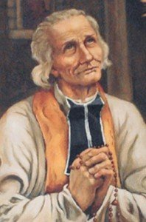

Jean-Baptiste-Marie Vianney, was born May 8, 1786 in Dardilly, France and was baptized the same day. He was the fourth of six children born to Matthieu and Marie Vianney. As a priest, Fr. Vianney realized many were either ignorant or indifferent to religion as a result of the French Revolution. He spent 11 to twelve hours each day working to reconcile people with God. In the summer months, he often worked 16-hour days and refused to retire. His fame spread until people began to travel to him in 1827. Within thirty years, it is said he received up to 20,000 pilgrims each year. St. John Vianney would often say: "Private prayer is like straw scattered here and there: If you set it on fire, it makes a lot of little flames. But gather these straws into a bundle and light them, and you get a mighty fire, rising like a column into the sky; public prayer is like that."

*Prayer of St. John Vianney*  
  
I love You, O my God, and my only desire is to love You until the last breath of my life.  
I love You, O my infinitely lovable God, and I would rather die loving You, than live without loving You.  
I love You, Lord and the only grace I ask is to love You eternally...  
My God, if my tongue cannot say in every moment that I love You, I want my heart to repeat it to You as often as I draw breath. *http://www.catholic.org/saints.php?saint_id=83*

**17th Sunday in Ordinary Time – Year A**

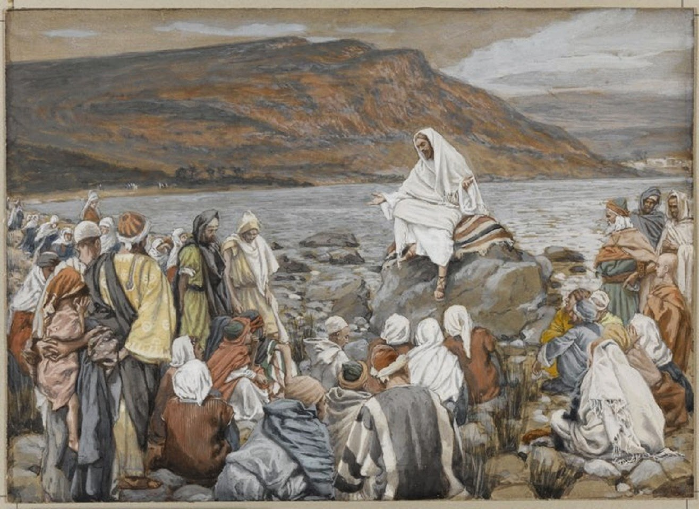

**Jesus, our priceless treasure**

What is our greatest treasure in life ?

In today’s Gospel, we read about a man who stumbled across a treasure hidden in a field. The field did not belong to him and so he sold everything he had in order to own the field as well as the treasure in it. This man’s joy was immeasurable. In the next story, we see a merchant looking hard for fibe pearls and he sold everything he owned when he found one just to possess it.

What do these parables mean to us ? When we find Jesus and recognise Him as our greatest treasure, we tool will experience a deep joy that nothing and nobody can take away from us. We too sill see everything else as secondary, and strive to gain more of Christ.

Having Jesus as our greatest treasure, we must never regard ourselves as superior and exclude others crom coming to know and encounter Him.

“…the kingdom of heaven is like a dragnet cast into the sea that brings in a haul of all kinds.”

The Church is made of saints and sinners, and no one should be excluded but all must be welcomed. We, as part of the people of God, must go out to welcome those who are most in need of God’s love and mercy. Because we have Jesus as our greatest treasure, we will help and guide them to joufully have Him also as their treasure and their fine pearl.

Reflection: **Is Jesus my greatest treasure ? How can I help others to search for Jesus and make Him become their greatest treasure ? What strikes me in this time of prayer ?**

*Source: ‘Prayer for Living-The Word of God for Daily Prayer Year A’, Sr. Sandra Seow, Verbum dei Missionaries, 2016.*

**Entrance Antiphon**

God is in his holy place,

God who unites those who dwell in his house;

He himself gives might and strength to his people.

**Responsorial Psalm**

Lord, I love your commands.

**Gospel Acclamation**

Alleluia, alleluia!

Blessed are you, Father, Lord of heaven and earth;

You have revealed to little ones the mysteries of the kingdom.

Alleluia!

**Communion Antiphon**

Bless the Lord, O my soul,

and never forget all his benefits.

**Readings of the week**

Sun 29 July **1st Reading** Kings3:5,7-12; **Ps** 118:57,72,76-77; **2nd Reading** Romans 8:28-30; **Gospel: Matthew** 13: 44-52

Sun 5 August **1st Reading** Isaiah 55:1-3; **Ps** 144:8-9,15-18.R.v.16; **2nd Reading** Romans 8:35,37-39; **Gospel: Matthew** 14:13-21